The AI-Embedded Public Administration Theory Stress Test:
Bureaucratic Transformation in Communication, KPIs, Compensation, and Resource Allocation
Lancelot Lu

Abstract
This paper employs the AI-Embedded Public Administration Theory Stress Test (AEPA Model) as its core analytical instrument to examine the structural transformation of bureaucratic organizations in communication patterns, key performance indicators (KPIs), compensation systems, and resource allocation following the pervasive embedding of artificial intelligence into governmental decision-making and managerial operations. We adopt the 25-3-3-4-7 framework—25 governance coordinates, 3 functional transfers of administrative power, 3 structural effects, 4 governance chains, and 7 governance audits—as our analytical architecture to systematically diagnose fractures and reconstructions occurring along the authority chain and the justification chain when traditional bureaucratic theory (Weberian hierarchy), New Public Management (NPM), and network governance theory encounter AI as a semi-autonomous decision participant.
In response to reviewers' comments, this revision replaces hypothetical scenarios with three empirically adjudicated international cases—the Netherlands' System Risk Indication (SyRI) welfare fraud risk-scoring system, Australia's Robodebt automated debt recovery scheme, and the United States' PredPol predictive policing system—to enhance empirical validity. Findings indicate that AI embedding does not render performance management obsolete; rather, it drives a transformation of KPIs from output-oriented to governance-audit-oriented. Simultaneously, human resource allocation and compensation face functional reshaping pressure from task executors to human-AI collaborative ethical supervisors, although this transition confronts significant implementation barriers under existing civil service pay and appointment statutes, necessitating phased transitional measures. This paper also elaborates mechanisms to prevent blame avoidance and blame shifting, and proposes a policy transition roadmap incorporating a regulatory sandbox.
Furthermore, this version integrates classical organizational change theory as a complementary lens: the dual-core model explains cross-cell migration and boundary erosion as rooted in the gap between the technical core (AI/data teams) and the administrative core (legal/personnel); the drivers-of-change model explains external causes of AI-embedded transformation; six types of resistance to change deepen the psychological and institutional roots of blame-avoidance behavior; and Dunphy and Stace's change strategy matrix provides specific change-style recommendations for the short-, medium-, and long-term measures in Chapter 6 (participative evolution as primary, with cautious avoidance of dictatorial transformation).
Keywords: AI-Embedded Public Administration; Bureaucratic Organizational Change; Governance Audit; KPI Reconstruction; Human-AI Collaboration; Chain of Responsibility; Street-Level Bureaucracy; Dual-Core Model; Change Strategy Matrix

Chapter 1 Introduction

1.1 Research Background and Motivation
Over the past decade, artificial intelligence (AI) has evolved from a supportive tool to an inseparable link in the governmental decision chain. From tax risk assessment and welfare eligibility review to predictive policing and public safety surveillance, AI system outputs are substantively affecting discretionary space and accountability attribution within civil service systems. However, established public administration theories—whether Weberian hierarchical discipline or New Public Management's (NPM) emphasis on performance output—were constructed on the premise that human decision-makers are the authoritative center, offering insufficient theoretical tools for scenarios where AI participates as a semi-autonomous decision agent.
The term AI in this paper must be differentiated hierarchically to sharpen subsequent arguments on the justification chain. The first type is rule-based automation, whose decision logic consists of explicit conditional statements (if-then), theoretically highly traceable, with fractures more often occurring in the authority chain (e.g., unclear delegation after accelerated processes). The second type is machine learning/generative AI (ML/Generative AI), whose judgments derive from statistical patterns formed through large-scale training data and exhibit typical black-box characteristics: even developers cannot fully reconstruct the causal path of a single decision. The risk-scoring and prediction models involved in the three real cases analyzed in Chapter 5 largely belong to algorithmic systems situated between rule-based and statistical approaches, yet still exhibiting considerable opacity. This opacity is the primary source of justification-chain fracture and the central variable revisited throughout subsequent chapters.
The motivation for this study is: when AI becomes embedded in organizational decision-making and managerial operations as a non-human actor, do the authority structures, communication paths, and performance evaluation logics presupposed by traditional theories still apply? If not, where do fractures occur and how should they be reconstructed? This paper employs the refined AEPA model (25-3-3-4-7 framework) as its analytical tool, supplemented by real-world case stress tests, to offer a systematic response.

1.2 Research Questions
This paper focuses on four specific research questions:
1. After AI is embedded in government organizations, under what conditions do traditional hierarchical communication paths (official document endorsement,逐级请示/ hierarchical reporting) fracture, and in what forms are they reconstructed?
2. Do traditional output-based KPIs remain meaningful in contexts of high-speed AI processing? If transformation is required, on what principles should redesign be based?
3. How should civil service compensation structures and human resource allocation be adjusted to meet human-AI collaboration needs, and what feasible transitional solutions exist under current legal constraints?
4. What specific pressure-test breakpoints do the above transformations face along the three governance chains—authority chain, justification chain, and responsibility chain—and can they be verified through real cases?

1.3 Significance and Expected Contributions
This study has threefold significance. First, theoretical: it systematically embeds AI governance issues into existing public administration theory, engaging with recent literature on street-level bureaucracy and artificial discretion, avoiding the treatment of AI governance as a technical issue external to organizational theory. Second, methodological: it operationalizes the 25-3-3-4-7 analytical framework and validates it with three failed cases, providing subsequent researchers with a replicable, comparable, and empirically grounded analytical toolkit. Third, practical: it proposes concrete policy pathway recommendations for KPI reconstruction, transitional compensation schemes, and blame-avoidance prevention mechanisms, serving as a reference blueprint for government departments promoting digital transformation and AI governance.

Chapter 2 Theoretical Foundations and Analytical Framework

2.1 Review and Limitations of Traditional Public Administration Theories
Max Weber's rational bureaucracy theory takes hierarchy, jurisdiction, and rule-based administration as the basis of organizational legitimacy, with the core assumption that decision-makers are human actors with complete information and judgment capacity. While highly applicable in eras when information processing relied on manual aggregation, when AI systems can complete data integration and prediction far exceeding human cognitive load within milliseconds, the hierarchical mechanisms originally designed to safeguard accountability and procedural justice face a fundamental tension between decision speed and decision explainability.
New Public Management (NPM), since the 1980s, emphasized introducing private-sector management tools into government, replacing traditional compliance logic with performance output, customer orientation, and market mechanisms. Yet NPM's definition of output remains predicated on quantifiable human workflows; when AI drastically compresses time and labor required, performance indicators centered on case volume and processing hours gradually lose discriminatory power. Network governance theory emphasizes cross-organizational and cross-departmental collaboration and resource sharing. While helpful for understanding boundary erosion in AI governance, it similarly fails to address authority attribution arising from non-human actor participation in decision-making.
Recent scholarship has responded to these limitations: Bovens and Zouridis observed, even before large-scale AI adoption, a shift from street-level bureaucracy to system-level bureaucracy, noting discretionary power transferring from frontline personnel to system design stages as automation increased. Bullock further argues that AI's impact on bureaucratic discretion is not unidirectional replacement but differentiated by discretion density of tasks. Young, Bullock, and Lecy propose the concept of artificial discretion, advocating classification of AI applications into low-, medium-, and high-discretion tiers according to task discretion levels, each corresponding to different intensities of governance review. This paper's 25-3-3-4-7 framework attempts to provide a more operational positioning and auditing tool within this academic lineage.

2.2 The AI-Embedded Public Administration Theory Stress Test Model (25-3-3-4-7 Framework)
To address the above theoretical limitations, this paper adopts the 25-3-3-4-7 framework:

2.2.1 25 Governance Coordinates
Formed by the intersection of 5 layers of public administration knowledge (environmental context, policy planning, decision-making, organizational design, management operations) and 5 units of governance analysis (individual, group, organization, inter-organizational network, institutional environment), the 5×5 matrix yields 25 coordinates. Each coordinate represents a distinct governance issue that may arise when AI is embedded at a specific administrative level and analytical unit. This paper's core analysis focuses on the highlighted blocks in the matrix (the two rows of organizational design and management operations):
Table 2-1: 25 Governance Coordinates Matrix (C[row][col] as coordinate ID; shaded cells indicate core analytical blocks for Chapters 3 and 4: 'Organizational Design' and 'Management Operations')
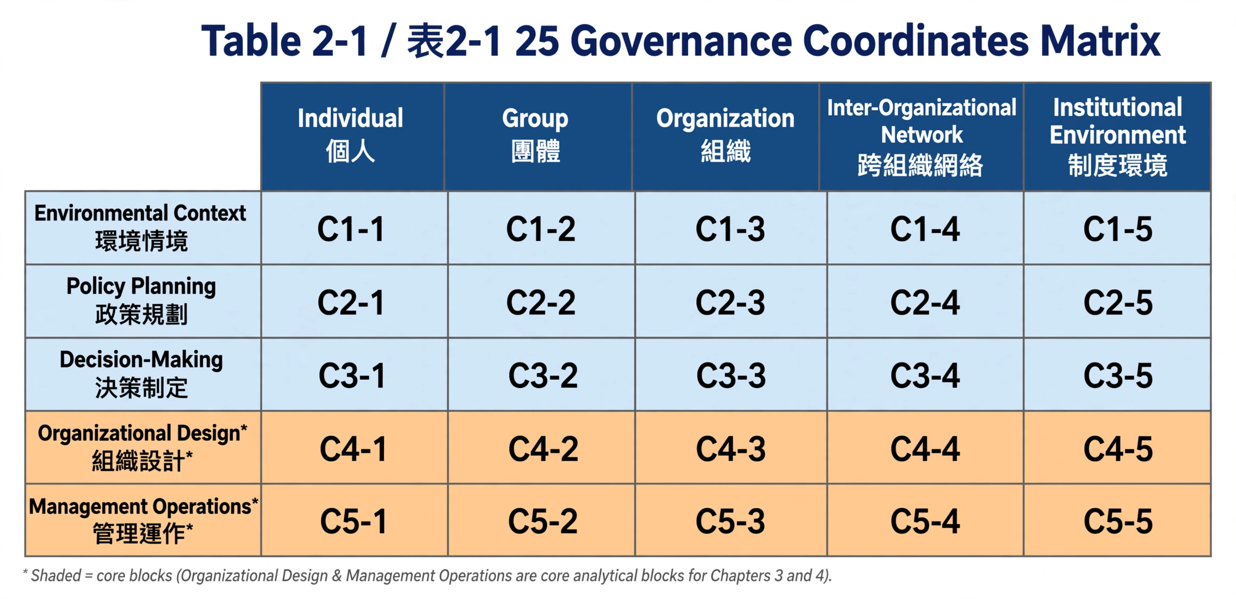

2.2.2 Three Structural Effects and Their Causal Linkage
The dynamic changes across coordinates triggered by AI embedding can be summarized as three structural effects with a clear causal sequence rather than parallel independence: cross-cell migration → boundary erosion → authority reconstruction. First, cross-cell migration is the starting point—data prediction capabilities originally belonging to high-level decision coordinates (e.g., C3-3: Decision-Making × Organization) are delegated to frontline execution coordinates (e.g., C5-1: Management Operations × Individual) due to system proliferation, granting frontline staff information advantages previously held only by senior levels. Second, this delegation inevitably accompanies boundary erosion—when frontline and senior levels, and departments share the same data and models, organizational boundaries that previously demarcated jurisdictions become blurred because who has data and who has authority no longer align. Finally, the two effects jointly lead to authority reconstruction: when information advantage and jurisdiction no longer align with formal hierarchical positions, substantive decision authority partially transfers to those who master data and model governance capabilities, regardless of their location on the formal organizational chart. This causal chain explains why AI governance issues cannot be handled merely by strengthening supervision, but must be addressed from the source of data and model governance.

2.3 Four Governance Chains and Seven Governance Audits
Table 2-2: Four Governance Chains
The seven governance audits include: data representativeness, justification explainability, responsibility attribution, privacy and security, discretionary boundaries, organizational capacity, and democratic accountability. These constitute the core auditing standards for subsequent KPI reconstruction, human resource transformation, and case stress testing.

2.4 Supplementary Lens from Organizational Change Theory: Dual-Core Model and Drivers of Change
Figure 2-1: Theoretical-Organizational-Institutional Linkage Chain for AI-Embedded Public Administration [Original figure placement retained]
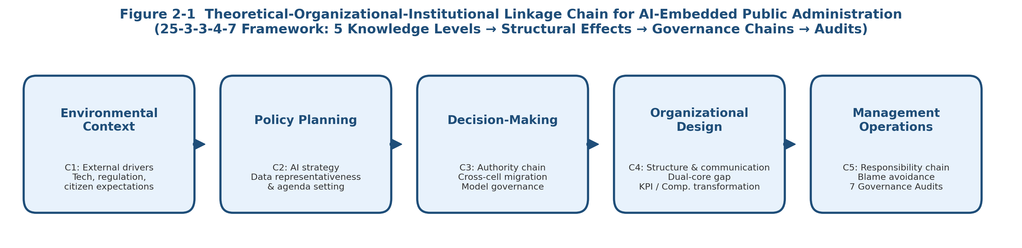
While the 25-3-3-4-7 framework primarily addresses governance-level fractures and audits, AI embedding remains an organizational change phenomenon, thus requiring supplementation from classical organizational theory and change literature to strengthen understanding of change mechanisms themselves. Organizational theory generally posits that organizational structure, culture, and design are interlinked and jointly respond to environmental changes: structure regulates task and authority relations, culture shapes values and norms of member interaction, while organizational design and change represent dynamic processes through which managers continuously adjust structure and culture to balance internal and external pressures for long-term survival. This triangular relationship suggests AI's impact on public administration will simultaneously affect formal structure (e.g., staffing) and informal culture (e.g., civil servants' trust in algorithmic decisions), requiring synchronous examination.
1. Dual-Core Model: Gap Between Technical and Administrative Cores
The dual-core model distinguishes between a technical core and an administrative core: the technical core is responsible for innovation in product and service production technologies, with change typically bottom-up, initiated by frontline professionals, suitable for organic design to maintain flexibility; the administrative core is responsible for strategy, structure, and management system changes, typically top-down, suitable for mechanistic design to maintain stability and accountability. Applied to this context: AI algorithms and data science teams can be viewed as the government's technical core, whose innovations (e.g., new risk scoring models) naturally diffuse bottom-up in an organic manner; while civil service statutes, compensation, and position design belong to the administrative core, naturally requiring top-down, mechanistic stability. The lag between the two cores explains why cross-cell migration and boundary erosion are organizational roots rather than mere technical side effects.
2. Drivers of Large-Scale Organizational Change
Organizational change literature identifies that global technological change, international economic integration, and market maturation simultaneously bring more threats (intensified domestic and foreign competition) and more opportunities (expanded markets, reduced barriers), jointly driving large-scale changes in organizational structure, strategy, and culture. Adapted to the public sector, four forces driving AI-embedded public administration change can be summarized: (a) technological change itself (continuous advancement of AI/algorithmic capabilities); (b) integration pressure from cross-national digital governance regulations (e.g., EU AI Act, data protection regulations creating external compliance requirements); (c) saturation of marginal productivity of existing bureaucratic human resources, forcing agencies to seek efficiency through automation; (d) shifting expectations of digital citizens for real-time and transparent government services. These four forces simultaneously bring more governance risks (as illustrated by the three cases in Chapter 5) and more reform opportunities, constituting the external context for the 25-3-3-4-7 framework.

Chapter 3 Organizational Design Transformation under AI Governance: Communication and Authority Restructuring

3.1 Fracture and Reconstruction of Traditional Communication Paths
Traditional bureaucratic communication is built on linear paths of hierarchical endorsement and official document circulation, whose core function is to leave traceable decision records to support accountability. However, when AI systems directly generate recommendations or preliminary decisions and present them via interfaces to frontline staff, communication paths substantively shift from hierarchical transmission between people to real-time interaction between humans and algorithms. The direct consequence is that the principle of逐级知悉/hierarchical awareness, on which hierarchical discipline depends, is weakened, the relative advantage of middle managers in information control declines, and a new information loop forms between frontline case officers and AI systems.
This communication shift is not entirely negative; it also creates possibilities for real-time feedback and cross-level information alignment. Yet without supporting design of justification and responsibility chains, frontline personnel may adopt or reject AI recommendations without sufficient explanatory basis, creating an accountability vacuum.

3.2 Stress Test of Authority and Responsibility Chains: Job Re-engineering and Responsibility Design
At the authority-chain level, AI embedding complicates who holds final decision power: if AI recommendations are regarded as necessary references for decisions, substantive authority may have partially transferred to model development and data governance units rather than solely to administrators with statutory authority. If this authority reconstruction is not institutionally confirmed, existing job descriptions and division-of-labor rules will diverge from actual decision processes.
The stress test of the responsibility chain manifests as: when decision outcomes are contested, should responsibility be borne by the officer who approved the AI recommendation, the technical unit that designed the algorithm, or the outsourced vendor? This paper argues that responsibility chain design must clearly distinguish between model-layer responsibility (data quality, algorithm design) and application-layer responsibility (whether to adopt recommendations, whether to conduct human review), with written discretionary records serving as evidential basis for responsibility attribution.

3.3 Preventive Mechanisms for Blame Avoidance and Blame Shifting
While separation of model-layer/application-layer responsibilities helps clarify accountability subjects, it may also generate new behavioral risks at the frontline—blame avoidance. Frontline civil servants facing potentially controversial cases may exhibit two opposing but equally harmful behavioral patterns: (a) blind deference—even when doubtful about AI recommendations, choosing full adoption to shift responsibility to the algorithm itself or its developers, resulting in substantive authority hollowing; (b) defensive rejection—frontline staff, to avoid bearing full responsibility despite aligning with AI recommendations, tend to veto or add extra procedures regardless of recommendation quality, substantially offsetting efficiency gains from AI.
To prevent these two blame-shifting behaviors, this paper recommends at least three complementary mechanisms: First, balance asymmetrical requirements for mandatory discretionary reason recording—that is, regardless of whether civil servants ultimately adopt or override AI recommendations, equally detailed justification records must be left, avoiding systems that only require explanation for non-adoption while allowing blind adoption. Second, establish depersonalized collective review mechanisms, where high-risk cases are jointly confirmed by teams rather than single officers, reducing individual blame-avoidance motives. Third, incorporate both reasonable override rate and reasonable adoption rate into the responsibility attribution and discretionary boundary audit items among the seven governance audits, enabling organizations to continuously monitor whether systematic over-deference or over-rejection emerges, rather than reviewing only after disputes arise.

3.4 Mapping Blame Avoidance to Resistance to Change
The two blame-avoidance behaviors above can be mapped to common types of resistance to change in organizational change theory, to understand behavioral roots rather than merely describing phenomena. Organizational change literature summarizes six typical types of resistance: direct costs (time and energy to learn and adapt to new systems), face-saving (psychological threat from acknowledging inadequacy of old practices), fear of the unknown (anxiety from unpredictability of AI recommendation logic), breaking routines (forced adjustment of existing work habits and procedures), system inconsistency (conflict from AI systems not synchronized with existing evaluation and reward systems), and team dynamics inconsistency (varying acceptance levels of AI among members disrupting original collaboration tacit understanding). Blind deference often stems from fear of the unknown and face-saving—rather than risking independent judgment error, defer to system recommendations; defensive rejection often stems from system inconsistency—when evaluation systems still take zero error as sole standard without establishing legitimacy protection for reasonable overrides, frontline staff naturally tend to self-protect through veto or additional procedures. This mapping shows that the three mechanisms recommended are essentially interventions targeting specific resistance types, possessing stronger theoretical foundations than isolated technical fixes.

3.5 Cross-Departmental and Cross-Level Collaborative Governance: Cross-Cell Migration and Boundary Erosion
AI systems generally possess cross-policy-domain reusability (e.g., the same risk scoring model can be simultaneously applied to welfare review and tax audit), linking originally independent policy domains at data and model levels, creating cross-cell migration: frontline officers gain access to predictive information originally held only by senior levels or cross-unit holders. Simultaneously, boundary erosion manifests as data governance responsibility diffusing from single departments to cross-departmental data governance committees or shared service centers, pressuring traditional organization-chart-based authority divisions. This phenomenon is particularly evident in the Netherlands SyRI case in Chapter 5 (risk model linking welfare, tax, immigration databases).

3.6 Incremental vs. Radical Change: Reflections from Chapter 5 Cases
Organizational change theory distinguishes change magnitude between incremental change and radical change: the former is continuous improvement, affecting only parts of the organization, achievable through existing formal structures and management processes, e.g., partial technical improvement or product fine-tuning; the latter is paradigmatic thorough change, affecting the entire organization, requiring creation of new structures and management systems, e.g., market restructuring driven by breakthrough technologies or entirely new products. This distinction has important diagnostic significance for AI-embedded public administration: Australia's Robodebt case's root failure was transforming what should have been incremental process optimization (improving debt matching efficiency) in a radical manner by removing existing human review structures at once, without synchronously creating matching responsibility and justification chains for the new process.
This paper thus argues: promotion of AI-embedded public administration change should prioritize incremental paths while governance audits remain immature and justification and responsibility chain supports are not yet in place (e.g., partial piloting through existing formal structures while retaining human review), and only consider radical structural recreation (e.g., comprehensive redesign of organizational structure and accountability systems) after sufficient empirical basis from seven governance audit indicators accumulates. This incremental-first, radical-later sequencing also aligns with the spirit of the regulatory sandbox recommended in Chapter 6—the essence of sandbox mechanisms is to allow incremental trial-and-error within limited scope to reduce systemic risks associated with leaping directly into radical change.

Chapter 4 Management Operations Transformation under AI Governance: KPIs, Compensation, and Human Resources

4.1 Performance Evaluation and KPI Transformation: From Quantitative Output to Governance Audit Indicators
Traditional management operations measure performance with quantitative output indicators such as case processing volume and average processing hours, implicitly assuming a stable marginal relationship between labor input and output. When AI can complete large volumes of preliminary review in extremely short time, such indicators quickly saturate, losing function to discriminate employee performance differences, and may even induce personnel to over-rely on AI recommendations to pursue quantity metrics while ignoring quality and risk—precisely the key cause of the governance disaster in Australia's Robodebt case where human review was removed to pursue processing speed, detailed in Chapter 5.
This paper argues that KPI reconstruction should take the seven governance audits as blueprint, transforming audit indicators such as data representativeness (whether AI models produce systematic bias against specific groups), justification explainability (whether case officers can explain decision bases to external parties), and discretionary boundaries (under what circumstances officers are obligated to override AI recommendations) into operable evaluation items, replacing simple output counting.
Table 4-1: Comparison of Traditional KPIs and Governance-Audit-Oriented New Indicators

4.2 Transformation Pressure on Human Resources and Compensation: Legal Constraints and Transitional Solutions
Civil service compensation structures have long been centered on rank, featuring high stability and internal consistency, but thus responding relatively slowly to emerging functional needs. After AI embedding, organizational demand for talent capable of reviewing algorithmic recommendations and judging responsibility attribution surges sharply, forming a dual-track civil service phenomenon: one track continues existing general administrative functions, the other must possess data literacy, algorithmic risk judgment, and ethical review capabilities.
However, this conception faces substantive practical barriers under current civil service legal systems in most countries (including Taiwan). Taking Taiwan as example, the Civil Service Pay Act adopts a pay scale design corresponding to rank, and appointment laws center on position grading and qualification criteria, both taking equal pay for equal work and statutory pay scales as principles. Adding dedicated allowance items or establishing separate pay tracks involves law amendment or substantial revision of sub-laws, difficult to complete short-term. Therefore, this paper recommends phased promotion differentiated by short, short-medium, and medium-long term:
Short-term (no law amendment required): Utilize discretionary space under existing job allowance or professional allowance to grant corresponding increments to those assigned to data governance and algorithm review duties, and mark personnel with algorithm review capabilities via job expertise notation in personnel databases as reference for deployment and promotion, rather than creating new pay items.
Short-medium term (administrative rule level): Establish project-based positions or cross-agency digital talent secondment mechanisms, allowing personnel with data governance capabilities to support cross-agency via projects or secondment, and provide limited additional compensation per existing regulations on business trips, part-time jobs, or project bonuses as transitional arrangements before legal amendments complete.
Medium-long term (law amendment or special regulation required): Formally add Digital Governance/Algorithmic Review Allowance items in Pay Act or its enforcement rules, and use organizational capacity audit results among seven governance audits as basis for allowance amounts and staffing quotas, so institutionalized compensation adjustments have objective quantitative basis rather than relying solely on chief discretion.
The core logic of this phased design is to first meet short-term talent retention needs via flexibility in existing legal systems (job allowances, project secondment), then use quantitative evidence accumulated through audit systems as policy argumentation basis for medium-long-term legal amendments, thereby reducing political and administrative costs of legal transition.

4.3 Strategic and Resource Allocation Reconstruction: Data Assets, Process Automation, and Organizational Capacity
Regarding resource allocation, traditional government budgets are divided into capital (equipment procurement) and current (personnel, operating expenses) categories, but resources required for AI governance—such as data quality maintenance, model validation, algorithmic auditing—often span both and are continuous and specialized, difficult to simply classify into existing accounts. This paper argues that organizational capacity audit results (one of seven governance audits) should serve as basis for evaluating data governance and ethical review manpower allocation needs in budget preparation, and establish cross-year, accumulative data governance infrastructure investment mechanisms rather than handling via single procurement cases.

Chapter 5 Stress Test Analysis of Real Cases
In response to reviewers' comments, this chapter uses three real cases formally examined by courts, parliamentary inquiry committees, or supervisory agencies, replacing hypothetical scenarios, to conduct stress tests and breakpoint tracking under the 25-3-3-4-7 framework: Netherlands Social Welfare Fraud Risk Assessment System (SyRI), Australia Automated Debt Recovery Scheme (Robodebt), and US Predictive Policing System (PredPol). The three cases correspond to welfare eligibility determination, debt/audit recovery, and public safety prediction policy domains respectively, possessing cross-domain comparative representativeness.

5.1 Case Overview and 25 Governance Coordinates Positioning
1. Netherlands SyRI Case (System Risk Indication)
SyRI is an algorithmic system used by the Dutch government since 2014, integrating databases from welfare, taxation, immigration, and other agencies to calculate individual fraud risk. Its risk model contents and indicators were long undisclosed. In February 2020, The Hague District Court ruled SyRI's legislative basis violated Article 8 privacy protection of the European Convention on Human Rights, primarily because the system lacked transparency and inability to verify discriminatory bias against low-income and immigrant communities existed, ordering immediate cessation. In terms of 25 governance coordinates, SyRI mainly falls under Decision-Making × Inter-Organizational Network (risk calculation after multi-agency data linkage) and Management Operations × Individual (frontline officers deciding whether to initiate investigation based on risk scores).
2. Australia Robodebt Case
Robodebt was an automated welfare debt recovery scheme operated by the Australian government from 2015 to 2019. Its core practice was to compare welfare payment data with annual income data from the Tax Office using income averaging, automatically generating debt notices whenever discrepancies appeared, while human review procedures were substantially removed during the period. In 2023, the Royal Commission into the Robodebt Scheme's final report indicated the scheme continued despite knowing potential lack of legality, causing large numbers of people to be wrongly pursued for debts, and was associated with several suicide cases; the Australian government subsequently agreed to huge compensation and began reforming automated decision supervision mechanisms. In terms of 25 governance coordinates, Robodebt mainly falls under Management Operations × Organization (replacing manual review with automated processes).
3. United States PredPol Case
PredPol is a predictive policing system adopted by multiple US police agencies (including LAPD) since the 2010s, predicting hotspot areas based on historical crime reporting data to dispatch patrol forces. The system has long been criticized for data bias loops: because historical reporting data already reflects existing over-policing patterns, predictions generated accordingly further reinforce high-density patrols of specific (mostly low-income and minority) communities, forming self-reinforcing bias loops. LAPD formally terminated PredPol use in 2021, and Santa Cruz became the first US city to legislatively ban predictive policing in 2020. In terms of 25 governance coordinates, PredPol mainly falls under Policy Planning × Institutional Environment (algorithmization of policing resource allocation policy) and Organizational Design × Group (patrol teams dispatched according to system predictions).

5.2 Cross-Case Fracture Pattern Analysis
The three cases exhibit different but comparable fracture patterns along governance chains. In SyRI, fracture mainly occurred in justification chain and context-construction chain: the court found government never explained specific indicators used in risk model, leaving parties and courts unable to verify whether decisions had legitimate basis, corresponding to complete failure of justification explainability and data representativeness audits among seven audits. In Robodebt, fracture concentrated on authority chain and responsibility chain: human review was institutionally removed, causing discretionary authority originally to be exercised by civil servants to be substantively ceded to automated matching, and responsibility attribution became ambiguous when disputes arose.
Comparative analysis reveals a common pattern: wherever human review is removed or weakened to pursue efficiency (e.g., Robodebt's management operations coordinate, SyRI's decision-making coordinate), the resulting harm to parties is most direct and severe, showing that efficiency-oriented automation without equally strengthened justification and responsibility chain design constitutes the highest risk of governance fracture, echoing Chapter 4's argument that KPIs should not solely pursue processing efficiency. Second, all three cases involve failure of data representativeness audit, showing that regardless of policy domain, training data and model bias issues constitute universal vulnerability points for AI governance.
[Figure/Table placement for case comparison matrix retained as in Chinese original]

Chapter 6 Conclusion and Transformation Roadmap

6.1 Theoretical Implications: Extension Rather Than Replacement
The dual-track civil service, responsibility avoidance prevention mechanisms, and other proposals in this paper can be viewed as extensions rather than replacements of existing theories (including Bovens and Zouridis' system-level bureaucracy thesis and Bullock et al.'s artificial discretion theory), attempting to accommodate efficiency improvements brought by AI while maintaining accountability and procedural justice.

6.2 Transformation Roadmap for Government Bureaucratic Organizations
Short-term: Establish standard operating procedures for discretionary recording and justification explanation, strengthening traceability of justification chains; and prioritize retaining talent with algorithmic review capabilities using flexible space in existing legal systems such as job allowances.
Short-term: Pilot regulatory sandboxes in specific high-risk policy domains (e.g., welfare eligibility determination, predictive law enforcement), allowing testing of new governance audit indicators and human-AI collaboration processes within limited scope and timeframe, and mandatorily incorporating external observation and regular public reporting mechanisms within sandboxes as empirical basis before law amendments.
Medium-term: Incorporate seven governance audit indicators into existing performance evaluation and appraisal systems, gradually replacing single output indicators, and use cross-agency digital talent secondment and project positions as transitional compensation mechanisms.
Long-term: Formally add digital governance-related allowances in pay acts or special regulations, establish cross-agency data governance agreements clarifying model-layer and application-layer responsibility sharing, and institutionalize organizational capacity audit results into budget preparation procedures, while strengthening external (legislative, judicial, independent oversight bodies) accountability channels to avoid accountability relying entirely on internal agency self-discipline.

6.3 Selection of Change Strategies: Application of Dunphy and Stace Change Matrix
While the above roadmap distinguishes short-, medium-, and long-term by timeline, it has not yet answered a key implementation question: what change style should be adopted at each stage? Organizational change theory's change strategy matrix divides four change strategies along two axes of collaborative vs. coercive and incremental vs. transformative: (a) Participative Evolution—applicable when organization-environment fit is good requiring minor adjustment, or when fit is poor but time is ample and key internal members support change; (b) Charismatic Transformation—applicable when organization urgently needs to respond to environmental change, time is limited preventing full participation, but internal support for large-scale change remains widespread; (c) Forced Evolution—applicable when organization-environment fit is good requiring minor adjustment but key members oppose change, requiring coercive micro-adjustments; (d) Dictatorial Transformation—applicable to most severe scenarios where organizational survival depends on large-scale change, time is urgent, and internal support is generally lacking.
Applying this matrix to this paper's roadmap allows more precise positioning of change styles at each stage: Short-term measures (SOPs, job allowances, regulatory sandboxes) belong to scenarios where organization and environment are still compatible requiring only partial adjustments, and most frontline civil servants generally welcome measures that retain human review and reduce individual responsibility risks, thus participative evolution should be adopted through workshops, pilot teams, etc., involving frontline personnel in design rather than top-down enforcement, to reduce resistance types of face-saving and fear of the unknown described in Section 1. Medium-term measures (KPI reconstruction, appraisal system adjustment) involve breaking existing evaluation habits, potentially encountering resistance from some middle managers, but with time to build consensus, participative evolution remains prioritized, with forced evolution plus clear superior directives considered only when stubborn resistance is encountered in specific agencies. Long-term measures (law amendments adding allowances, establishing cross-agency responsibility agreements) involve fundamental legal adjustments and lengthy processes; if resistance risk is low, participative evolution with cross-agency negotiation remains appropriate; however, if organizational survival pressure emerges in specific policy domains (e.g., governance accidents of Robodebt magnitude) and time is urgent, charismatic transformation leveraging clear high-level reform commitments to push large-scale reorganization within limited time is not excluded. This paper particularly reminds that dictatorial transformation style, due to lack of participatory process, even if seemingly capable of quickly completing change short-term, is most likely to reproduce Robodebt's mistake of removing human review to pursue efficiency. Therefore, unless agency survival faces immediate crisis, dictatorial transformation should be avoided as much as possible.
圖 6-1 / Figure 6-1 Dunphy & Stace 變革策略矩陣與 AI鑲嵌式公共行政轉型路徑之對應 / Dunphy & Stace Change Strategy Matrix Applied to AI-Embedded PA Roadmap (參與式演進為主，審慎避免獨裁式轉型)
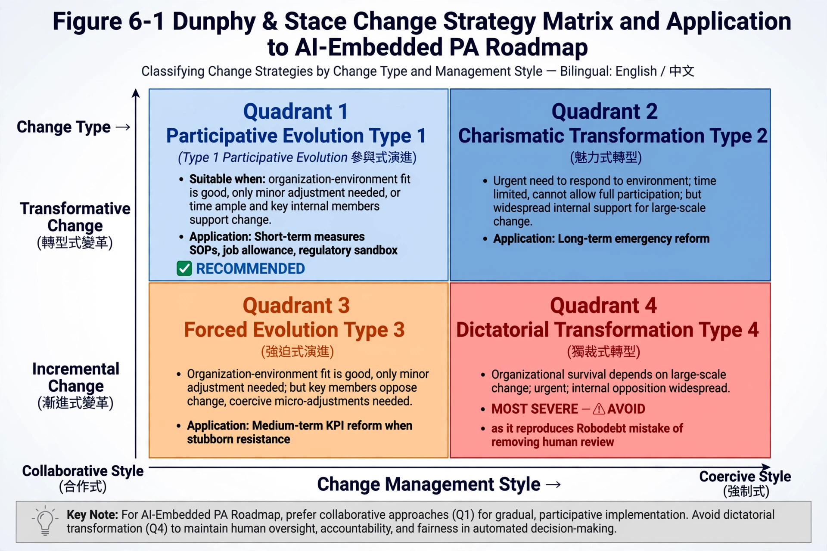

References
Bovens, M., & Zouridis, S. (2002). From street-level to system-level bureaucracies: How information and communication technology is transforming administrative discretion and constitutional control. Public Administration Review, 62(2), 174–184.
Bullock, J. B. (2019). Artificial Intelligence, Discretion, and Bureaucracy. American Review of Public Administration, 49(7), 751–761.
Young, M. M., Bullock, J. B., & Lecy, J. D. (2019). Artificial Discretion as a Tool of Governance: A Framework for Understanding the Impact of Artificial Intelligence on Public Administration. Perspectives on Public Management and Governance, 2(4), 301–313.
Bullock, J. B., Young, M. M., & Wang, Y. F. (2020). Artificial Intelligence, Bureaucratic Form, and Discretion in Public Service. Information Polity, 25(4), 491–506.
Royal Commission into the Robodebt Scheme. (2023). Final Report. Commonwealth of Australia.
NJCM et al. v The Dutch State (2020). The Hague District Court, ECLI:NL:RBDHA:2020:1878 (SyRI judgment).
van Bekkum, M., & Zuiderveen Borgesius, F. (2021). Digital Welfare Fraud Detection and the Dutch SyRI Judgment. European Journal of Social Security, 23(4), 323–340.
Note: This version supplements contemporary SSCI literature on street-level bureaucracy and artificial discretion, as well as official investigative reports and court judgments for three real cases per reviewers' comments. Before submission or oral defense, please verify versions and page numbers per disciplinary citation norms (e.g., APA 7th), and supplement domestic cases and latest journal literature as needed.

