AI Governance Research Series, Article Thirteen

Who Interprets Land History?

Cadastral Records, Property Rights Determination, and Governance Responsibility under Generative AI

Lancelot Lu

Abstract
This article examines how generative artificial intelligence is changing the way historical cadastral materials enter contemporary land rights investigations and administrative determinations. Taiwan’s land records have passed through Qing-era contracts and traditional measurement practices, Japanese colonial land surveys, postwar registration systems, and modern digital spatial data. These materials differ not only in technical formats but also in concepts of rights, purposes of registration, and legal effect. This article does not claim that AI already makes property decisions in Taiwan. Rather, it advances an institutional risk proposition: when AI moves from archival retrieval, text recognition, and map linkage into factual narration, reason drafting, and administrative adoption, the uncertainties of historical materials may be compressed into seemingly definite conclusions about rights. Employing a norm–counterexample–institutional-design method, the article subjects this risk to three stress tests and, applying the 25-3-3-4-7 master framework, proposes a “contestable model of cadastral interpretation.” Its core is not to prohibit AI assistance in land administration, but to require that every AI output that may affect land rights remain traceable to original evidence, disclose inference and uncertainty, receive substantive human judgment, and be effectively challengeable by the parties concerned.
Keywords: cadastre, historical land deeds, property rights determination, generative artificial intelligence, land administration, governance responsibility

One. Problem Consciousness: A Cadastre Is Not a Map, but the Language through Which the State Understands Land
An old land deed, a yellowed map, or a land survey form is originally only historical material. When it is digitized, linked to a modern parcel number, and then summarized by generative AI as “so-and-so possesses such-and-such land right,” it may enter today’s land rights investigation. The issue is not whether a computer can read old characters, but who has the authority to translate records that cross eras and institutions into conclusions that affect contemporary rights.
The scope of this article is deliberately narrowed to the fact-construction stage that occurs before historical cadastral materials, after being linked, summarized, or narrated by AI, enter land rights investigations and administrative determinations. This article does not address housing-price prediction, judicial-decision prediction, general national spatial planning, or all land disputes; nor does it presuppose that AI has already replaced registration authorities or courts. What it examines is an earlier and more easily overlooked transfer of power: whether AI first determines what materials the case handler sees, how those materials are understood, and which conclusions appear reasonable.

Two. The Institutional Ruptures in Historical Cadastral Materials
In 1898 the Taiwan Governor-General’s Office established the Provisional Taiwan Land Survey Bureau and launched a large-scale land survey to clarify ownership, establish a tax base, and serve modern colonial rule. This survey profoundly shaped the modern cadastral system, yet it did not simply copy existing land relations intact. Rather, through measurement, classification, declaration, examination, and authoritative confirmation, it translated complex land practices into a registerable order of rights. Research by Chang An-chi (2016) on the evolution of the concept of “public ancestral trusts” (gongye) illustrates that classification in the land survey was not a neutral technical act.
Consequently, Qing contracts, Japanese-period survey materials, postwar registers, and modern cadastral maps cannot be treated as establishing automatic legal continuity of rights merely because of textual similarity, proximate parcel numbers, or geographic overlap. Digital cadastral surveying can improve data quality and spatial management capacity (National Land Surveying and Mapping Center, n.d.), but it cannot automatically resolve conceptual gaps between old measurements and modern coordinates, old place names and modern parcel numbers, or traditional uses and registered rights.
Timeline: Qing deeds and traditional measurement; Japanese colonial land survey (from 1898); postwar cadastre and registration system; digital cadastre and spatial layers; generative AI assistance. Core proposition: materials that are searchable or spatially overlapping do not automatically establish legal continuity of rights.
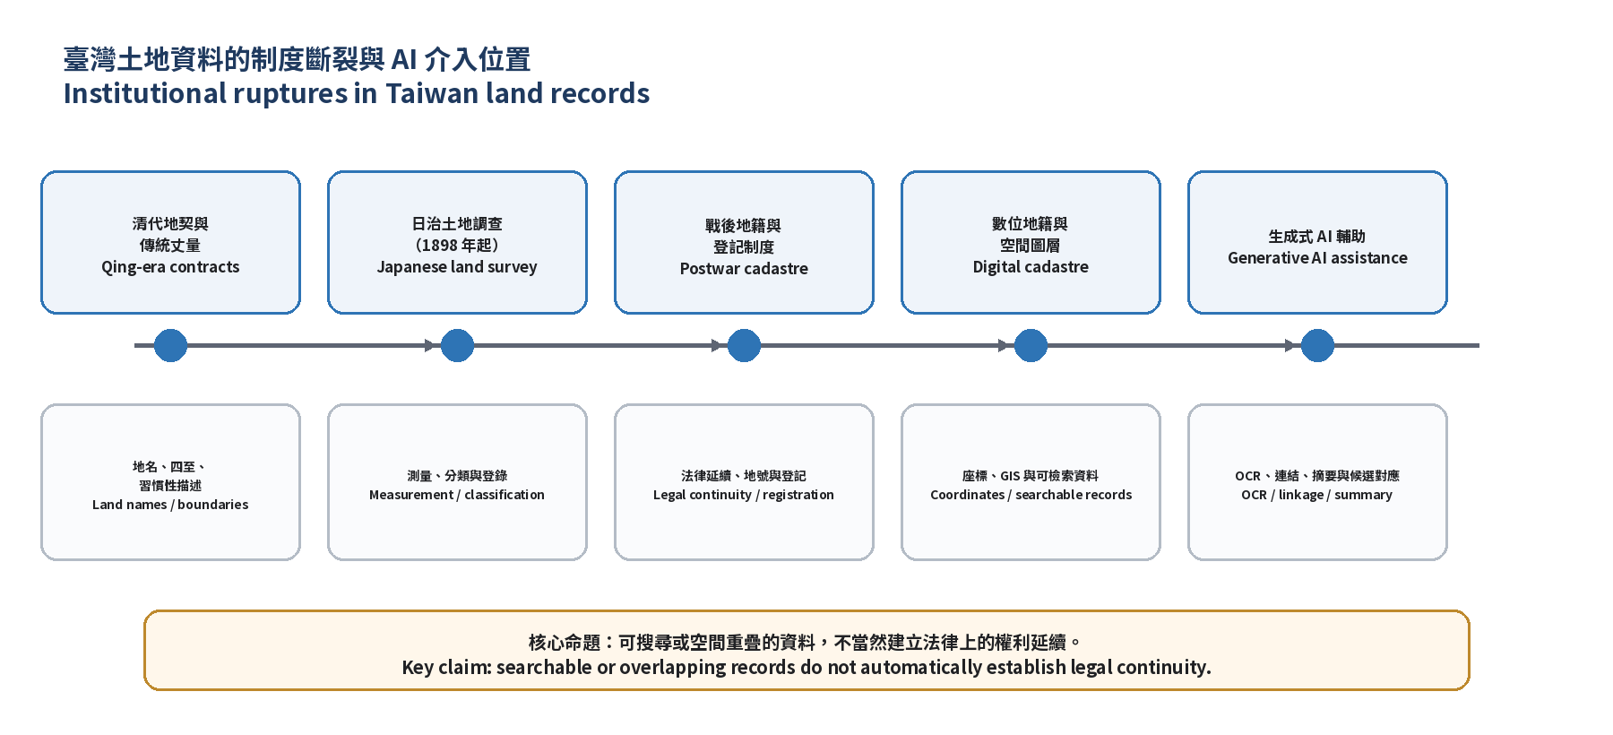
Figure 1. Institutional Ruptures in Taiwan’s Land Materials and the Point of AI Intervention

Three. Research Method and Analytical Framework
This article adopts conceptual construction and normative institutional research, proceeding through four tasks: first, analyzing the institutional ruptures among land survey, cadastre, and registration; second, identifying possible points of AI intervention from data processing to administrative adoption; third, conducting stress tests with counterexample scenarios; and fourth, proposing institutional conditions of traceability, explainability, contestability, and accountability. This method does not disguise situational hypotheses as already-occurring empirical facts; rather, it uses counterexamples to test under what conditions the institution may fail.
The role of the 25-3-3-4-7 framework in this article is as follows: P1 examines how AI constructs land facts; P2 examines how administrative personnel convert data inferences into legal and value judgments; P3 examines when those judgments affect registration, compensation, use restrictions, or other rights consequences. The four governance chains respectively require that facts, authority, reasons, and responsibility remain traceable; the seven governance audits supply cross-stage checkpoints.
To avoid misunderstanding “25” as merely a numerical label, its content is briefly stated. The twenty-five governance coordinates are formed by crossing five analytical levels (philosophy and values, institutional division of labor, policy system, organizational design, managerial operation) with five units of analysis (individual, group, organization, society, international). They locate at which level of public-administration theory AI intervenes and which unit of analysis it affects (Lu, 2026). For the cadastral-interpretation issues treated here, the principal coordinates involved include: policy system × individual (formation of parties’ boundary-pointing opinions in cadastral surveys), policy system × organization (AI assistance in policy execution by land offices), managerial operation × individual (case-level cadastral investigation and registration handling), and institutional division of labor × organization (collaborative division between land offices and AI vendors). The twenty-five coordinates do not require filling every one of one hundred seventy-five cells in each case; they provide a coordinate system for locating different cases on the same analytical plane and for cross-case comparison. This article and Article Twelve, “Who Is Recognized by the State?,” can be mutually located and compared by means of this coordinate system.

Four. Existing Legal and Procedural Foundations: Taking Cadastral Investigation in Cadastral Map Remeasurement as an Example
This article takes cadastral investigation in the remeasurement of cadastral maps as a single administrative setting. Its significance lies not in claiming that generative AI is already used in remeasurement procedures, but in clearly showing how land history, survey data, and administrative judgment enter results that can affect people’s rights through statutory procedures. The National Land Surveying and Mapping Center explains that remeasurement is work that brings outdated cadastral maps into mutual consistency with actual boundaries and the land register under statutory procedures; its results are not merely technical map updates.
Under Article 46-2 of the Land Act, when cadastral measurement is re-implemented, owners shall set boundary markers and appear to point out boundaries within the notified period; only if they fail to appear may the land office proceed with measurement according to the sequence of neighboring boundaries, current users’ pointing, old cadastral maps, and local custom. This rule is of great significance for the present article: the old cadastral map is only one reference among others when measurement is conducted ex officio; it is not an answer that can by itself determine boundaries or rights outside the procedure.
Procedurally, after receiving notice the owner appears to point boundaries; survey personnel record the actual pointing on the cadastral investigation form, which the owner certifies item by item with signature or seal. Remeasurement results are then announced for thirty days by means of the remeasurement result inventory, cadastral announcement map, and cadastral investigation form, with written notice. Those who consider the measurement erroneous may, in principle, apply for objection resurvey within the announcement period. When adjacent rights-holders’ pointing is inconsistent, coordination and real-estate dispute mediation are first conducted; those dissatisfied with the mediation result may sue in court for determination of boundaries. Only after the announcement period expires without objection, or after resurvey results are finalized, does the land office proceed with alteration of land description registration (National Land Surveying and Mapping Center, 2024).
Accordingly, the normative proposition of this article can be stated with precision: if in the future AI assists in incorporating historical contracts, old maps, or old parcel numbers into cadastral investigation, ex-officio measurement, or the formation of remeasurement opinions, it must not bypass the existing procedures of notice, boundary pointing, investigation-form certification, announcement, objection resurvey, mediation, and judicial remedy. The place of AI can only be to propose candidate materials, display uncertainty, and assist in identifying matters requiring further inquiry; it must not, through opaque linkages or summaries, replace owners’ participation or diminish their opportunity to present contrary evidence.
Table 1. Single-Case Card: The Rights Chain when AI Assists Historical Materials in Entering Cadastral Investigation
Procedure Node | What AI May Do | Procedural Rights of Persons that Must Not Be Replaced | Short-Term Procedural Burden | Long-Term Rights Effects
P1: Inquiry and Candidate Linkage | Find possible associations among old maps, old place names, contracts, and parcel numbers | Know the sources of materials, submit materials not retrieved, challenge candidate linkages | Increased period for supplementary proof; must actively present contrary evidence | Erroneous linkages, if not corrected in time, may solidify into established factual bases invoked in subsequent cases
P2: Cadastral Investigation and Opinion Formation | Flag contradictions, organize matters requiring inquiry, draft data summaries | Appear to point boundaries, certify the investigation form item by item, demand explanation and substantive review | Investigation direction and reasons pre-framed; must provide additional explanation or apply for review | Scope of boundary determination restricted, affecting the factual foundation of subsequent resurvey and registration results
P3: Announcement, Objection, and Registration Result | Assist in presenting announcement materials and objection records | Inspect, apply for objection resurvey, mediation, sue in court, and obtain reasons | Increased costs of objection and litigation; processing delay | Once land-description alteration is finalized, binding effect on third parties and subsequent transactions

Five. The Positive Case: Institutional Promise of Digital Cadastre and AI Assistance
AI can assist with text recognition, vectorization of map materials, lookup of place names and parcel numbers, cross-archive retrieval, and preliminary flagging of contradictions. For land offices this may shorten the time required for search and comparison; for the public it may make materials that were previously difficult to access more readily discoverable. Local governments have successively integrated cadastral maps, zoning, and other spatial layers and have experimented with AI-assisted query and spatial analysis (Nantou County Government, 2025; Yunlin County Government, 2026). Within the currently observable range, these applications remain concentrated at the data-organization level of text recognition, map vectorization, place-name and parcel-number lookup, and cross-layer retrieval, and have not yet involved legal judgments on ownership attribution or boundary scope. What this article seeks to examine in advance is precisely the next boundary that may be crossed when such retrieval and organization capacities are further combined with generative narration.
Yet these benefits only demonstrate that AI is suitable for assisting in “finding materials” or “raising questions requiring inquiry”; they do not demonstrate that it is suitable for replacing rights determinations. Discussions of digital land administration by the International Federation of Surveyors (FIG, 2020) likewise emphasize that land rights belong to a high-consequence domain: technology may assist in handling documents and data, but interpretation and decisions involving rights must retain accountable human responsibility.

Six. The Negative Case: Three Stress Tests
(1) Old Deeds and Modern Parcel Numbers Cannot Be Matched One-to-One
AI may automatically link place names, four-boundary descriptions, or areas in old contracts to modern parcel numbers, producing efficient candidate results; yet candidate results are not rights facts. Changes of place names, adjustments of boundaries, subdivision and consolidation, and differences in measurement benchmarks may all distort one-to-one linkages. If the model writes “most probable correspondence” as “confirmed as,” the uncertainty of P1 has already been erased.
(2) Overlap of Old Measurements and Modern Coordinates Produces Boundary Narratives
Historical maps, after scanning, rectification, and vectorization, can be overlaid with modern map materials; yet scale, projection, measurement error, and the original purpose of drawing all affect the overlay result. Petitpierre et al. (2023) note that when processing historical cadastral maps, the errors and inconsistencies of the original data are themselves historical information and must not be quietly “corrected” in annotation or processing. If AI outputs only a clean boundary line without indicating error and source, technical approximation may be mistaken for rights certainty. In administrative practice this risk is not purely hypothetical: if case handlers treat an apparently matching boundary after overlay directly as “already determined boundary” rather than merely as a reference for ex-officio measurement, they may compress the space for judgment that the procedures of notice, boundary pointing, investigation-form certification, and announcement described in Section Four ought to leave to the parties. In that event, the objection-resurvey procedure becomes the sole avenue through which parties can demand re-verification of overlay error rather than simply accepting the technical output; its importance therefore does not diminish with advances in overlay technology but becomes even greater.
(3) Generative Summaries Write Use Relations as Ownership
Generative AI can summarize contracts, investigation forms, registers, and maps into complete narratives. Its danger lies not in inevitable fabrication but in its skill at making incomplete materials appear coherent. If the model compresses “there was once a relation of use, rent payment, or management” into “ownership has been proved,” it directly crosses the boundary that should be explained by humans among facts, legal concepts, and rights effects.

Seven. Land-Rights Controversies that Must Not Disappear under AI Intervention
This article does not take “whether AI makes the final property decision in law” as the sole threshold. The key to AI governance is this: when the system’s linkages, rankings, summaries, or risk flags have already altered what proof people must present, what facts the case handler first sees, which reasons are regarded as reasonable, or how the case is handled, it has already entered land-rights controversy. That the final legal signatory remains human does not mean that power has not already been redistributed at the front end.
(1) P1: Rights to Be Seen, Linked, and Not Excluded
At the fact-construction stage, people’s rights are not merely rights to “correct data,” but rights that their original materials, historical uses, contrary evidence, and data gaps not be systematically excluded. If AI fails to retrieve a certain old contract, mislinks a place name to a modern parcel number, or treats data gaps as unfavorable inferences, parties may already bear additional burdens of supplementary proof, processing delay, or exclusion from the scope of investigation before formal judgment even begins.
(2) P2: Rights to Reasons, Discretion, and Substantive Review
At the stage of administrative reason formation, the controversy appears as whether the case handler can see materials the model did not adopt, can explain why a particular candidate correspondence was accepted, and can refuse an AI suggestion on the basis of original evidence. If “human review” is merely acceptance of a system-generated narrative, people appear to confront an administrative reason yet in substance have no way to understand or rebut the factual framework pre-set by the model.
(3) P3: Substantive Rights Consequences and Effective Remedies
P3 does not require that AI directly register, deprive, or transfer property before consequences arise. So long as AI-assisted opinions lead to a change in the direction of boundary investigation, an increase in the burden of supplementary proof, delay in registration examination, restriction of the scope of compensation, or the imposition on people of higher costs of objection and litigation, substantive rights consequences may already have occurred. This article therefore maintains that any AI-assisted conclusion that may produce adverse effects on people must provide avenues for inspection of materials, submission of supplementary evidence, correction of linkages, demand for human redetermination, and organizational accountability.
This rights chain allows the article to avoid two extremes: on the one hand, it does not exaggerate that AI has already replaced land offices or courts; on the other, it does not accept “the final decision is still made by humans” as an answer that relieves governance responsibility. What AI governance governs is how human institutions reorganize facts, reasons, and land-rights consequences by means of AI.

Eight. Synthesis: A Contestable Model of Cadastral Interpretation
The institutional goal proposed by this article is not “to make AI better at judging land,” but to ensure that AI assistance does not eliminate the contestability of land history. Its minimum conditions are as follows:
- Evidence-source card: list for every contract, map, investigation form, or register the source, date, original form, method of digital conversion, and known limitations.
- Inference marking: clearly distinguish original entries, system comparison results, model summaries, and legal judgments by administrative personnel.
- Uncertainty output: when parcel numbers, boundaries, or rights relations cannot be determined, the system must output candidate ranges, errors, and matters requiring inquiry, rather than a single conclusion.
- Dual gate: AI may assist in retrieval and in raising questions; any adverse conclusion that may affect land rights must be reviewed against original materials by a person with authority, who must provide understandable reasons.
- People’s right of objection: parties may inspect the materials used, submit contrary evidence, demand correction of erroneous linkages or summaries, and obtain a substantive redetermination that does not take the system conclusion as its premise.
- Organizational audit: preserve model and data versions, prompts and retrieval records, review reasons, objection results, and correction feedback, so that responsibility is not outsourced to the system.
Swim-lane diagram: Archive / original materials; AI assistance; administrative case handler; affected persons; audit / accountability. Core proposition: no adverse land-rights effect may rest solely on AI linkage or generative summary.
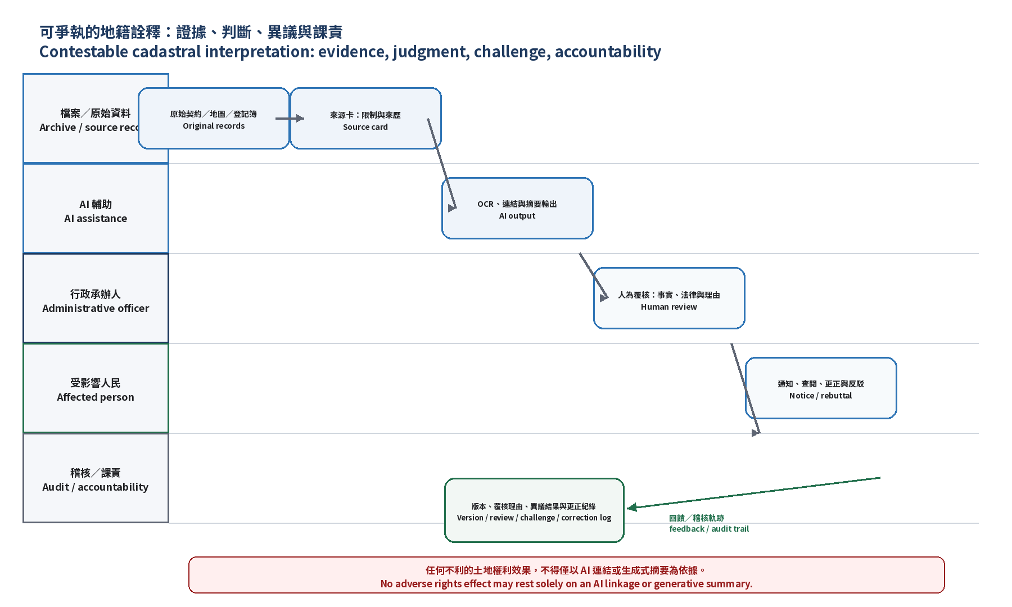
Figure 2. Contestable Cadastral Interpretation: Swim-Lane Evidence Chain, Objection, and Accountability Procedures

Nine. The Dual-Track Boundary between Administrative Procedure and Civil Litigation
Cadastral investigation, objection resurvey, mediation, and alteration of land-description registration belong to administrative operations handled by land offices according to legal procedures. When adjacent rights-holders still dispute boundaries or private-rights attribution, the matter may enter civil litigation for determination of boundaries or confirmation of ownership. This article does not maintain that courts should treat AI outputs as legal conclusions possessing independent evidentiary force.
What this article maintains is a stricter and more operable requirement: if AI has participated in an administrative organ’s linkage of old maps, place names, parcel numbers, or contract materials, its source cards, data versions, candidate correspondences, case-handler review reasons, and objection-handling records must be completely preserved as administrative procedural records subject to examination. In objection resurvey, mediation, or subsequent judicial disputes, parties may thereby understand and rebut the factual foundation of the administrative organ; courts continue to judge boundaries or rights attribution according to the Code of Civil Procedure and the rules of evidence in each case.
This dual-track design avoids two misunderstandings: first, it does not mistake AI-generated summaries for automatic evidence of cadastral alteration or private-rights attribution; second, it does not allow administrative organs to use “model suggestions” to mask the responsibility they ought to bear for data selection, procedural explanation, and reason formation.

Ten. Practical Recommendations for Implementation
The institutional proposals of this article and of Article Twelve are already operable, yet moving from concept to practice still requires concrete administrative supporting measures. The following three directions may be adopted in advance by land-administration organs (such as the Department of Land Administration of the Ministry of the Interior and the National Land Surveying and Mapping Center) without waiting for completion of new legislation.
First, direction for amendment of operational guidelines: land offices may, in the supplementary provisions of existing operational rules on cadastral surveying, add “Matters for Attention in AI-Assisted Processing of Cadastral Materials,” expressly providing that AI may be used only for candidate linkage, contradiction flagging, and organization of matters requiring inquiry, and may not directly output definitive boundary or rights conclusions, and requiring case handlers to record on the investigation form whether AI assistance was used and the model version.
Second, source-card template: the following table is recommended as a standardized attachment when land offices introduce AI-assisted tools, recording for each entry the data source, date, original form, digital-conversion method, known limitations, and whether model inference was involved.
Table 2. Template for Cadastral Data Source Card
Field Name | Content Description
Data source | Original issuing organ or archival unit of the contract, map, investigation form, or register
Date | Time of formation, registration, or last update of the material
Original form | Paper contract, hand-drawn or printed map, electronic register, etc.
Digital-conversion method | Scanning, OCR text recognition, map vectorization, coordinate transformation, etc.
Known limitations | Scale, projection method, measurement error, original purpose of drawing or declaration, etc.
Whether model inference was used | Whether the value in that field was inferred, completed, or summarized by AI, or is original input
Third, dual-gate checklist: when reviewing AI-assisted candidate linkages or summaries, land offices should confirm item by item: (1) the case handler has reviewed the original contract, map, or investigation form; (2) the review reasons specifically record the basis for acceptance or non-acceptance; (3) the parties have been lawfully notified and are aware of the fact of AI assistance; (4) the right to objection resurvey has not been restricted by the AI-assisted conclusion.
The three supporting measures above may all be implemented in advance through administrative rules, operational guidelines, or internal checklists, without waiting for the subsequent subordinate legislation of the Artificial Intelligence Basic Act; once that subordinate legislation is completed, these three measures may further be elevated to requirements of legal rank, reducing the external impression that “one must wait for new law.”

Eleven. Conclusion: The State Must Not Treat the Silence of History as the Answer of the System
Once land materials are digitized, the easiest illusion to arise is that what is searchable equals what is complete, what can be overlaid equals what is the same, and what can be summarized equals what has been proved. The argument of Article Thirteen is that AI is most worth using to present evidence and uncertainty, not to close controversy on behalf of the state. Historical cadastres may assist in understanding land, but they cannot relieve the state of responsibility for interpreting rights. When a system says that a piece of old material is sufficient to support, deny, or restrict someone’s land rights, people must be able to ask: What did the material originally say? What linkages and inferences occurred in between? And finally, who made the legally responsible conclusion?
Regarding its relation to the sister article in the series, this article and Article Twelve, “Who Is Recognized by the State?,” share the same governance logic: data are not neutral facts; AI must not pre-frame facts, reasons, and imaginable conclusions. Yet land rights involve spatial boundaries and adjacent relations; once boundary or description alteration is finalized, its effect often extends to third parties and subsequent transactions, and the costs of objection and remedy are usually higher than those of pure status or qualification determinations. Therefore the requirements of “dual gate” and “source card” in this article should be stricter than in status-recognition settings, especially ensuring that existing procedural rights such as objection resurvey are not hollowed out by AI assistance.
This article also anticipates possible criticism: does emphasis on uncertainty and contestability hinder administrative efficiency? The reply is that the contestable model does not prohibit AI assistance in land administration, nor does it require exhaustive verification of every item of data; it requires that efficiency gains must not be purchased at the cost of compressing procedural rights and historical uncertainty. When AI can help land offices find candidate materials more quickly, that is precisely the time that should be used to ensure that review and objection mechanisms actually function, not a reason for further compression.

References
National Laws and Regulations Database (2026). Land Act, Articles 46-2 and 46-3. https://law.moj.gov.tw/LawClass/LawAll.aspx?pcode=D0060058
National Land Surveying and Mapping Center (n.d.). Matters for Coordination and Attention in Conducting Cadastral Map Remeasurement. https://www.nlsc.gov.tw/cp.aspx?n=1565
National Land Surveying and Mapping Center (2025). Results of the 2025 Cadastral Map Remeasurement to Be Announced Progressively from 30 September 2025. https://www.nlsc.gov.tw/NLSC_Content.aspx?n=1742&s=331674&sms=9680
Chang, A.-C. (2016). Evolution of the Concept of “Gongye” during the Taiwan Land Survey in the Early Japanese Period. Academia Historica Journal, 50, 47–96.
FIG. (2020). Digital land administration: Principles, visions and reality. International Federation of Surveyors. https://www.fig.net/resources/proceedings/fig_proceedings/fig2020/papers/ts03h/TS03H_ivan_10367.pdf
National Land Surveying and Mapping Center, Ministry of the Interior (n.d.). Numerical Cadastral Survey. https://www.nlsc.gov.tw/en/cp.aspx?n=2154
Nantou County Government (2025). A New Land-Administration Tool You Must Know: Nantou Smart Land Spatial Service Network IG660. https://www.nantou.gov.tw/big5/bureau/news_content.php?cid=3663&dptid=376480000au210000&id=162685
Petitpierre, C., et al. (2023). Historical cadastral map vectorization: A case study. Digital Scholarship in the Humanities, 38(3), 1227–1244. https://doi.org/10.1093/llc/fqad005
Lu, Lancelot (2026). Reconceptualizing Artificial Intelligence Governance: Twenty-Five Governance Coordinates, Three Functional Transfers of Administrative Power, Three Structural Effects, Four Governance Chains, and Seven Governance Audits from the Perspective of Public Administration Theory. AI Governance Research Series, Article Two.
Yunlin County Government (2026). Yunlin Geographic Information Integration Application Platform. https://map.yunlin.gov.tw/

