AI Governance Research Series No. 12
Who Is Recognized by the State? Household Registration, Identity Determination, and Governance Responsibility in the Age of Generative AI
Lancelot Lu | Working Draft, August 2026 - Synchronized English Version

Abstract
As generative artificial intelligence enters public administration, household registration is no longer a static record. It is increasingly linked with nationality, residence, welfare, electoral, and other administrative databases to infer eligibility and allocate rights. This article argues that the central risk is not merely data or model accuracy, but how the state recognizes a person through data and model-mediated interpretation.
Taiwan's successive registration regimes—from baojia and lijia, to the Japanese colonial koseki chosa, to postwar household registration, to digital household administration and cross-agency databases—have produced historical records marked by incompleteness, shifting classifications, and omissions (louji). When agencies translate missing records or model inferences into determinations of identity and eligibility, epistemic uncertainty can be institutionally transformed into exclusion.
Adopting a norm-counterexample-institutional-design approach, this article first examines the institutional promise of digital registration and AI-assisted eligibility, then stress-tests that promise through four risk mechanisms: (1) missing data misread as lack of qualification, (2) cross-database mis-linkage of persons and relationships, (3) generative narration compressing uncertainty into determinate conclusions, and (4) human review degenerating into formalistic stamping. Drawing on international cases including Australia's Robodebt (2015-2019), the Netherlands' Toeslagenaffaire (2005-2019), and Amsterdam's Smart Check experiment (2023-2025), the analysis shows that technical compliance does not equal procedural justice.
Applying the 25-3-3-4-7 AI governance meta-framework, the article develops a contestable identity determination model. Its minimum conditions are: source cards that retain provenance, omission and contradiction flags, and whether inference was involved; double-gate review requiring substantive human comparison of original evidence for any adverse identity or eligibility determination; uncertainty preservation prohibiting rewriting missing data, automated matching, or probabilistic inference as determinate legal facts; access, correction, and rebuttal rights enabling affected persons to know what data were used, supplement evidence, and obtain a de novo determination not reliant on the system conclusion; and organizational accountability recording model versions, prompts, retrieval sources, review content, challenge outcomes, and correction logs for audit, appeal, and systemic feedback. Adverse determinations must not rest solely on an AI linkage or generative summary. Administrative efficiency should not make people systematically invisible to the state.
Keywords: household registration; identity determination; generative AI; algorithmic bias; administrative discretion; governance accountability; contestability by design; source card; double-gate review

1. Problem Framing: When the State Answers 'Who Are You?' with AI
A person who just turned 65 may become eligible for senior welfare. What appears to be a simple eligibility check in fact simultaneously involves personal identification, legal status, household or residence status, and the specific conditions of a benefit scheme. Age can be a clear number; administrative identity rarely is. Especially in contexts of cross-agency data linkage and generative AI assisting retrieval and drafting, the apparent completeness presented by the system can easily obscure ruptures in how data were formed.
This article does not imagine AI as a direct automated decision-maker replacing household registration officers. Instead, it focuses on an earlier and more easily overlooked stage: agencies using AI to search historical and current records, synthesize evidence, link cases, flag risks, or generate draft opinions. At this point, although the model has not legally made a disposition, it may have already framed what facts case officers see, what reasons are available, and what conclusions are imaginable. The transfer of administrative power often does not begin at the moment of pressing 'approve.'
Three questions are posed: (1) How are household registration data marked by omissions and shifting classifications transformed into identity and eligibility judgments with AI assistance? (2) When generative AI compresses dispersed records into seemingly coherent narratives, how is administrative discretion quietly pre-framed? (3) What governance design enables people to substantively contest adverse determinations, rather than only facing the answer 'the system shows so'?

2. Household Registration as the State's System for Recognizing Persons
According to Article 1 of the Montevideo Convention, a permanent population and a defined territory are essential conditions of statehood. The state must identify, record, and recognize persons through institutions. Household registration is therefore not merely an administrative convenience, but a foundational institution through which the state includes individuals within the scope of rights, obligations, and protection.
Taiwan's history is not a smooth line of cumulative data. The establishment of household survey registers in the early Japanese colonial period formed a systematic basis for modern population registration, but was also accompanied by reshaping of classification, verification, and inclusion (Wang, 2014). Research on omission (louji) reminds us that blanks may stem from survey capacity, migration, institutional change, or administrative omission, and cannot be lightly interpreted as non-existence (Wang, 2010).
Figure 1: Institutional ruptures in Taiwan household registration and AI intervention points (Qing-era baojia → Japanese household survey → Postwar household registration → Digital household registration & cross-agency DB → Generative AI assistance). Key claim: Absence in the record does not mean absence of status.
In contemporary institutions, 'national,' 'national with household registration,' 'resident,' and 'qualified beneficiary' do not necessarily coincide. The distinction between National ID number and UI number illustrates that legal identity and specific registration status cannot be arbitrarily interchanged. The Senior Citizens Welfare Act defines seniors as 65+, but individual programs may attach residence, income requirements. AI's most common error is compressing distinct layers into 'eligible/ineligible'.
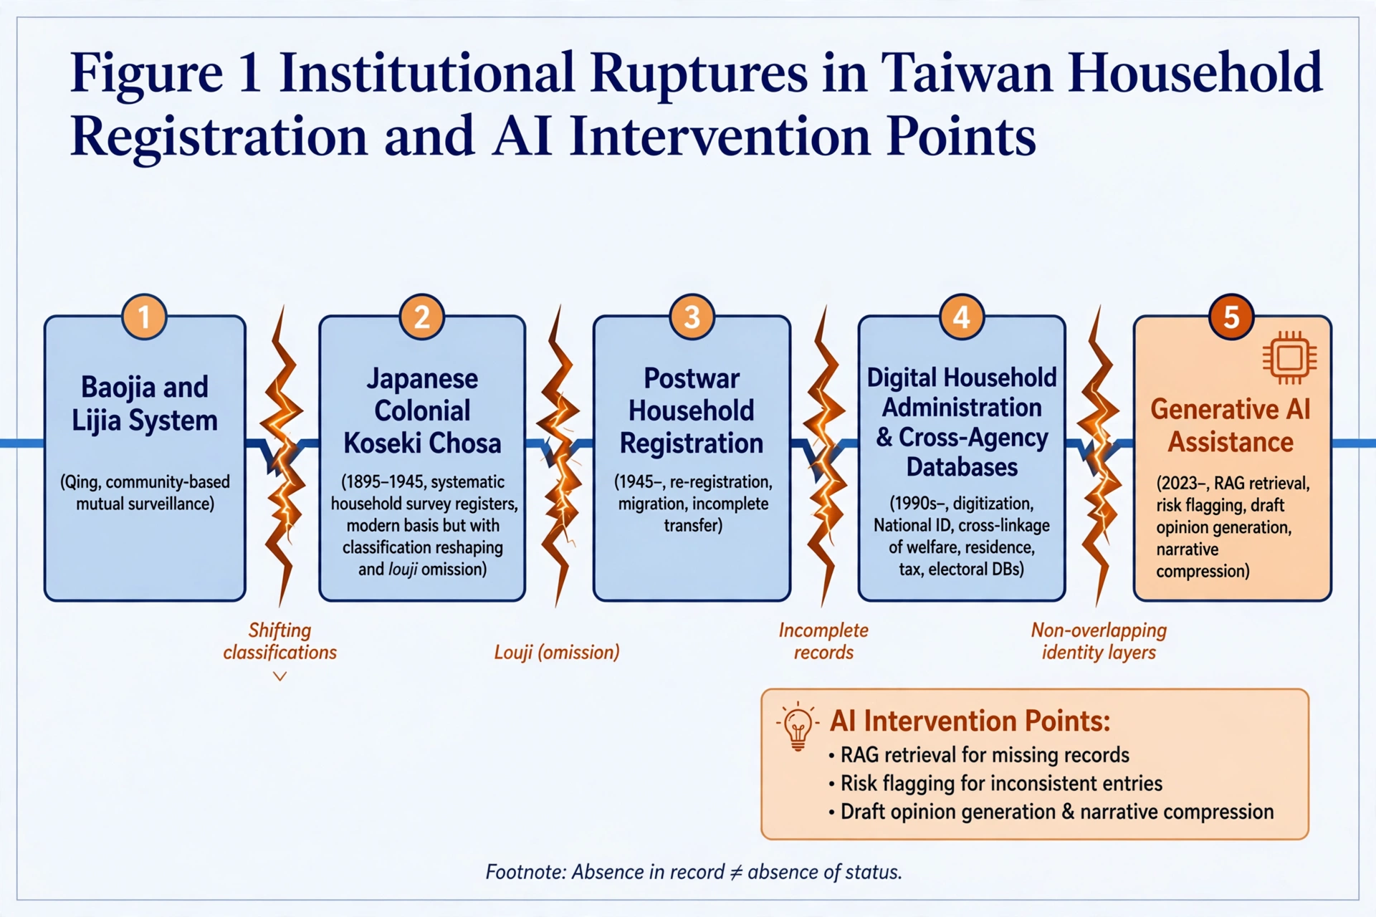

▲ Figure 1 Redrawn HD English Version: Institutional ruptures in Taiwan household registration - Absence in record ≠ absence of status
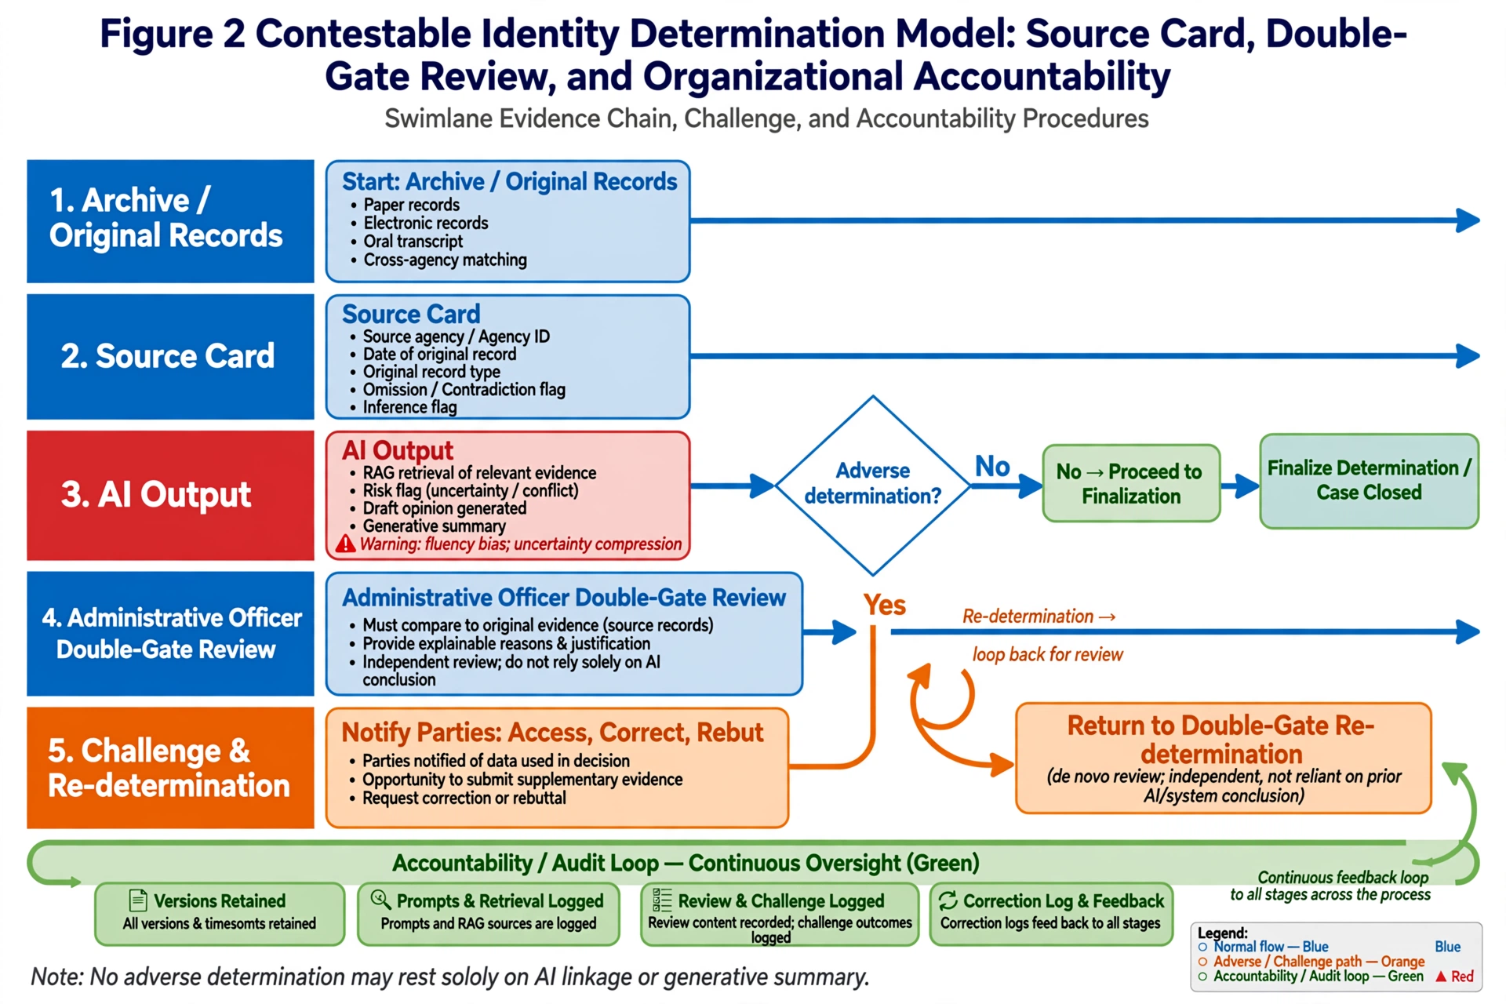
▲ Figure 2 Redrawn HD English Version: Contestable Identity Determination - No adverse determination may rest solely on AI linkage or generative summary

3. Methods
Conceptual and normative public administration research with four steps: legal and literature analysis; historical-institutional contextual analysis; counterexample scenario construction; normative institutional construction via thesis-antithesis-synthesis translating 25-3-3-4-7 framework into traceable, contestable procedural conditions.

4. Thesis: Institutional Promise
Digitalization can reduce costs, identify duplicates, shorten waiting for disadvantaged, help discover services. RAG can integrate regulations. However, efficiency does not automatically constitute legitimacy. Netherlands SyRI case shows opacity weakens legal certainty, privacy, equality, judicial supervision (Rachovitsa & Johann, 2022). UN Special Rapporteur Alston (2019) warned digital welfare may become invisible behind interfaces, making challenge rights formalistic. Integration must include explanation, duty to give reasons, and remedies.

5. Antithesis: Four Risk Mechanisms
(1) Missing data misread as lack of qualification: Unregistered or inconsistent historical records transformed into 'no record found' probability. Historical data may reproduce biases (CDEI, 2020). Most dangerous is system says scarcity means person does not exist. Eubanks (2018) digital poorhouse concept: resource-poor most likely marked incomplete and excluded. Louji is product of survey capacity and classification, not neutral fact.
(2) Cross-database mis-linkage: Names, birthdates, addresses, kinship matched across DBs may mis-connect same-name persons, migrants, name-changers. Forms superficially complete but internally misplaced profile. Hard to return to source documents.
(3) Generative narration compresses uncertainty: LLMs organize fragments into fluent text. Attractive and risky. Can rewrite 'possibly' 'pending proof' 'contradictory sources' into reasonable story. Processing fluency research shows fluent text judged more true (Alter & Oppenheimer, 2009). When LLMs output affirmative without uncertainty markers, users trust and adopt more even when erroneous (Kim et al., 2024). Unlike rule engines retaining discrete traceable nodes, fluency bias smooths contradictions, making formalistic stamping easier and harder to detect.
(4) Human review degenerating: Even with 'final human decision,' substantive supervision not guaranteed. When AI recommendations presented as summaries, risk scores, or completed reasoning, officers tend to adopt under volume and time pressure. Bovens & Zouridis (2002) street-level to system-level bureaucracy: when information systems replace grassroots discretion, due process may be hollowed; generative AI pre-organizes facts and reasons, discretion transfers before signing. Experimental research shows adoption influenced by stereotypes and advice direction (Alon-Barkat & Busuioc, 2023). Signing is starting point, not end, of accountability.
(5) International cases: Technical compliance ≠ procedural justice. Table 1 shows Robodebt, Toeslagenaffaire, Smart Check share structural lesson: without substantive human intervention and effective remedy, data/model errors amplified into exclusion.
Household registration is institutional starting point for state recognizing people. When AI enters registration, identity, eligibility, what changes is not paper to digital, but how facts selected, who has power to compress uncertainty into conclusions, and whether people still retain entry to rebut. Taiwan's historical registration reminds: even official data not necessarily complete; even precise data still needs correct interpretation.
Proposition is not replace technology with people, but refuse to let technology first determine people's visibility. AI can help state see faster, broader; but cannot, without traceable evidence, explainable reasons, feasible remedies, answer who belongs to people and who qualified to enjoy rights. Bottom line: When system identification wrong, people can require state to answer again—On what basis do you determine me this way?
Recent developments: NSTC plans regulatory adaptation within two years after AI Basic Act, MODA will issue AI Risk Classification Framework per Article 16 (UDN 2026). Formulation is key entry for contestable model to embed in practice: If framework clearly defines AI involving identity, qualification, welfare as high-risk, it can require agencies implement source cards, double-gate, challenge remedies, rather than letting each agency interpret human supervision on its own.

Table 1: International Cases Comparison
Case / Period | Core Failure Mechanism | Corresponding Risk Mechanism | Implications for Model Design
Robodebt (Australia, 2015-2019) | Directly converted audit data matching into debt determinations, canceling substantive human review | (4) Human review degenerating into formalistic stamping | Double-gate must have auditable review records, otherwise review can be circumvented
Childcare Benefits Scandal Toeslagenaffaire (Netherlands, 2005-2019) | Used dual nationality, name as risk scoring factors, cross-database amplified bias | (1)(2) Missing data misread as lack / Cross-database mis-linkage | If source card does not label discriminatory proxy effects, integration itself may be source of bias
Smart Check Experiment (Amsterdam, 2023-2025) | Even following responsible AI best practices (bias testing, HRIA, stakeholder consultation), still disproportionate erroneous flagging, city decommissioned | Extends (3): Technical debiasing != Institutional contestability | Procedural justice needs uncertainty preservation and accessible/correctable/rebuttable nodes as last defenses

6. Synthesis: Contestable Identity Determination Model
Using 25-3-3-4-7 meta-framework, shift from accuracy to governance chain completeness. 25 coordinates identify whether intervention is data organization, risk prompting, reason drafting, or close to eligibility determination; 3 functional transfers examine whether AI participated in situation construction (P1), discretion and value judgment (P2), or caused actual service and rights outcomes (P3); 3 structural effects observe opacity, responsibility dispersion, contestation shrinkage. 4 chains require facts, authority, reasons, responsibility traceable; 7 audits provide checkpoints. Comparable to NIST AI RMF 1.0 (Govern, Map, Measure, Manage) and OECD (2024), but 25-3-3-4-7 focuses more on functional transfer of administrative power and traceable responsibility chain.
Minimum conditions:
- Source Card: label source agency, date, original record type, omission/contradiction, whether model inference involved.
- Double-Gate: AI may assist finding data and raising issues; adverse identity/eligibility/welfare conclusions must be made by authorized persons comparing original evidence with explainable reasons.
- Uncertainty Preservation: System must not rewrite missing data, automated matching, or probabilistic inference as determinate legal facts; output 'pending clarification' rather than 'non-compliant' when necessary.
- Accessible, Correctable, Rebuttable: Parties can know what data were used, supplement evidence, request correction, obtain substantive re-determination not reliant on system conclusion.
- Organizational Accountability: Record model versions, prompts, retrieval sources, review content, challenge outcomes, correction logs for audit, complaint, feedback.
Methodologically echoes contestability by design (Alfrink et al., 2022), cross-agency workshop recommendations (Landau et al., 2024: opt-out, reproducibility, contestability in procurement), and CDT/BTAH report that human-in-the-loop without resources, escalation paths, stakeholder participation easily degenerates into formalistic gatekeeping (Quay-de la Vallee & De Liban, 2025). IOM (2026) notes biometric and AI identity management exclusion barriers; Microsoft (2026) agentic AI identity & eligibility architecture lists human-in-the-loop for edge cases and auditable records.
Domestically, AI Basic Act passed Dec 23, 2025 Article 4 human autonomy principle allows human supervision as basis for double-gate (Laws DB 2026b); but Judicial Reform Foundation (2026) notes lack of explicit rights to know, explanation, human review—showing accessible/correctable/rebuttable fills gap. Administrative Procedure Act Art.96 requires written dispositions record facts, reasons, legal basis (2026c) corresponds to source card; Personal Data Protection Act Art.10-11 rights to inquire, review, request correction provide basis (2026d). EU AI Act Annex III lists AI for public welfare eligibility as high-risk requiring human supervision, risk management, data governance (EU 2024), consistent with double-gate.
Figure 2: Contestable Identity Determination - Swimlane evidence chain, challenge, accountability (Archive/Source Records → Source Card → AI Output → Administrative Officer Double-Gate Review → [If adverse] Notify parties to access, correct, rebut → Return to Double-Gate Re-determination; Versions, review reasons, challenge results retained by Audit/Accountability and feedback throughout). Bottom line: No adverse identity or eligibility determination may rest solely on an AI linkage or generative summary.
Table 2: Source Card Standard Fields and Double-Gate Audit Indicators
(A) Source Card Standard Fields
Field Name | Description
Source Agency | Name of agency originally collecting or registering data
Collection / Registration Date | Time when data were formed or last updated
Original Record Type | Paper, electronic form, oral transcript, cross-agency matching result, etc.
Omission or Contradiction Flag | Whether unrecorded, ambiguous, or mutually contradictory, and possible causes
Inference Flag | Whether datum underwent model inference, generative summarization, or automated linkage, and its confidence/uncertainty level
(B) Double-Gate Audit Indicator Examples
Audit Indicator | Description
Disagreement Rate | Proportion where authorized persons do not adopt AI conclusions; approaching zero may indicate review degenerated
Challenge Success Rate | Proportion of adverse determinations corrected after party challenge
Average Review Time | Time spent comparing original evidence, detecting sufficient substantive review
Source Card Completeness Audit Pass Rate | Proportion of sampled audits where source card fields complete and traceable
Correction and Feedback Loop Closure Rate | Proportion of errors discovered via challenges/audits that complete correction and system feedback

7. Conclusion: People Are Not Residual Values in Databases

