When Government Cannot Buy Control: Information, Audit, and Suspension Rights in Public-Sector AI Procurement

Lancelot Lu | Doctor of Public Administration, University of Southern California, USA
This article was completed with AI assistance. AI supported textual organisation and argument checking; conceptual development and final judgement remain the author’s responsibility.

Abstract
When governments procure AI systems, the usual assurance is that vendors have been required to meet cybersecurity, privacy, and functional specifications; once the product is compliant, responsibility is said to have been discharged.
That assurance rests on the assumption that control can be purchased. If contractual terms are sufficiently comprehensive, government should be able to trace, verify, and halt a system when it affects people’s rights and obligations.
The gap becomes visible only when a dispute arises. A claimant for public assistance is classified as high-risk and the agency must explain why; a group is systematically disadvantaged and the agency must identify the cause; a model update changes system behaviour and the agency must decide whether use may continue. The response is often that the matter is a trade secret, an upstream technology, a separately priced service, or outside the contract’s scope. Such responses may be defensible in private law. Yet an agency’s public-law responsibilities to citizens do not diminish merely because the contract did not anticipate the matter.
This article calls this condition nominal accountability: responsibility is unmistakably assigned to the agency, but that responsibility is not matched by the capacity to exercise control. The problem is not the absence of an accountable actor; it is the presence of one who lacks the means to respond.
The article argues that the minimum conditions for discharging public-law responsibility can be specified as three rights: information, audit, and suspension. These are not a parallel checklist but a progressive sequence. Information rights enable an agency to know how a system operates; audit rights enable it to verify that knowledge; suspension rights enable it to alter or stop the resulting action. Without information, there is nothing to audit; without audit, information is merely a vendor’s assertion; without suspension, the first two generate knowledge but not control.
Two structural constraints follow. First, private-law remedies are not equivalent to public-law capacity. Damages operate between agency and vendor, while public-law responsibility operates between agency and citizen. By the time a damages clause is invoked, rights may already have been harmed. Second, suspension rights face an exercisability paradox: the more deeply a system is embedded in operational processes, the higher the organisational cost of stopping it. Without a recoverable human fallback process, a suspension clause is little more than words on paper.
Across the supply chain, a government agency normally contracts only with a system integrator, not with upstream foundation-model providers or data-service providers. Unless the three rights are extended upstream through flow-down provisions, control breaks at the point where the contractual relationship ends. Comparing bespoke development, commercial off-the-shelf systems, and cloud AI services, this article shows that the form with the least available control is often the fastest to deploy and the most widely used.
Keywords: AI procurement, information rights, audit rights, suspension rights, nominal accountability, algorithmic supply chains, public-law responsibility, control capacity

I. Introduction: A Compliant Product Is Not a Controllable System
Existing policy commitments are clear. The EU AI Act imposes technical-documentation and cooperation obligations on high-risk systems; the NIST AI Risk Management Framework calls for traceability and third-party evaluation; and Taiwan’s Executive Yuan guidance requires agencies to retain final judgement. The promise is that governance is secured once the product is compliant.
The implicit premise is that an agency’s public-law responsibility can be fully translated, through a private-law contract, into requirements placed on the vendor, and then translated again through performance of that contract into protection for citizens.
The practical gap is that contractual remedies are private-law remedies; they cannot substitute for fulfilment of public-law responsibility. Compensation runs between agency and vendor, whereas responsibility is owed to the public. When compensation begins, a right has already been impaired. More importantly, whether any clause can be exercised depends upon the agency’s own organisational capacity—capacity that the contracting counterparty cannot supply.
This produces a question that changes the answer: has government purchased a system, or has it purchased the ability to identify the cause of an error and halt its effects? If it cannot purchase the latter, should the agency decide before deployment that the system is unsuitable for work with significant effects on people’s rights and interests?
For readers unfamiliar with the parent framework, its minimum relevant content may be stated as follows. “25-3-3-4-7” refers to twenty-five positioning coordinates formed by crossing five policy-issue types with five governance levels; three mechanisms of power transfer—P1, situation construction and fact determination; P2, administrative discretion and value judgement; and P3, the formal attribution of public-power decisions; three structural effects—boundary dissolution, authority reconstruction, and responsibility diffusion; four governance chains—situation construction, authority, reasons, and responsibility; and seven governance audits, including data representativeness, responsibility attribution, privacy and cybersecurity, organisational capacity, and democratic accountability. This article uses only the elements directly relevant to procurement control; the full coordinate and scoring logic is set out in Lu’s (2026) working paper.
Under this framework, the article is positioned principally at [institutional division of labour × organisation] and [policy system × organisation], with extensions to [management operations × individual] and [society × organisation]. It examines the distribution of P1/P2/P3 across the supply chain, the structural effects of boundary dissolution and authority reconstruction, and breaks in the authority and responsibility chains. Five of the seven governance audits—data representativeness, responsibility attribution, privacy and cybersecurity, organisational capacity, and democratic accountability—serve as focal checks. It positions the case without attempting to score all twenty-five cells.

Figure 1. Application of the parent framework’s eight steps in this article
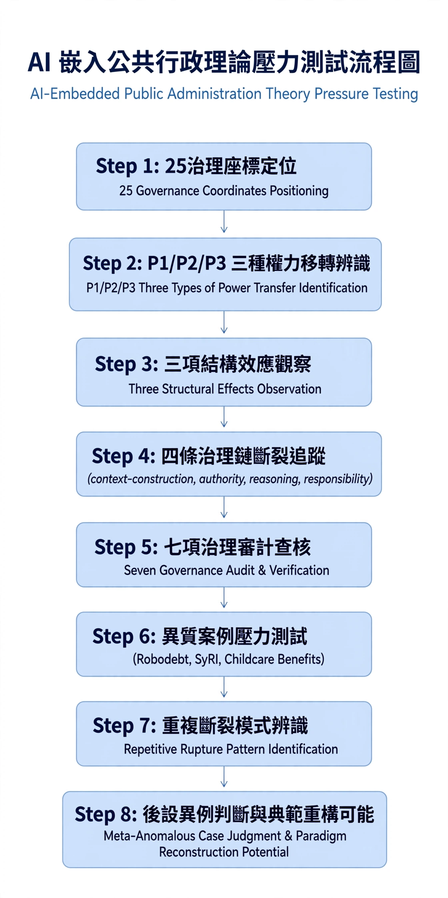
Source: Redrawn from Lu (2026), Figure 3.2, for the procurement context of this article.

II. The Three Rights: Conceptual Construction and Progressive Structure
Control capacity is defined conditionally. In this article, it means the minimum capacity an agency must retain, in order to discharge its public-law responsibility to citizens, with respect to an AI system participating in an administrative task: the capacity to know how it operates, verify whether what is known is true, and, where necessary, alter or terminate its effects.
It is not ownership. An agency may possess control capacity without owning the model or source code; conversely, it may own source code yet lack control capacity if it has no version records or output monitoring. Nor is it technical comprehension. The agency need not reproduce the computation; it needs access to evidence sufficient to support administrative reasons and remedy procedures.
Defining control as what is necessary to discharge responsibility marks the floor for contract negotiation. Not every item of technical information should be demanded: excessive demands raise costs and restrict competition. But information necessary to give reasons, identify causes, and stop harm should not be conceded on the ground of trade secrecy.

1. Content of the Three Rights
Right | Core function: operative verb | Conditions for exercise | Who bears the consequence of failure
Information right | Know how the system operates | Scope specified in the contract; continuing provision during performance; proactive notice of changes | Legal and operational units cannot give reasons; citizens cannot meaningfully contest
Audit right | Verify whether what is known is true | May commission a third party; not contingent on vendor consent; extends to records and actual outputs | Agency can rely only on vendor self-report; courts and oversight bodies cannot review effectively
Suspension right | Alter the outcome on that basis | Suspension is not breach; process and cost of reverting to human handling agreed in advance; handover responsibility clear if upstream service stops | Agency must continue using a system it knows is wrong; responsibility concentrates in the agency
Table 1. The Three Rights and Responsible Actors (Source: Developed for this article)

2. Progressive Structure and the Exercisability Paradox
The three rights are not a parallel list that can be assessed independently. Information rights provide the object of audit; audit rights verify information; suspension rights give effect to both.
This structure has two institutional consequences. First, private-law remedies cannot replace public-law capacity. Treating compensation as a substitute for control may even weaken the evidentiary basis needed to claim compensation, because the evidence required to identify the cause is itself held by the vendor. Second, suspension rights face an exercisability paradox. The existence of a clause and the ability to exercise it often move in opposite directions: the more stably a system is embedded in business processes, the greater the cost of stopping it. The right therefore depends not only on contractual language, but on whether the agency maintains a recoverable human fallback process. Government must still specify who maintains that fallback, who budgets for it, and who has authority to order suspension.
This is not a matter for negotiation after the fact. Where an agency has no fallback, the suspension right exists in law but not in the organisation.
Information right | Audit right | Suspension right | State of control | Explanation
Present | Present | Exercisable | Complete control | Knowledge, verification, and action are connected
Present | Absent | Exercisable | Constrained control | The explanation comes only from vendor self-report; the agency cannot serve as a credible explaining authority
Present | Present | Formal only | Constrained control | The problem can be known and proved, but effects cannot be stopped before remediation
Absent | Absent | Formal only | Nominal accountability | Responsibility is clear, but both investigative and response capacity are absent
Table 2. Combinations of the Three Rights and States of Control

III. Supply-Chain Structure and Breaks in Governance Chains: Where Control Is Interrupted
An AI system procured by government is in fact composed of multiple actors: foundation-model providers, fine-tuning or application developers, system integrators, cloud-infrastructure providers, data-labelling services, and finally the user agency. The agency ordinarily contracts with only one of these layers.
Under privity of contract, the agency may assert its rights only against its contractual counterparty. If an upstream actor refuses to disclose data sources or submit to an audit, the system integrator can perform only within the scope of what it controls. Control is interrupted where the contractual relationship ends—and that point is often where the critical settings are located. The composition of a foundation model’s training data, its safety alignment, and changes in its behaviour across versions are typically what the agency most needs to know yet is least able to obtain through the principal contract.
Among the framework’s four chains, the authority and responsibility chains are central here. The authority-chain break occurs because legal authority ends with the agency while practical influence extends to suppliers with no public-law obligations, leaving no traceable delegation between them. The responsibility-chain break occurs because responsibility is clearly assigned to the agency while the evidence needed to establish what happened is held by third parties outside the contractual relationship. The situation-construction chain is not irrelevant; rather, its causal break lies outside this article’s scope. The three rights examined here are preconditions for making situation construction reviewable.
In structural terms, this is a typical instance of boundary dissolution and authority reconstruction. Classification logic and thresholds are formed in technical implementation rather than through an express policy decision, yet they generate public-power effects; critical settings are controlled by actors not bound by administrative procedure.

Table 3. Governance Chains, Structural Effects, and Corresponding Rights
Governance chain / effect | Break in the procurement context | Corresponding right and audit
Authority chain | Legal authority ends at the agency, while practical influence extends to suppliers | Information and audit rights—data-representativeness and organisational-capacity audits
Responsibility chain | Responsibility rests with the agency, while evidence sits with third parties | Audit right—responsibility-attribution audit
Boundary dissolution | Classification logic is formed in technical implementation, not a policy decision | Information right—discretion-boundary audit
Authority reconstruction | Critical settings are controlled by actors not bound by administrative procedure | Suspension right—democratic-accountability audit

IV. Stress-Testing Three Procurement Types: Heterogeneous Cases
Step six of the parent framework calls for concepts to be tested through heterogeneous cases. This article uses three procurement types—bespoke development, commercial off-the-shelf (COTS) products, and cloud AI services—classified by the technical and contractual distance between agency and system.
Flow-down provisions are a common response. They require the system integrator to extend the three rights upstream on a back-to-back basis and to disclose in advance the scope and reasons for any right that cannot be obtained. Their practical limit should be stated candidly: where the upstream provider is a global foundation-model firm and a single agency lacks purchasing power, the provision may do no more than reveal where it cannot penetrate. That disclosure remains valuable, however, because it allows an agency to understand the gap before deployment and decide whether the system is suitable for high-impact work.
Procurement type | Typical setting | Information right | Audit right | Suspension right | Principal gap and who bears it
Bespoke development | Built to agency requirements, with model and data established in the agency environment | High | High | Medium | Maintenance dependency; difficult to exercise where agency capability is weak, so information and budget units must make up the gap
Commercial off-the-shelf (COTS) | Existing packaged product is purchased and configured | Medium | Medium | Medium | Model core is vendor property; data sources are often restricted as trade secrets, requiring negotiation by legal units
Cloud AI service | External model service is connected and billed by usage | Low | Low | Low | Versions are unilaterally updated by the supplier; records and audit are constrained by terms of service; cross-border processing
Table 4. Relative Availability of the Three Rights across Procurement Types (comparative, not absolute ratings)
Table 4 shows an inverse relationship: cloud AI services, for which the rights are least available, are often the quickest to adopt, the least costly, and the most widely used. This structure cannot be addressed through case-by-case contract negotiations alone. If each agency must bargain separately with global suppliers, most will accept standard terms of service.
The policy implication is that institutionalising the three rights is better pursued through central model clauses, common-supply contracts, or pooled bargaining mechanisms. The point of centralisation is not uniformity for its own sake, but a procurement scale sufficient for meaningful bargaining. Taiwan’s Ministry of Digital Affairs and Public Construction Commission should jointly account for who undertakes that role.
Revision—feedback loop. Agencies should establish a dashboard of dissent statistics, using de-identified counts of frontline micro-pauses discussed in Paper 009 as triggers for the macro-level suspension right developed here. When accumulated dissent reaches a threshold, the agency head should be required to initiate a systemic audit and suspension assessment, and feed the results back into frontline guidance, creating a closed loop of dual-layer control.
Second-round revision—thresholds. The illustrative figures of a 5% dissent rate and a 30% substantiation rate are not empirically validated standards. They are used only to show how early-warning pressure indicators could operate. Agencies may adjust them dynamically by risk level: high-impact work should use stricter thresholds, ordinary support work more permissive ones. Actual thresholds should be set through pilots or risk assessments; this article does not claim they are universally applicable.
Second-round revision—market constraints and ultimate control. Even national-level pooled bargaining may confront global technology firms that decline to bid or offer only standard terms for general-purpose model APIs. In that circumstance, ultimate control lies not in negotiating technique, but in a risk-sensitive substantive decision not to procure or not to use the system in high-risk work (withdrawal power). This is the article’s central point: when control cannot be bought, the agency must have both the capacity and responsibility not to buy or not to use.

V. Differentiated Requirements and Refutability: A Meta-Level Judgement
This article does not argue that every government AI procurement must include all three rights in their fullest form. Applying the highest standard indiscriminately would raise costs and restrict bidding, obscuring the distinction needed for cases that genuinely require stringent control.
A more reasonable approach is risk adjustment. Systems affecting people’s rights and obligations, resource allocation, or risks of disparate treatment should require all three rights; for routine document-assistance work, information and suspension rights are the minimum. This differentiation is itself a function of governance audit.
Following step eight of the parent framework, the article states operational falsification conditions. Three kinds of evidence would require revision of the argument: (1) where procurement and performance records show that agencies lacking the three rights nevertheless obtain substantive control through informal bargaining or long-term trust—for example, by promptly identifying causes and changing outcomes when disputes occur—the necessity of flow-down provisions must be reconsidered; (2) where maintenance records show that agencies possessing all three rights cannot exercise them because of insufficient technical capacity—for example, an audit right exists but is never activated—the issue must also be addressed through organisational-capacity building rather than contractual design alone; and (3) where contract terms and market observation show cloud-service suppliers voluntarily providing full audit and suspension mechanisms under market pressure—for example, standard terms begin to include auditable exit clauses—the judgement that cloud services offer the least availability must be revised. All three types of evidence can be tested using existing procurement records, contract terms, and maintenance records; no new indicators need be constructed.

VI. Conclusion: Has Government Bought a System or Control Capacity?
Revision—control transmission and substitutability. The three external rights must be translated internally before they reach the frontline. Agencies should establish three mechanisms—document translation, interface translation, and delegation of authority—otherwise procurement documents will remain in information units while caseworkers see only a score. To make suspension practicable, procurement should also include preparations for substitutability: portability of data and prompts, a 30–90-day parallel version-freeze period, return of output samples and version records, and disclosure of the upstream dependency map. Exit arrangements are not preparations for failure; they are the organisational precondition for a suspension right. Because exercising that right often incurs the organisational cost of service interruption, it will remain impracticable without corresponding financial preparation. The total procurement budget should therefore include maintenance costs for an old system or human-process fallback as an inherent cost, not an extra expense. In this way, withdrawal power becomes not merely a legally asserted right but a financially and organisationally executable preparedness. The relationship among these three mechanisms, the internal dissent capacity developed in Paper 009, and the three external rights is shown in Figure 2, “Integrated Architecture of a Dual-Layer Control System.”
When government procures AI, what it needs to purchase is not simply a system that meets specifications, but the ability to identify the cause of an error and stop its effects.
Where that ability cannot be obtained through procurement, the agency should decide before deployment whether the system is appropriate for work affecting people’s rights and interests—not discover after a dispute that responsibility remains with the agency while control never existed.
The article finally returns the answer to named actors. Information rights should be stated specifically in tender documents by agency legal and information units; the agency head should decide whether to commission third-party audits and allocate the budget; operational and budget units should jointly maintain a recoverable human fallback for suspension; and the Ministry of Digital Affairs and Public Construction Commission should account for the pooled bargaining of flow-down provisions. If these actors cannot provide such an account, nominal accountability will persist. The ultimate purpose of external contractual rights is to protect frontline officials’ professional capacity to dissent and to avoid the accountability trap of merely formal approval; see Lu (2026), “From Formal Approval to Meaningful Human Oversight: Professional Dissent Capacity and Organisational Safeguards in AI-Assisted Administrative Decision-Making.”

References (APA 7th ed., verified)
Executive Yuan. (2023). Reference guidelines for the use of generative AI by the Executive Yuan and its subordinate agencies [in Chinese].
Ministry of Justice. (n.d.). Government Procurement Act. Laws and Regulations Database of the Republic of China (Taiwan).
Huang, H.-Y., et al. (2021). When artificial intelligence enters government [in Chinese]. Civil Service Review, 13(2).
Tseng, K.-C. (2017). A dynamic force for good governance or a crippled foundation? [in Chinese]. Civil Service Quarterly, 9(3).
Lu, L. (1996a). A literature-review framework for public administration [in Chinese]. Open University Journal of Public Administration, 5.
Lu, L. (2007). Action pathways for successful change in public organisations [in Chinese]. Training Forum Monthly, 78.
Lu, L. (2009). Public service ethics: Integrating the concept of public governance [in Chinese]. Civil Service Quarterly.
Lu, L. (2026). Reconceptualising artificial intelligence governance: A stress test of embedded AI public administration theory [Working paper].
Ministry of Digital Affairs. (2025). Reference handbook for artificial intelligence applications in the public sector [in Chinese].
Bovens, M. (2007). Analysing accountability. European Law Journal.
Brown, T. L., et al. (2006). Managing public service contracts. Journal of Public Administration Research and Theory.
Cobbe, J., et al. (2023). Understanding accountability in algorithmic supply chains. FAccT.
Raji, I. D., et al. (2020). Closing the AI accountability gap. FAccT.
Van Slyke, D. M. (2007). Agents or stewards. Journal of Public Administration Research and Theory.
Young, M. M., et al. (2019). Artificial discretion. Perspectives on Public Management and Governance.
Note: The original draft’s citation to a 2026 Presidential Office AI Basic Act lacked an official promulgation number and has been replaced by Executive Yuan guidance. Future-dated references, including Busch (2025), were removed to avoid unverifiable citations.

Figure 2. Integrated Architecture of a Dual-Layer Control System
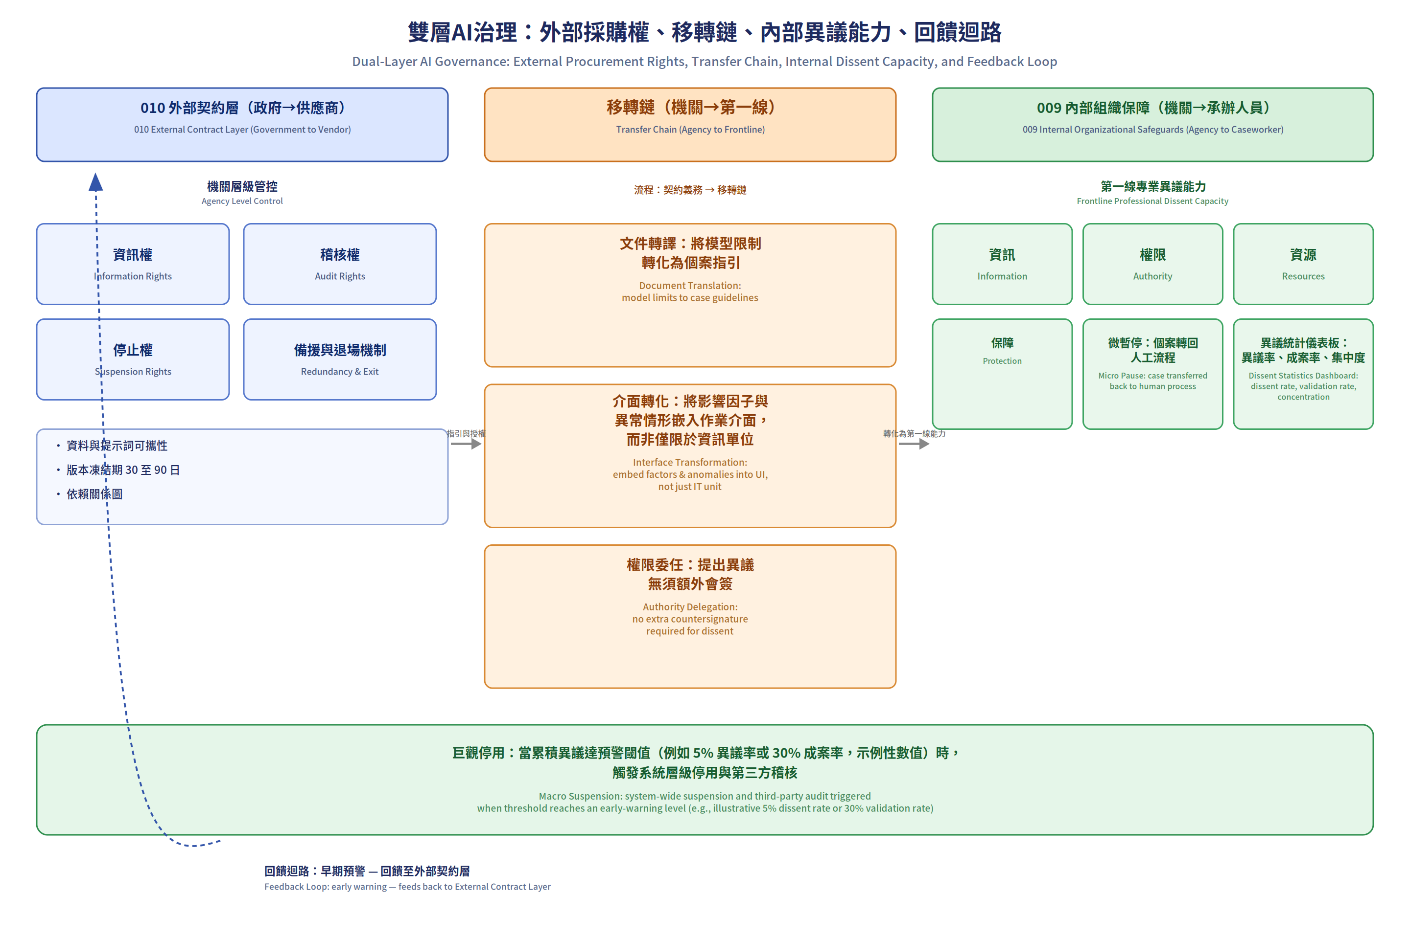
Source: Developed by the author in response to review comments. The left layer, the external contractual layer of Paper 010 (government → supplier), obtains agency-level controls: information, audit, and suspension rights, as well as fallback and exit arrangements. The middle transfer chain (agency → frontline) comprises document translation, interface translation, and delegated authority, addressing the break in which an agency has documents but frontline staff see only a score. The right layer, the internal organisational safeguards of Paper 009 (agency → caseworker), forms frontline professional dissent capacity through information, authority, resources, and safeguards; micro-pauses and a dissent-statistics dashboard accumulate evidence. When aggregate dissent reaches an early-warning threshold—for example, a 5% dissent rate or 30% substantiation rate, which are illustrative values only and must be adjusted by risk level and pilot results rather than treated as universal requirements—it triggers macro-level suspension and third-party audit below, and the feedback loop returns to the external contractual layer. Data and prompt portability, a 30–90-day version-freeze period, and dependency mapping make suspension practicable and reduce vendor lock-in.

