From Formal Approval to Meaningful Human Oversight: Professional Dissent Capacity and Organizational Safeguards in AI-Assisted Administrative Decision-Making
Lancelot Lu | Doctor of Public Administration, University of Southern California
This article was produced in collaboration with AI. AI assisted with text organization and argument verification; conceptual design and final judgment remain the author’s responsibility.

Abstract
Governments deploying AI to assist administrative decision-making commonly promise that AI is only assistive and the final decision remains human. The promise presumes that formal attribution equals substantive control: if a case file contains an official’s signature and time stamp, someone has judged and someone can be held responsible. This paper examines whether that presumption survives actual organizational conditions.
A civil servant cannot exercise meaningful oversight merely because a rule permits non-adoption. Meaningful human oversight requires four conditions: information sufficient to identify a plausible error; authority to override, suspend, or return a case to human review; resources of time, expertise, and alternative procedure; and safeguards against unreasonable professional risk after dissent. Without all four, a formally human decision can be system-led in substance. The paper applies the P1/P2/P3 framework and four governance chains to Robodebt, SyRI, and the Dutch childcare-benefits scandal, identifying recurring ruptures in reasoning and responsibility.
Keywords: professional dissent capacity; meaningful human oversight; formal approval; AI-assisted administrative decision-making; organizational safeguards; automation bias; administrative accountability

1. The Promise, Assumption, and Gap
High-risk AI rules, risk-management guidance, and Taiwan’s administrative guidance converge on a familiar assurance: a human remains in the loop. That assurance is necessary but incomplete. A person who sees only a score or label, faces performance pressure, lacks a usable escalation path, and risks career penalty for disagreeing may supply a signature without exercising professional judgment.
The question is therefore not whether a human appears at the final decision node. It is whether the organization has transmitted the information, authority, time, and protection required for a civil servant to form and act on a reasoned objection.
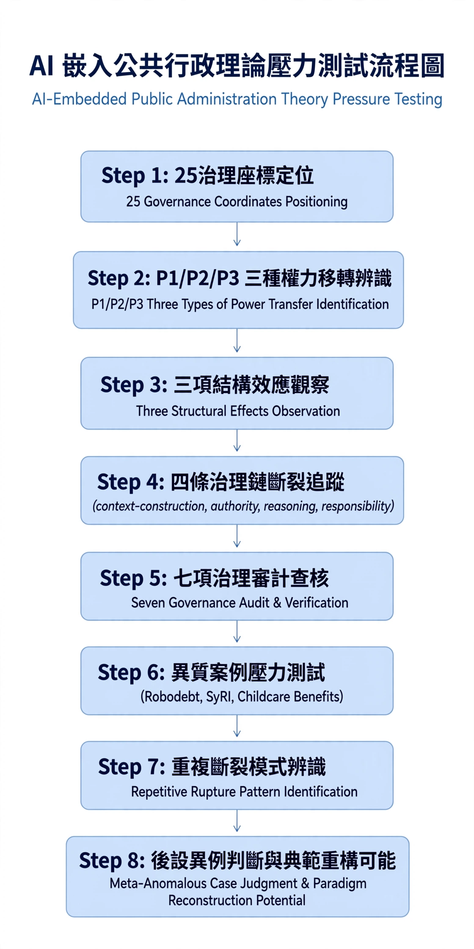
Figure 1. Eight-step AI-embedded public-administration stress test.

2. From Human in the Loop to Human with Capacity
Professional dissent capacity is the practical ability to question, refuse, suspend, or escalate an AI recommendation for stated public reasons. It is not a personal virtue alone. It is an organizational capability produced by information, authority, resources, and safeguards. The four conditions must be present together; a right to dissent without information or protection is largely ceremonial.
Table 1. Four Conditions of Professional Dissent Capacity
Condition | Core question | Typical sign of absence | Institutional tool and provider
Information | What can I see, and is it enough to judge what may be wrong? | The officer receives only a score or classification and cannot explain its origin. | Agency and IT unit provide data sources, model limitations, audit records, and version-change notices.
Authority | Can I really override, suspend, or refuse? | Rules allow non-adoption, but practice requires extra sign-off and proof. | Agency head and legal unit specify review, suspension, and return-to-human procedures.
Resources | Do I have time, capability, and an alternative procedure to check? | AI increases throughput targets and compresses review time. | Personnel and budget units reserve review time and provide training and consultation.
Safeguards | Will dissent expose me to unreasonable risk? | Those who overturn recommendations are slower and receive adverse performance treatment. | Agency and training/evaluation units provide safe-harbour rules, reporting channels, and adjusted performance criteria.

3. Formal Approval as a P1/P2/P3 Misalignment
P1 concerns situation construction and fact recognition; P2 concerns administrative discretion and value judgment; P3 concerns substantive influence over public-power outcomes. Formal approval is the distinctive configuration in which P1 and P2 have moved into the system while P3 remains legally attributed to the official. The official is then asked to answer for a decision whose framing and ranking they may not have been equipped to control.
Table 2. P1/P2/P3 Configurations and Oversight Forms
P1 | P2 | P3 | Oversight form | Who must explain
Not transferred | Not transferred | Not transferred | Traditional human decision | Case officer
Transferred | Not transferred | Not transferred | Framed human decision | System designer and case officer jointly explain framing logic
Transferred | Transferred | Not transferred | Formal approval (this paper’s focus) | Agency explains how P1/P2 are controlled; officer can explain only the formal basis
Transferred | Transferred | Transferred | Substantively automated decision | Agency and vendor explain; law on fully automated decisions applies

Table 3. Four Governance-Chain Ruptures in Formal Approval
Governance chain | Rupture | Primary supporting condition and responsible actor
Context construction | The system determines ranking, labels, and summaries, and framing cannot be traced. | Information: agency and IT unit provide traceable records.
Authority | Decision power is formally assigned to the officer but substantively led by the system. | Authority: agency head authorizes override and controls procedural cost.
Reasoning | The officer adopts a recommendation but cannot explain the factual and normative basis. | Information + resources: officer and legal unit explain together.
Responsibility | The four conditions are absent but responsibility remains assigned to the signatory. | Safeguards: agency and personnel/training units adjust accountability allocation.

4. Stress Testing Heterogeneous Cases
The cases are not identical systems, but they repeatedly expose the same organizational weakness: formal responsibility remains with human staff after the means to form an independent objection have been relocated into automated workflows, supply chains, or performance regimes. This recurrence supports a stress-test diagnosis rather than a claim of universal empirical prevalence.
Table 4. Recurrent Ruptures across Heterogeneous Cases
Case | Core mechanism | Information | Authority | Resources / safeguards | Outcome and rupture
Robodebt (2016–2020) | Income averaging automatically calculated debts and issued notices. | Severely absent | Severely absent | Severely absent; approximately 20,000 notices weekly | Reasoning and responsibility chains ruptured; 433,000 incorrect notices.
SyRI (2014–2020) | Opaque risk scoring targeted neighbourhoods. | Severely absent | Partly absent | Partly absent | Context-construction and reasoning chains ruptured; 2020 judgment found a violation of ECHR Article 8.
Dutch childcare-benefits scandal (2005–2019) | Erroneous fraud labels triggered recovery. | Severely absent | Severely absent | Severely absent | Authority, reasoning, and responsibility ruptured together; about 26,000 people affected and the cabinet resigned.

5. Operationalization and Falsifiability
The argument can be challenged. If agencies can demonstrate that staff routinely receive intelligible information, exercise documented overrides without extra procedural burden, have protected review time, and face no undue career penalty for justified dissent, then formal human approval may constitute meaningful oversight. Conversely, evidence of high adoption rates, absent override records, unexplained workload pressure, or sanctions for dissent would support the diagnosis of formal approval.
The agency’s external control rights—for example, procurement audit rights or access to vendor documentation—do not automatically become a case officer’s dissent capacity. A transmission chain is required: documents must be translated into case-review guidance; key factors and anomaly signals must be converted into the working interface rather than stored in an IT office; and the right not to adopt must be operationalized without additional retaliatory sign-off. Without these three translations, external control does not generate internal oversight capacity.
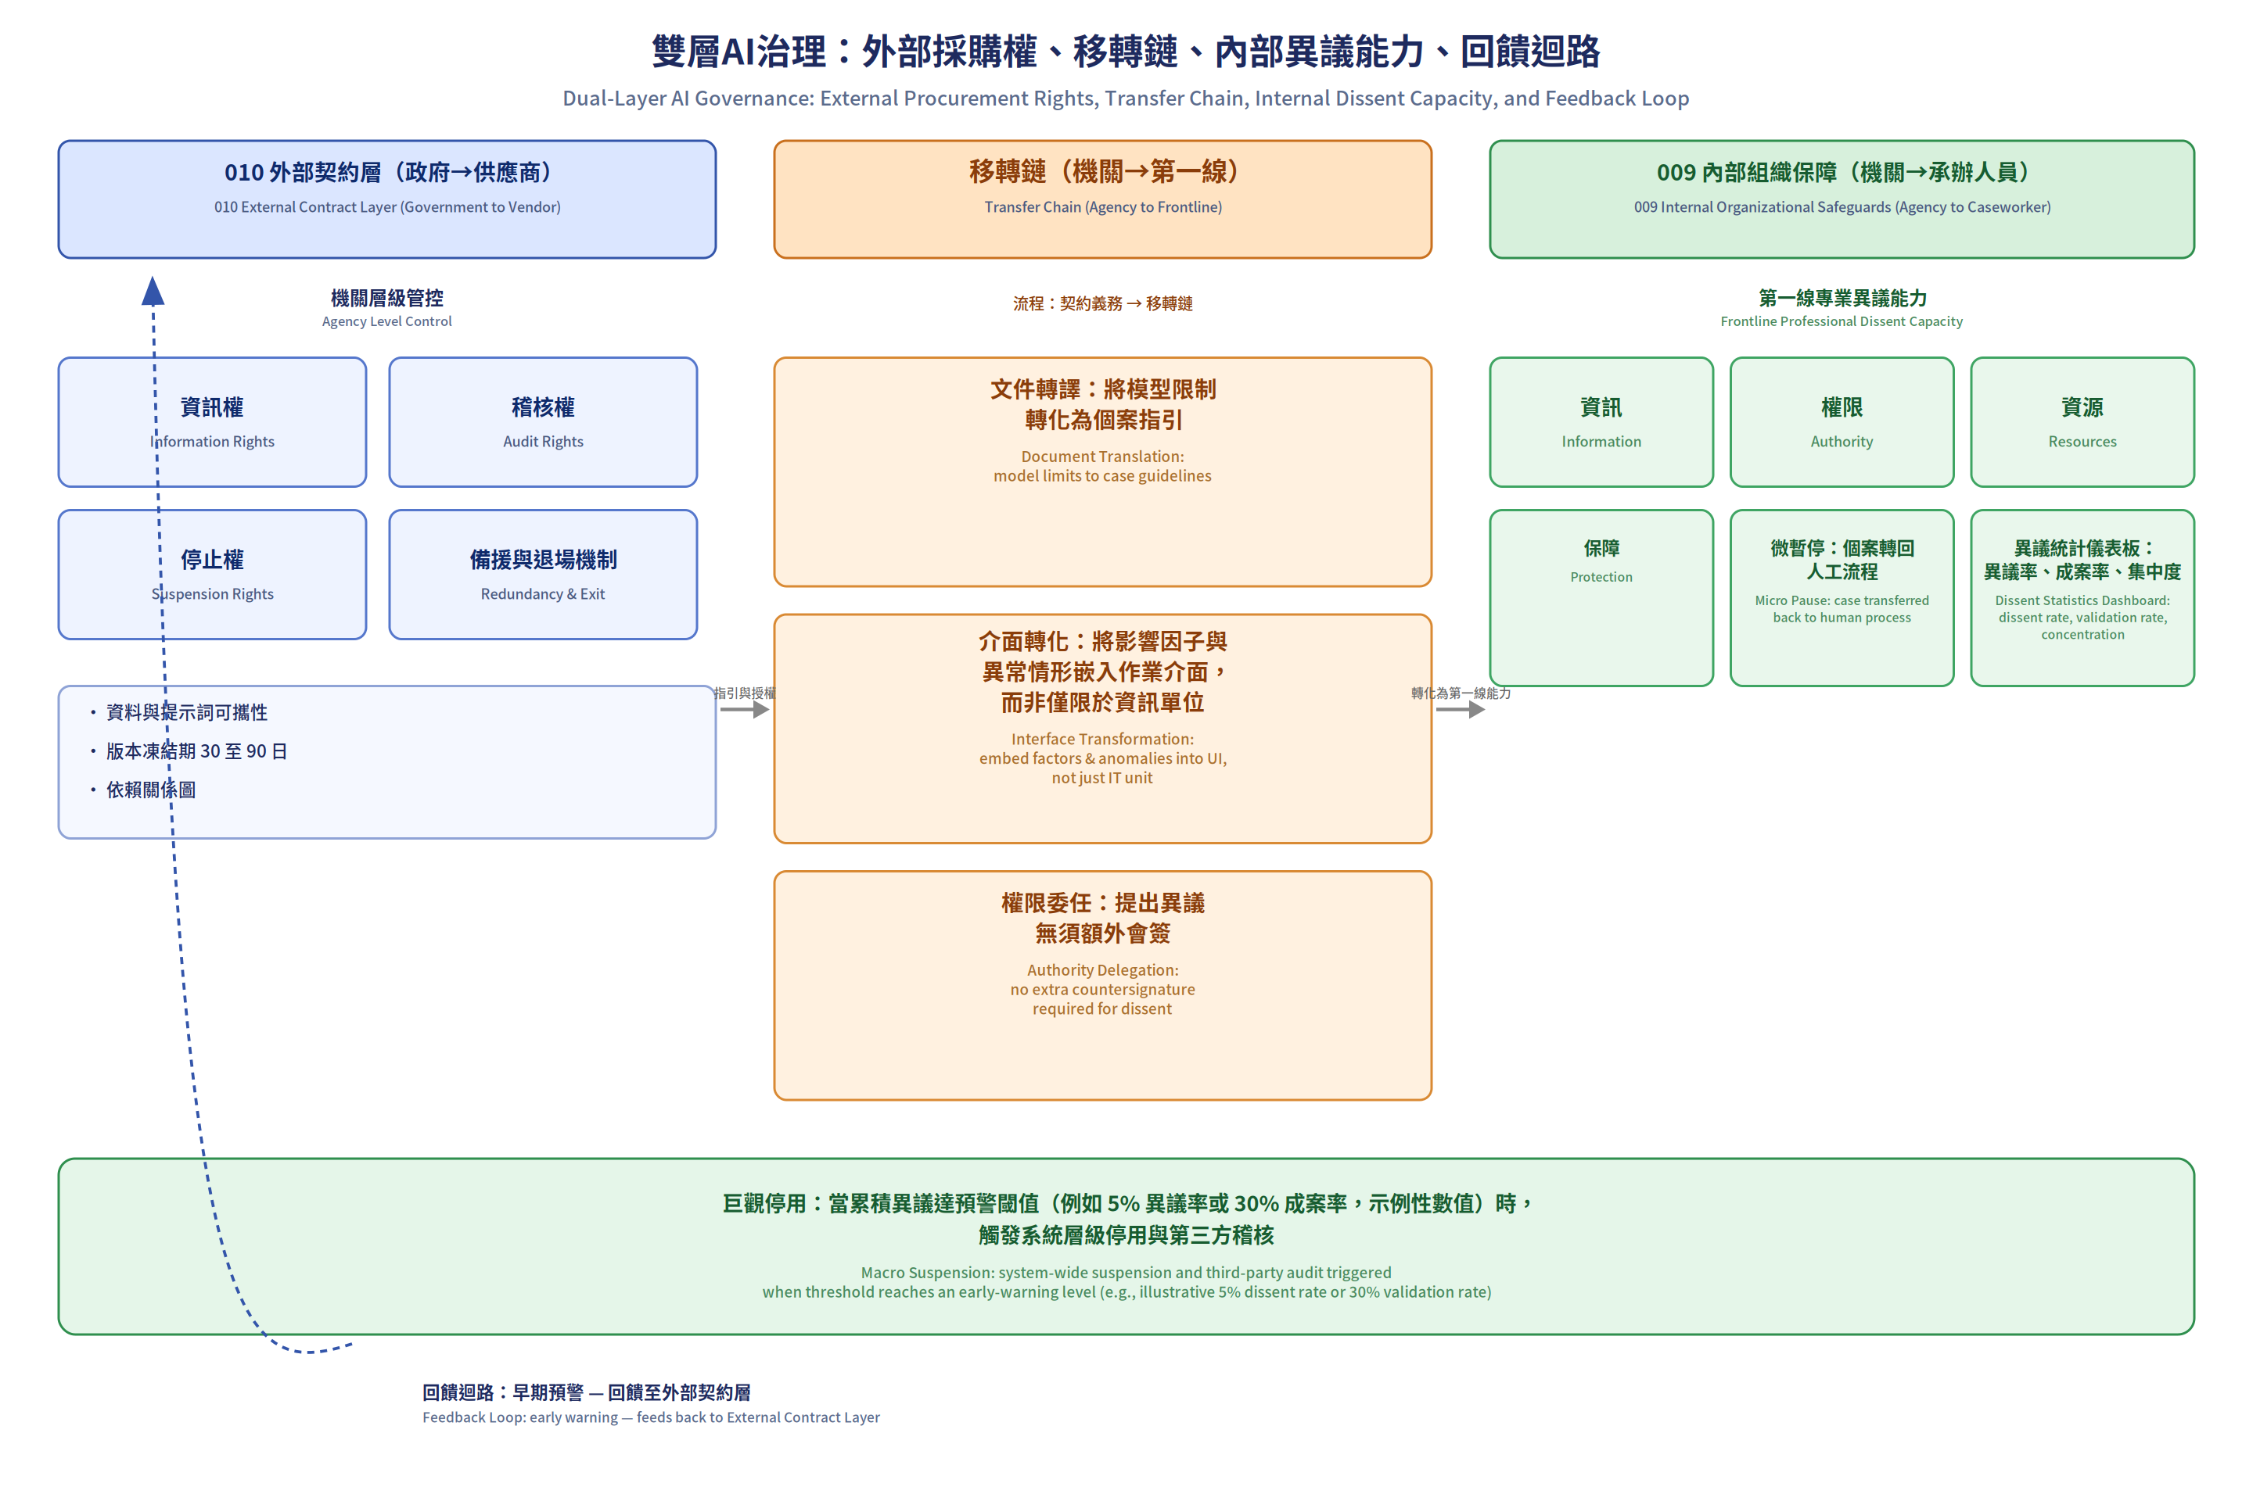
Figure 2. Integrated two-layer control system for meaningful human oversight.

6. Conclusion
Meaningful human oversight is a collective institutional accomplishment, not proof supplied by a signature. AI-assisted administration retains democratic and professional legitimacy only when those expected to exercise judgment can see, question, alter, and defend the grounds of action without being punished for doing so. The practical reform agenda is therefore clear: make dissent information available, make override authority real, fund review time and expertise, and protect justified professional disagreement.

References
European Union. (2024). Artificial Intelligence Act, Article 14.
National Institute of Standards and Technology. (2023). AI Risk Management Framework 1.0.
Royal Commission into the Robodebt Scheme. (2023). Report.
District Court of The Hague. (2020). NJCM c.s./De Staat der Nederlanden (SyRI).
Wallach, W., & Allen, C. (2009). Moral Machines. Oxford University Press.

