Academic Website Research Paper | SSCI Submission-Preparation Version

Negotiated Governance of AI Robots: From Value Embedding to Multi-Stakeholder Co-Construction
Lancelot Lu
August 2026

Abstract
When artificial intelligence (AI) robots enter domestic and care settings, the fundamental governance challenge extends beyond how ethical values ought to be embedded into system architectures. Human institutions must also systematically resolve who possesses the authority to define risks, who is empowered to make decisions, who is required to provide justifications, and who ultimately bears the consequences. This article applies a 5 × 5 framework of twenty-five governance coordinates at the individual and organizational levels, employing four governance chains—context construction, authority, reason, and responsibility—to evaluate and compare four institutional pathways: vendor embedding, government command, market contracting, and multi-stakeholder negotiation. Rather than treating these pathways as isolated institutional alternatives, the analysis demonstrates how they intersect, shift, and form hybrid arrangements. The study synthesizes structured literature and legal analysis, a bounded retrospective account of the author's participation in Taiwanese interagency robotics-policy discussions from 2002 to 2005, and prospective thought experiments regarding domestic care robots. It further establishes a graded deadlock resolution mechanism, a predefined reversion point, and an actionable six-step workflow tailored for government research units. Ultimately, this article offers a meso-level public-administration framework that seamlessly bridges ethics-by-design with institutional authority and administrative responsibility. Its core thesis is not that negotiation invariably outperforms command, contract, or technical embedding, but rather that legitimate governance must render problem framing, lawful authority, reasoned justification, and responsibility transparent—while providing a secure institutional fallback when consensus or system performance fails.
Keywords: AI robot governance, negotiated governance, artificial moral agents, value sensitive design, governance possibility space, reversion point
Research Position and Relationship to the Series:
This article serves as a companion piece to Embedded Universalism. While both papers share the foundational twenty-five governance coordinates and four governance chains (Lu, 2026a, 2026b), this article pivots the unit of analysis toward individuals and organizations. It rigorously examines the governance friction that emerges as AI robots—specifically domestic and care assistance systems—integrate into daily life. The discussion incorporates international and Taiwanese legal frameworks, including Taiwan's Artificial Intelligence Basic Act (promulgated January 14, 2026). Ultimately, this paper constructs a scholarly analytical framework designed to anchor subsequent empirical inquiries, policy debates, and practical pilot projects.

I. Introduction

1. Clarifying Who Negotiates
In the context of this study, "negotiation" does not denote an interactive dialogue between a human user and an autonomous robot. Instead, it refers to the institutional mechanisms through which human organizations address and resolve value conflicts generated by robotic deployment. Relevant stakeholders encompass manufacturers, end-users, family members, care providers, regulatory bodies, and advocacy organizations representing older adults and persons with disabilities. Once system design and autonomous behavior begin to impact human safety, personal autonomy, and daily routines, institutions must confront three decisive questions: who holds the right to define risk, who is authorized to decide, and who assumes legal and moral liability? These questions reside entirely within human institutional networks. This analysis intentionally avoids assuming that AI systems possess consciousness, intentionality, legal personhood, or negotiating standing.
Establishing this analytical boundary is crucial because machine-ethics scholarship frequently explores the concept of artificial moral agents (Wallach & Allen, 2009; Anderson & Anderson, 2011). This article neither dismisses that theoretical literature nor enters metaphysical disputes regarding the moral status of AI. Its focus is squarely administrative and institutional: how can established governance structures absorb value conflicts without allowing institutional authority and responsibility to dissolve as technical autonomy advances?

2. The Problem and Strategic Intention
Governance in AI ethics traditionally originates from two primary mechanisms. Governments may enact statutes to define the permissible boundaries of design and deployment, while commercial entities may encode hierarchical values directly into model architectures, system defaults, and terms of service. Although both approaches are essential, each leaves significant institutional vulnerabilities. Statutory command often exists without sufficient administrative enforcement capacity, whereas vendor embedding risks converting public values into internal corporate decisions. Multi-stakeholder or negotiated governance emerges as a necessary response. It does not replace legal mandates or technical design; rather, it requires developers, users, care practitioners, rights advocates, and regulatory agencies to publicly disclose and justify their analytical frames, authorities, justifications, and responsibilities through a structured institutional procedure.
As argued in the companion paper, high-level philosophical consensus at Level 1 does not automatically translate into coordinated institutional action at Level 2 (Lu, 2026b). Value Sensitive Design (VSD) introduced crucial conceptual, empirical, and technical investigations into engineering processes (Friedman et al., 2006; Friedman & Hendry, 2019), and multi-stakeholder paradigms have expanded participation across research, regulatory, and civil domains (Resseguier et al., 2021). Nevertheless, the unresolved administrative bottleneck persists: when value conflicts enter interagency negotiations, public procurement, field trials, and emergency incident responses, how can general participatory principles be converted into an actionable, executable procedure? This article resolves this challenge by introducing a structured risk map, a negotiation script, and a predefined reversion point.

3. Research Question and Core Argument
The central research question driving this study is: When AI robots enter human living environments—particularly domestic and care settings—what institutional governance arrangements should absorb their multifaceted impacts on human values?
Domestic and care robotics simultaneously touch upon human dignity, personal autonomy, non-discrimination, labor rights, product safety, data privacy, national security, property rights, inheritance, consumer protection, distributive justice, and environmental sustainability. This cross-domain complexity makes care robotics an ideal stress test for evaluating whether the twenty-five governance coordinates function effectively across different scales. Moving beyond a static catalog of values, this analysis investigates how core principles enter institutional divisions of labor, policy formulations, and liability frameworks, and demonstrates how they can be operationalized into risk maps and negotiation scripts directly actionable by public research institutions.

II. Research Design and Analytical Strategy

1. Research Approach and Analytical Purpose
This article adopts a theory-building qualitative research design. It utilizes the complex, cross-sectoral conflicts triggered by AI robots in home and care environments as an institutional stress test. In this context, "stress testing" does not imply statistical validation of a single predictive model. Rather, it places identical governance problems across diverse coordinates, institutional pathways, and operational failure scenarios to identify precisely where existing structures of authority, reasoning, and responsibility break down. The primary unit of analysis is the institutional governance arrangement itself, rather than individual robotic units. The analytical emphasis centers on how human actors frame policy problems, secure legal authorization, substantiate decisions, and assume ultimate responsibility.

2. Selection of Materials and Evidentiary Boundaries
The evidentiary base of this study rests on four distinct categories of material. First, scholarly literature spanning machine ethics, Value Sensitive Design, care robotics, and stakeholder governance establishes the conceptual baseline. Second, Taiwanese and comparative legal instruments, regulatory policy programs, and official reports clarify statutory authority, sectoral jurisdictions, and binding rules. Third, the study incorporates a bounded retrospective account derived from the author's direct participation in Taiwanese interagency robotics-policy initiatives between 2002 and 2005. While participant recall illuminates framing dynamics and strategic interactions absent from formal public records, remembered statements are handled with analytical rigor and are not treated as verbatim transcripts or definitive historical facts. Fourth, prospective thought experiments regarding domestic care robots are deployed to reveal institutional blind spots and liability gaps at regulatory interfaces, without purporting to predict specific judicial outcomes.

3. Analytical Procedure
The analysis unfolds across four systematic stages. First, the twenty-five governance coordinates locate the initial problem space and chart potential cross-cell dynamics. Second, the four governance chains—context construction, authority, reason, and responsibility—are applied across each institutional configuration. Third, vendor embedding, government command, market contracting, and multi-stakeholder negotiation are critically evaluated regarding operational effectiveness, normative legitimacy, administrative capacity, and responsibility risks. Fourth, these institutional configurations are subjected to stress testing under conditions of negotiation deadlock, physical accidents, information asymmetry, and administrative capacity deficits. The resulting framework yields a predefined reversion point and a six-step administrative workflow, delivering traceable institutional decisions rather than arbitrary aggregated metrics.

4. Testable Theoretical Claims
This study advances three core theoretical claims for future empirical testing:
- Claim 1: As the technical autonomy of AI robots increases, problem-definition authority tends to shift away from legally competent public agencies toward commercial suppliers and deploying organizations. When context construction remains opaque, structural authority reconstruction precedes formal legal adaptation.
- Claim 2: Expanding the circle of participants does not inherently generate institutional legitimacy. Multi-stakeholder engagement constitutes genuine negotiated governance only when affected parties possess adequate information, objections can substantively alter proposals, and legally competent authorities retain final public accountability.
- Claim 3: A predefined reversion point functions as more than a technical fail-safe. By institutionalizing the legal authority and administrative reasons for system suspension, manual takeover, renewed deliberation, and safe re-operation, it operates as an accountability mechanism that actively prevents responsibility drift.

III. Analytical Framework: Rescaling the Coordinates and Engaging Existing Theory

1. Rescaling the Twenty-Five Governance Coordinates
This study recalibrates the 5 × 5 governance matrix—spanning five analytical levels across five units of analysis—by focusing specifically on individual and organizational tiers rather than macro-societal or international systems (Lu, 2026a). This shift represents a crucial analytical expansion. A conceptual framework that accounts solely for macro-level international governance offers limited utility for real-world public administration. Examining commercial consumer purchases, organizational service integration, and product design offers a rigorous cross-scale evaluation of institutional governance.
Figure 3.1. The 5 × 5 Public-Administration Matrix under AI Governance
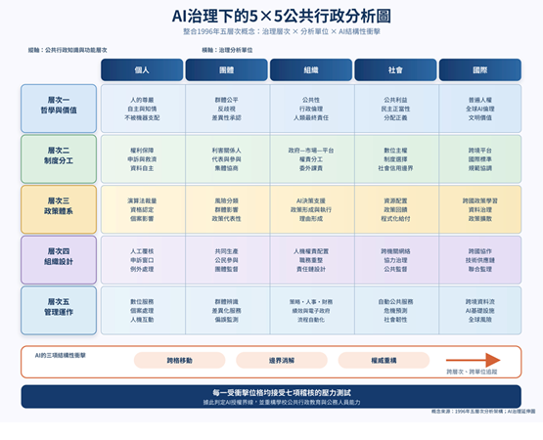
Source: Extended from Lu (1996a, 1996b, 2026a); authored by the researcher.
Figure 3.1 provides a structured grid to locate administrative challenges without confining them to rigid compartments. The vertical axis encompasses philosophy and values, institutional division of labor, policy systems, organizational design, and managerial operations. The horizontal axis covers individuals, groups, organizations, society, and the international domain. Advanced AI deployment frequently propels governance problems across multiple coordinates, blurring traditional boundaries and restructuring authority. Consequently, the matrix serves as a dynamic analytical language for tracking institutional movement rather than a static classification scheme.
For example, a domestic care robot initially operates at the intersection of Philosophy & Values × Individual (dignity and autonomy), Institutional Division of Labor × Organization (role allocation among manufacturers, care providers, and state regulators), and Managerial Operations × Individual (daily activity monitoring and medical reminders). Over time, accumulated systemic effects shift the issue into Policy Systems × Society and Institutional Division of Labor × Society. This structural movement mirrors the boundary dissolution, authority reconstruction, and cross-cell migration observed in automated governance systems like AFST, SyRI, and Robodebt.

2. Relationship to Value Sensitive Design and Machine Ethics
While negotiated governance aligns with Value Sensitive Design (VSD) and machine ethics, the three paradigms address distinct governance questions:
Dimension | Value Sensitive Design (VSD) | Machine Ethics | Negotiated Governance (This Article)
Main Question | How can human values be systematically embedded into technical design? | How can AI systems or robots execute ethical judgments during runtime? | How can human stakeholders transform value conflicts into executable institutional arrangements?
Principal Actors | Engineers, technical designers, direct/indirect stakeholders | The autonomous AI system or artificial moral agent (AMA) | Manufacturers, end-users, family members, care providers, regulatory agencies, rights advocates
Operational Stage | Primarily ex-ante engineering and design phase | Real-time runtime execution and decision logic | Ex-ante design, deployment, interagency oversight, and post-incident response
Core Method | Iterative conceptual, empirical, and technical investigations | Rule-based, consequentialist, or hybrid ethical algorithms | Structured risk mapping and four-chain negotiation scripts
AI Moral Agency | Generally not required or assumed | Frequently explored or modeled functionally | Explicitly rejected; negotiating standing remains strictly human
Representative works | Friedman & Hendry (2019); care-centred VSD in van Wynsberghe (2013) | Wallach & Allen (2009); Anderson & Anderson (2011) | This article’s negotiated, multi-stakeholder co-construction pathway
VSD emphasizes the prospective integration of human values through iterative conceptual, empirical, and technical inquiries (Friedman et al., 2006; Friedman & Hendry, 2019). Conceptual inquiries clarify core values; empirical inquiries evaluate stakeholder experiences; technical inquiries assess how architectural features support or hinder specific normative values. Within healthcare robotics, van Wynsberghe (2013) introduced care-centered VSD, structuring system design around core care values—attentiveness, responsibility, competence, and reciprocity—rather than prioritizing mechanical efficiency or basic safety alone.
Machine ethics focuses on real-time algorithmic decision-making inside autonomous architectures (Wallach & Allen, 2009; Anderson & Anderson, 2011). In clinical or domestic contexts, a care robot may face trade-offs between issuing a crucial medication alert and honoring a patient's immediate refusal, or balancing safety interventions against personal liberty. Literature in this domain evaluates whether systems should implement deontological rules, consequentialist evaluations, virtue ethics, or case-based reasoning, with some scholars debating whether artificial agents should attain functional moral standing.

3. The Dispute over Artificial Moral Agents
Wallach and Allen (2009) distinguish operational morality, functional morality, and full moral agency, a taxonomy complemented by Moor's (2006) explicit gradations. The core debates within this spectrum are contrasted below:
Issue Dimension | Exploratory / Supportive Position | Cautious Position (Adopted in This Study)
Core Premise | Robots executing life-impacting decisions require embedded moral reasoning routines. | True moral agency requires conscious intent and moral liability; attributing agency to software dilutes human accountability.
Responsibility | Novel legal frameworks may allocate partial responsibility directly to autonomous systems. | Design, manufacturing, deployment, oversight, and legal remedy must remain strictly bound to human and corporate entities.
Ethical Theory | Robotic systems can effectively execute formal ethical frameworks (duties, utility, virtues). | A designer's unilateral selection of an ethical theory represents an unnegotiated, subjective value choice.
Care Risk | Robotics can alleviate care burdens and execute objective, ethically sound interventions. | Institutional reliance on machines risks displacing human contact, exploiting emotional attachment, or simulating fake care (Sharkey & Sharkey, 2012).
Relationship to this article | A technical and philosophical line of inquiry within machine ethics. | This article’s defensive declaration adopts this position: the negotiating parties are always human stakeholder networks; AI is not presumed to possess moral standing.
Representative works | Wallach & Allen (2009); Anderson & Anderson (2011); selected work in machine ethics. | This article’s defensive declaration; Rachum-Twaig (2020) on responsibility; Sharkey & Sharkey (2012) on care ethics.
While technical debate centers on whether machines can simulate ethical reasoning, the crucial public administration question is whether legal responsibility can be transferred to non-human entities. This article adopts a firm posture: functional moral computations cannot replace statutory authority, reasoned public justification, or ultimate human accountability. The negotiation script proposed here assigns explicit responsibility across human and organizational actors, refusing to grant AI systems standing at the negotiating table.

4. Autonomous Vehicles as an Evaluative Benchmark
Ethical discussions surrounding autonomous vehicles (AVs) are frequently reduced to stylized trolley problems—debating whether an automated vehicle should sacrifice passengers or pedestrians in unavoidable collisions. However, Nyholm and Smids (2016) and Himmelreich (2018) demonstrate that real-world governance centers on systemic risk distribution, infrastructure integration, traffic regulations, and meaningful human supervision.
Partial driving automation closely mirrors the governance realities of care robotics. Drivers frequently over-rely on automated features, vendors obscure operational boundaries, and regulators struggle with inadequate testing paradigms. Taiwan's Unmanned Vehicles Technology Innovative Experimentation Act explicitly maintains civil and criminal liability standards, affirming that automation does not create a novel legal subject. Similarly, the German Ethics Commission on Automated and Connected Driving (2017) mandated the absolute priority of human life protection, prohibited discrimination based on personal characteristics, and rejected corporate attempts to transfer liability from manufacturers to software systems. Across domains, the administrative baseline remains consistent: technical autonomy cannot be leveraged to create a liability vacuum.

IV. Case Materials: Values, Participant Experience, and Prospective Problems

1. A Comprehensive Value Map for AI Robots
Deploying domestic and care robots implicates a complex matrix of rights, values, and statutory regimes:
- Dignity, Autonomy, and Inclusion: Protecting personal liberty, self-determination, active participation, and accessibility under the UN Convention on the Rights of Persons with Disabilities (United Nations, 2006).
- Non-Discrimination: Preventing algorithmic bias and social exclusion that stem from flawed design assumptions in care contexts (Sharkey & Sharkey, 2012).
- Labor Rights and Displacement: Balancing automation with workforce protections. Taiwan's robotics policies view labor shortages as a primary driver, while the Artificial Intelligence Basic Act obligates the state to safeguard worker rights during AI transitions.
- Product Safety and Tort Liability: Managing strict liability and negligence standards when adaptive machine learning complicates conventional causation analysis (Rachum-Twaig, 2020).
- Data Privacy and Security: Regulating continuous audio-visual, behavioral, and biometric data harvesting within private domestic spaces.
- Supply Chain and Hardware Security: Mitigating cybersecurity vulnerabilities and data leakage across global hardware and software supply networks.
- Property and Consumer Rights: Resolving legal friction between physical device ownership and restricted access to proprietary, cloud-hosted interaction logs and memories.
- Distributive Justice and Environmental Sustainability: Addressing wealth concentration driven by technology ownership alongside the energy footprint of large-scale infrastructure.

2. Retrospective Participant Account (2002–2005)
From 2002 to 2005, the author participated as an international-affairs practitioner in Taiwanese interagency policy planning involving robotics scholars, the Institute for Information Industry, the National Science Council, the Ministry of Economic Affairs, the Chung-Shan Institute of Science and Technology, and the Department of Health. Discussions targeted a national robotics strategic horizon extending to 2030.
During these sessions, a senior engineering researcher questioned the strategic rationale for funding humanoid robotics, advocating instead for established industrial and specialized service classifications. Conversely, international practitioners argued from sociological and psychological perspectives that humanoid forms could minimize adjustments to human-built environments and facilitate natural social integration. Concurrently, healthcare representatives exhibited significant difficulty in articulating substantive, domain-specific requirements.
Analyzed through the four governance chains, engineering efficiency and psychosocial embedding represented fundamentally competing frames regarding the core purpose of national robotics policy. The absence of a proactive voice from health agencies exposed a structural administrative flaw: the institutional framework had failed to determine who was authorized to represent long-term care needs or assume responsibility for operational outcomes. The technology did not generate this institutional gap; rather, it rendered pre-existing governance weaknesses visible.
This structural challenge persists today in an evolved format. In July 2025, the Executive Yuan approved the Smart Robot Industry Promotion Program (2026–2029), addressing core technologies, industrial supply chains, cybersecurity standards, regulatory compliance, and market applications (Executive Yuan, 2025). While this program confirms that robotics occupies a high priority on the national agenda, an industrial promotion plan does not resolve underlying ethical dilemmas regarding care quality, user autonomy, or legal liability.
Taiwan's Artificial Intelligence Basic Act (promulgated January 14, 2026) establishes seven core governance principles, designates the National Science and Technology Council (NSTC) as the primary coordinating authority, mandates a national AI strategy committee, establishes risk-based management tiers, and requires comprehensive regulatory reviews within two years. Under this framework, high-risk applications must display clear warnings as designated by competent authorities in coordination with the Ministry of Digital Affairs. Although the Act provides a solid formal structure at Level 2, underlying framing conflicts persist: should domestic care robots be governed primarily as driver of industrial growth, a managed safety risk, or an institutional mechanism to protect human dignity?

3. Four Prospective Governance Thought Experiments
The following prospective thought experiments highlight critical legal intersections, serving as analytical stress tests rather than binding legal predictions:
- Criminal and Civil Attribution in Domestic Defense: If a home assistance robot causes physical injury to an intruder while protecting a resident, legal liability must be systematically traced through algorithmic rules, user settings, proportionality thresholds, product safety standards, and real-time human oversight. Asserting that "the robot made an autonomous decision" is legally untenable.
- Inheritance vs. Proprietary Cloud Memories: Upon a user's death, physical robotic hardware transfers to legal heirs as personal property. However, personalized interaction histories and cloud-hosted behavioral models remain locked under proprietary terms of service, leaving heirs with a physical shell stripped of its dynamic relational identity.
- Asset Repossession of Essential Assistive Technology: When a financed care robot faces repossession under standard commercial debt enforcement, severe ethical conflicts emerge if the device serves as the user's primary infrastructure for fall detection, medication delivery, and emergency calls. Applying standardized debt enforcement risks endangering basic human safety. Resolving this requires a functional legal assessment evaluating user disability, actual device reliance, alternative care options, and interruption risks, supported by specific statutory protections.
- Maintenance, Inspection, and Classification: Regulatory duties depend heavily on whether a care robot is legally classified as a medical device, a long-term care assistive tool, or a general consumer product. A Legislative Yuan analysis emphasized that distinct legal classifications are urgently needed to clarify operational scopes and maintenance duties (Lee, 2022). Establishing periodic safety inspections and mandatory defect recalls represents a far more defensible regulatory approach than enforcing arbitrary generational hardware retirements.

V. Four Governance Chains and Four Intersecting Pathways
Are the four institutional pathways isolated tracks leading to fixed endpoints? They are not. Vendor embedding, government command, market contracting, and multi-stakeholder negotiation continuously intersect, diverge, and recombine. The twenty-five coordinates pinpoint points of conflict; the four governance chains audit framing, authority, justification, and responsibility; the four pathways offer distinct structural approaches; the governance space illustrates hybrid dynamics; and the six-step workflow transforms these concepts into concrete administrative practice.
Figure 5.1. Governance Possibility Space across Four Institutional Pathways
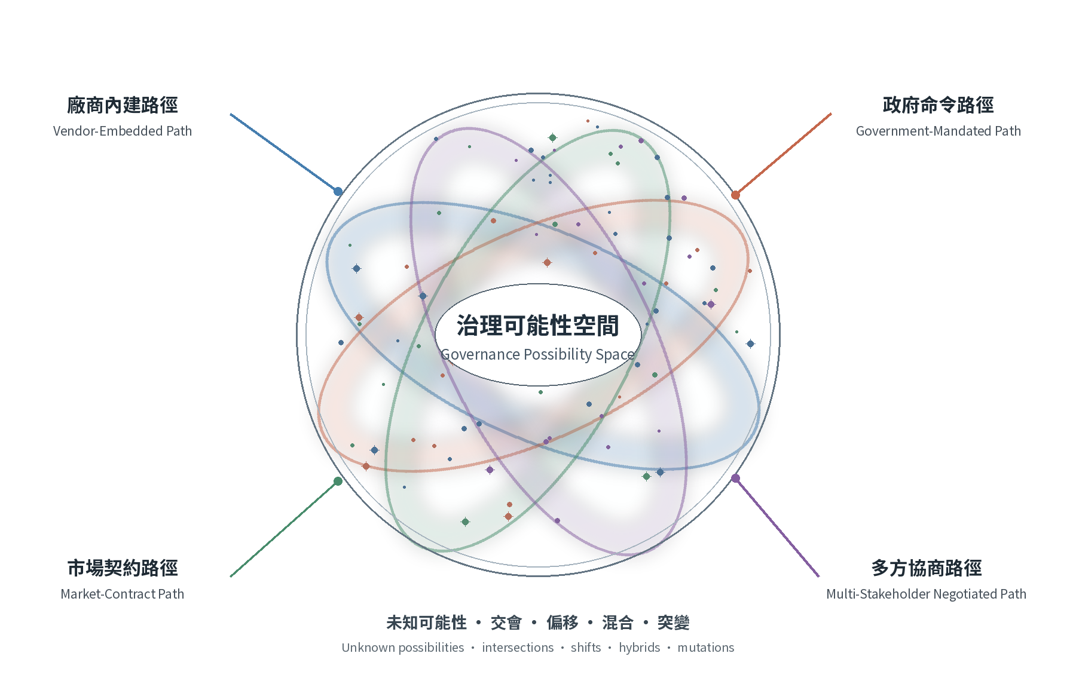
Source: Authored by the researcher.
Figure 5.1 charts an expandable operational arena for governance options. The intersecting pathways demonstrate that classifications serve as analytical entry points rather than rigid boundaries. The specific dynamics of each pathway are detailed below:

1. Vendor Embedding
Commercial developers directly code safety parameters, operational speed, and interaction logic into software architectures and product defaults. While this pathway enables rapid implementation, end-users and civil rights advocates are often forced into purely reactive positions post-deployment. The deeper institutional risk is that suppliers gain de facto authority to define public risks, leaving regulatory agencies to intervene only after severe failures occur.

2. Government Command
Top-down regulation establishes binding legal minimums and safety baselines. Taiwan's Basic Act defines statutory competencies and risk tiers, mirroring the structured obligations imposed by the EU AI Act on high-risk applications. However, legal mandates alone do not guarantee administrative enforcement capacity. Absent technical expertise and staff, statutory command risks degrading into superficial compliance or imposing overly rigid regulatory frameworks that stifle innovation.

3. Market Contracting
Private service contracts, liability insurance, and civil litigation distribute operational risks across manufacturers, vendors, and consumers. However, older adults and vulnerable users rarely possess equal bargaining power when agreeing to complex end-user terms. Contractual freedom fails to safeguard privacy and public welfare when severe information asymmetries exist.

4. Multi-Stakeholder Negotiation
Negotiated governance mandates that manufacturers, users, care practitioners, advocacy groups, and state agencies explicitly justify their analytical frames, legal authorities, and liability commitments before and after system deployment. It translates abstract ethical values into real-world administrative operations, though it does not guarantee automatic consensus. As demonstrated by the 2002–2005 policy discussions, technical engineering frames and social care priorities can remain locked in stalemate for years. Consequently, structured negotiation requires clear agendas, strict deadlines, explicit legal authority, and binding deadlock resolution rules to prevent participation from becoming a strategy for delaying decision-making.
This study advocates for negotiated governance not to discard command, contract, or technical embedding, but to place them within an accountable framework that subjects framing, authority, justification, and responsibility to systematic review. While stakeholder participation strengthens democratic accountability, it does not replace statutory rights and legal duties (Kaminski & Malgieri, 2025). Furthermore, because power asymmetries can distort negotiation dynamics, genuine legitimacy requires equal access to technical information, actionable rights to object, demonstrable influence over policy outcomes, and final decision-making held by legally accountable state authorities.

VI. Operationalizing the Risk Map and Negotiation Script
The risk map and negotiation script translate the four governance chains into actionable administrative processes. Rather than replacing political judgment, these tools prevent core ethical choices from being obscured by technical default settings or fragmented bureaucratic jurisdictions.

1. Context Construction: Pre-Meeting Disclosure
All participating parties must submit written position papers defining their underlying framing—whether focused on industrial competitiveness, labor shortage mitigation, personal dignity, product safety, or data sovereignty. Core assumptions must be explicitly disclosed prior to deliberation, fulfilling the requirements of representative and discretionary-boundary audits.

2. Authority: Mapping Jurisdiction
Stakeholders must detail their explicit legal mandates and statutory competencies, carefully distinguishing advisory expert bodies from legally binding authorities. Operational duties under the Artificial Intelligence Basic Act must be mapped directly to named organizations, satisfying discretionary-boundary and democratic-accountability audits.

3. Reasons: Preparing Comparable Options
Deliberation must evaluate at least three distinct, executable policy options—such as mandatory real-time human-machine co-operation, compulsory liability insurance paired with periodic inspections, or tiered functional operational approvals. Each option must be accompanied by plain-language justifications and systematic impact assessments, satisfying reason-giving audits.

4. Responsibility: Ex-Ante Commitments
Participating entities must formally declare the specific liabilities they accept under each proposed option—spanning system design, deployment oversight, real-time supervision, accident investigation, consumer dispute resolution, and emergency shutdown protocols. Clear role assignments and defined remedy channels fulfill responsibility-attribution and organizational-capacity audits.

5. Graded Deadlock Resolution and Reversion Point
Negotiation lacking definitive deadlock rules risks converting public participation into endless administrative delay. At initiation, the process must establish clear timelines, minimum evidentiary standards, required participants, and explicit deadlock triggers.
- Trigger: Deadlock is formally triggered when established deadlines expire without an executable policy choice, when a key actor refuses to disclose essential data or accept statutory liability, or when all proposed options violate core safety or human rights baselines. Formal dissenting opinions must be officially recorded.
- High-Risk Reversion: For robotic systems impacting physical safety, irreversible rights violations, continuous home surveillance, or vulnerable populations, deadlock automatically triggers immediate system suspension, feature degradation, or reversion to a strict command-based regulatory baseline. Temporary risk control serves as a protective measure, not a permanent endpoint.
- Lower-Risk Interim Measures: Where operational risks are fully reversible and human intervention remains effective, competent authorities may authorize time-limited field trials featuring restricted deployment sites, reduced user cohorts, mandatory human override, heightened monitoring, and explicit review schedules. Exceeding predefined risk thresholds instantly activates high-risk reversion.
- Authority and Reason-Giving: Interim operational approvals must be executed directly by competent state agencies rather than advisory deliberative bodies. The administrative record must articulate core justifications, rejected alternatives, minority objections, responsible officials, and mandatory review dates.
- Process Restart: Stakeholders may petition to reopen formal negotiations upon presenting novel technical evidence, verified architectural updates, expanded organizational capacity, or revised liability commitments. The regulatory authority must verify that deadlock triggers have been resolved before granting renewed trial approvals.

6. Six-Step Workflow for Government Research Units
Public agency researchers should avoid making value choices on behalf of elected officials or public stakeholders. Instead, their task is to organize framing assumptions, legal authorities, justifications, liabilities, and exit protocols into decision-ready policy packages.
Figure 6.1. Six-Step Workflow for Administrative Translation
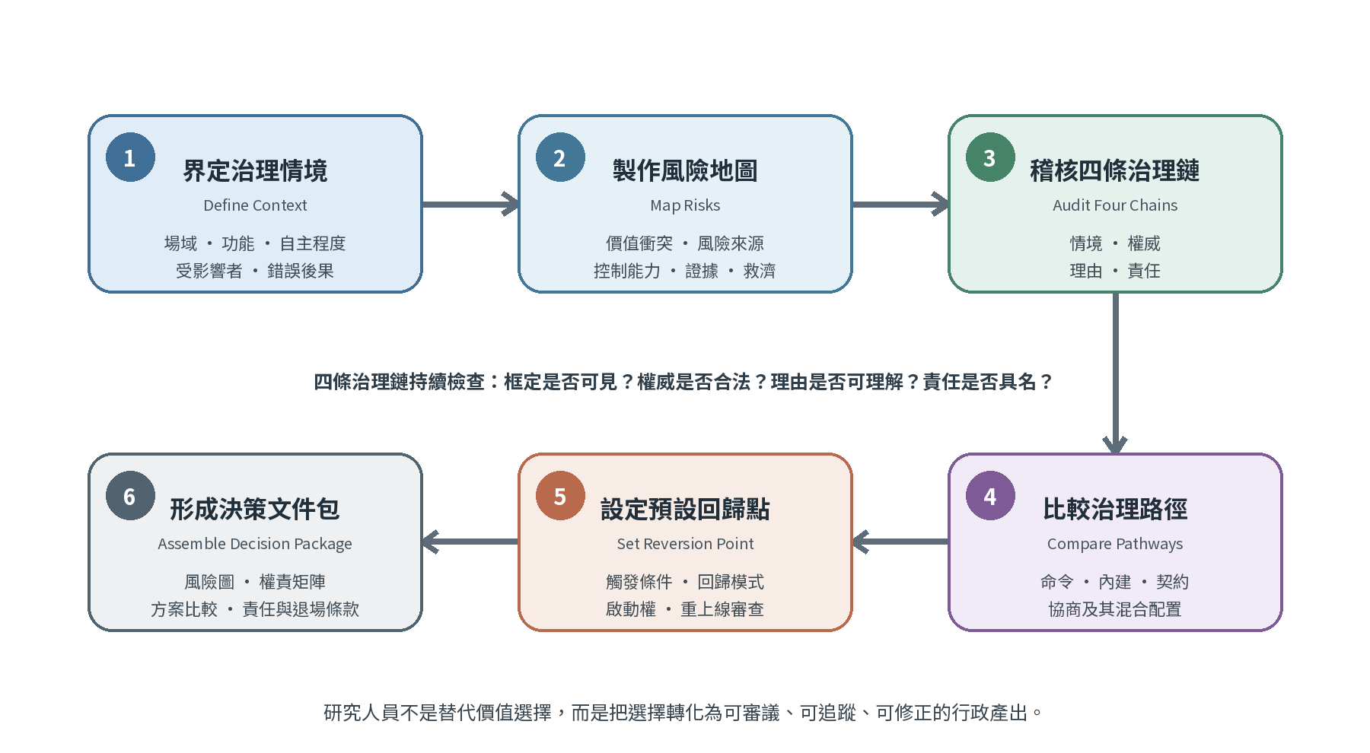
Source: Authored by the researcher.
- Step 1: Define the Governance Context. Document the physical deployment setting, primary operational functions, system autonomy level, affected user cohorts, and failure consequences. Replace vague goals with precise operational boundaries, distinguishing simple reminders from continuous monitoring or automated decision-making.
- Step 2: Produce a One-Page Risk Map. Catalog specific risk vectors, affected groups, conflicting values, risk origins, primary risk-controlling entities, empirical evidence, incident reporting channels, and available legal remedies.
- Step 3: Audit the Four Governance Chains. Systematically verify who defined the primary problem frame, identify legal and final authorities, evaluate at least three viable options, and specify designated actors for incident handling, system shutdowns, and user remedies. Highlight any broken links as unassigned institutional risks.
- Step 4: Compare Pathways and Hybrids. Systematically evaluate vendor embedding, government command, market contracting, and multi-stakeholder negotiation across operational effectiveness, normative legitimacy, administrative capacity, and responsibility risks, building effective hybrid arrangements where appropriate.
- Step 5: Establish the Default Reversion Point. Define clear operational suspension triggers, manual fallback protocols, designated decision-makers, user notification procedures, data logging mandates, and re-certification conditions. Ensure "human control" functions as an executable operational protocol rather than an abstract principle.
- Step 6: Assemble the Final Decision Package. Compile the complete risk map, interagency responsibility matrix, comparative options analysis, designated accountable officials, pilot operational conditions, and public justification summaries, transforming research insights into actionable administrative specifications.

7. Interagency Division of Work and Direct Outputs
Government Unit | Principal Governance Task | Direct Administrative Output
National Science and Technology Council (NSTC) | Strategic foresight, research funding, technology policy, interagency coordination | Grant conditions, risk classification frameworks, ethical/social impact rules, testbed governance, exit protocols
Ministry of Digital Affairs (MoDA) | Data governance, cybersecurity standards, algorithmic transparency, logging, public procurement rules | Procurement clauses, audit formats, incident reporting protocols, software update/retirement duties, transparency summaries
Ministry of Health and Welfare (MOHW) & Sectoral Authorities | Informed consent/refusal, human oversight boundaries, service quality, protection of vulnerable groups, legal remedies | Site approval criteria, consent procedures, human-machine operational limits, safety monitoring, dispute resolution, compensation mechanisms

8. Practical Application: Domestic Care-Robot Pilot
Consider a government-sponsored pilot deploying home care robots equipped with camera arrays and automated fall-detection algorithms. Rather than assessing only computer-vision accuracy, agency researchers must resolve specific operational questions: Can users physically disable cameras? How are false alarms managed? How are incident logs secured and accessed? What real-time oversight duties fall on care providers? Do software updates require regulatory re-certification? Do repeated false alarms trigger automatic reversion to human care visits?
This structured approach ensures policy choices move beyond binary purchasing decisions into fully articulated administrative systems. The six-step workflow bridges abstract ethics and practical public administration, preventing core values from dissolving into technical code, private contracts, or bureaucratic inaction.

VII. Conclusion: Boundaries and Policy Implications
The negotiating parties in AI governance are human institutions and citizens, not autonomous software agents. While machine ethics and Value Sensitive Design have made foundational contributions to technical ethics (Wallach & Allen, 2009; Friedman & Hendry, 2019), this article redirects focus toward public administration: how institutions absorb and remain accountable for technology-driven value conflicts.
Negotiated governance provides immediate operational support for implementing Taiwan's Artificial Intelligence Basic Act, sectoral risk rules, and the Smart Robot Industry Promotion Program. For domestic and care robotics, policy priorities must center on mandatory high-risk labeling, clear human-machine operational boundaries, legal protections for essential assistive devices, interagency alignment, and substantive participation for vulnerable users.
This article delivers three theoretical contributions. First, it extends machine ethics and VSD beyond initial design phases into deployment, interagency oversight, and incident accountability, resolving a meso-level institutional gap in public administration. Second, the four governance chains demonstrate that AI deployment restructures problem framing, statutory authority, and legal liability well before formal legislation is enacted. Third, the framework theorizes negotiation deadlocks, establishing predefined reversion points that bind physical safety to administrative capacity and democratic accountability.
Public administration cannot allow technical optimization to supplant the deliberate balancing of public values. As AI robots gain greater societal influence, statutory authority, transparent justification, clear liability, real-time human intervention, and democratic oversight become indispensable. Far from obstructing technical progress, negotiated governance ensures that innovation remains explainable, legitimate, and accountable within human society.

Limitations and Future Research
The 2002–2005 policy account relies on participant recollection and warrants further verification through complete archival research. The prospective thought experiments serve as theoretical stress tests rather than binding judicial rulings. The governance space visualization offers a conceptual layout rather than a predictive model, and the six-step workflow will require domain-specific adjustments across agencies. Future research should apply the four chains to active procurement and pilot programs, comparing reversion mechanics across high-risk and reversible deployment settings.
Series Note and Suggested Citation:
This is the third paper in a scholarly series. The first establishes the twenty-five coordinates and four chains through automated governance cases (AFST, SyRI, Robodebt) (Lu, 2026a); the second analyzes tension between universal AI principles and national implementations via deepfake election interference cases (Lu, 2026b); this paper focuses on individual/organizational units and operationalizes negotiated governance. All three share a foundational framework while addressing distinct research questions, empirical cases, and evidence.
Suggested Citation: Lu, J.-S. (2026). Negotiated governance of AI robots: From value embedding to multi-stakeholder co-construction (Academic website research design paper, August 2026 version). Lancelot Lu Academic Website.

References
Chinese-language Sources
Artificial Intelligence Basic Act. (2026). Presidential Order Hua-Zong-I-Yi No. 11500001671, January 14, 2026. https://www.president.gov.tw/File/Doc/80165b6d-cb49-4b49-952f-56e1e6abe51b
Executive Yuan. (2025). Policy report to the Fourth Session of the Eleventh Legislative Yuan [Including the Smart Robot Industry Promotion Program, 2026–2029]. Executive Yuan, Taiwan. https://www.ey.gov.tw/File/EE89497142D2768B
Lee, Y.-C. (2022). A preliminary legal study of care robots under population ageing and low fertility (Issue Analysis R01618). Legislative Yuan, Taiwan. https://www.ly.gov.tw/Pages/Detail.aspx?nodeid=6590&pid=217407
Lu, J.-S. (1996a). A framework for reviewing public administration literature. Open University Journal of Public Administration, 5, 177–210. [In Chinese]
Lu, J.-S. (1996b). New public-administration issues in the information society. Taiwanese Political Science Review, 7, 231–256. [In Chinese]
Lu, J.-S. (2026a). Reconceptualizing artificial intelligence governance: Twenty-five governance coordinates, four governance chains, and human–AI collaborative governance from a public-administration perspective. Academic website research paper. [In Chinese]
Lu, J.-S. (2026b). Embedded universalism: The universalization of AI ethics principles and a cross-national comparison of deepfake election interference. Academic website research paper. [In Chinese]
Tsai, D. F.-C., Hu, C.-H., Wang, C.-H., Chuang, Y.-C., & Fu, L.-C. (2021). Ethical issues of care robots. Formosan Journal of Medicine, 25(4), 441–452. [In Chinese]
English-language Sources
Anderson, M., & Anderson, S. L. (Eds.). (2011). Machine ethics. Cambridge University Press.
European Parliament & Council of the European Union. (2024). Regulation (EU) 2024/1689 laying down harmonised rules on artificial intelligence. Official Journal of the European Union, L, 2024/1689. https://eur-lex.europa.eu/eli/reg/2024/1689/oj
Friedman, B., & Hendry, D. G. (2019). Value sensitive design: Shaping technology with moral imagination. MIT Press.
Friedman, B., Kahn, P. H., Jr., & Borning, A. (2006). Value sensitive design and information systems. In P. Zhang & D. Galletta (Eds.), Human-computer interaction and management information systems: Foundations (pp. 348–372). M. E. Sharpe.
German Ethics Commission on Automated and Connected Driving. (2017). Ethics Commission: Automated and connected driving. Federal Ministry of Transport and Digital Infrastructure.
Himmelreich, J. (2018). Never mind the trolley: The ethics of autonomous vehicles in mundane situations. Ethical Theory and Moral Practice, 21(3), 669–684. https://doi.org/10.1007/s10677-018-9896-4
Kaminski, M. E., & Malgieri, G. (2025). Impacted stakeholder participation in AI and data governance. Yale Journal of Law & Technology, 27, 247–326. https://yjolt.org/impacted-stakeholder-participation-ai-and-data-governance
Moor, J. H. (2006). The nature, importance, and difficulty of machine ethics. IEEE Intelligent Systems, 21(4), 18–21. https://doi.org/10.1109/MIS.2006.80
Nyholm, S. R., & Smids, J. (2016). The ethics of accident-algorithms for self-driving cars: An applied trolley problem? Ethical Theory and Moral Practice, 19(5), 1275–1289. https://doi.org/10.1007/s10677-016-9745-2
Rachum-Twaig, O. (2020). Whose robot is it anyway? Liability for artificial-intelligence-based robots. University of Illinois Law Review, 2020(4), 1141–1176. https://www.illinoislawreview.org/wp-content/uploads/2020/08/Rachum-Twaig.pdf
Resseguier, A., Brey, P., Dainow, B., & Drozdzewska, A. (2021). SIENNA D5.4: Multi-stakeholder strategy and practical tools for ethical AI and robotics (Version 4.0). Zenodo. https://doi.org/10.5281/zenodo.5536176
Sharkey, A., & Sharkey, N. (2012). Granny and the robots: Ethical issues in robot care for the elderly. Ethics and Information Technology, 14(1), 27–40. https://doi.org/10.1007/s10676-010-9234-6
United Nations. (2006). Convention on the Rights of Persons with Disabilities. https://www.un.org/development/desa/disabilities/convention-on-the-rights-of-persons-with-disabilities.html
van Wynsberghe, A. (2013). Designing robots for care: Care centered value-sensitive design. Science and Engineering Ethics, 19(2), 407–433. https://doi.org/10.1007/s11948-011-9343-6
Wallach, W., & Allen, C. (2009). Moral machines: Teaching robots right from wrong. Oxford University Press.

