Reconceptualizing AI Governance: Twenty-Five Governance Coordinates, Three Functional Transfers of Administrative Power, Three Structural Effects, Four Governance Chains, and Seven Governance Audits from the Perspective of Public Administration Theory
重新概念化人工智慧治理：公共行政理論視角下的二十五治理座標、四條治理鏈與人機協同治理架構
Lancelot Lu 盧建旭
Doctor of Public Administration, University of Southern California, USA
jslu2020@gmail.com；jyanshiulu@gmail.com
lancelotlu.org
This article was produced in collaboration with AI. AI assisted with text organization and argument verification; conceptual design and final judgment remain the author's responsibility.

Abstract
After artificial intelligence—particularly generative AI—enters government service delivery, policy formulation, and internal administration, public administration scholarship has examined artificial discretion, algorithmic accountability, bias, transparency, and policy framing in separate strands. What remains missing is a shared analytical procedure that can simultaneously locate where AI intervenes, trace governance legitimacy, and identify institutional ruptures. This article adopts conceptual development and a problematizing literature review to propose an AI-embedded stress test, the “25-3-3-4-7” framework: twenty-five governance coordinates, three functional transfers of administrative power, three structural effects, four governance chains, and seven governance audits.
The analysis proceeds in eight steps: locating a case through five analytical levels by five units of analysis; identifying three functional transfers—P1 context construction and fact recognition, P2 administrative discretion and value judgment, and P3 substantive influence over public-power decisions; identifying cross-coordinate movement, boundary dissolution, and authority reconfiguration; tracing legitimacy through the chains of context construction, authority, reasoning, and responsibility; auditing evidence through data representativeness, reason-giving, responsibility attribution, privacy and security, discretion boundaries, organizational capacity, and democratic accountability; stress-testing heterogeneous cases; identifying recurring rupture patterns that established theory cannot absorb; and, finally, making a meta-exception judgment about whether paradigm reconstruction is warranted. The article offers document-based demonstrations using AFST, SyRI, Robodebt, and Taiwan’s Executive Yuan guidelines for the use of generative AI.
The article’s principal theoretical addition is to place problem definition and data selection—the concerns of policy-framing research—into a context-construction chain at the front of the accountability process, linking it to the subsequent chains of authority, reasoning, and responsibility. The demonstrations show how AI systems can technically frame a problem before a formal decision is made, separating the locations of authority, reasons, and responsibility.
This article's contribution is to propose a conceptual procedure usable for comparing cases, not to claim that empirical validation has been completed. Its external validity, audit criteria, and claims about paradigm reconstruction still require testing by subsequent empirical research.
Keywords: public administration theory, reconceptualization, functional transfers of administrative power, governance chains, governance audits

1. Introduction

1.1 Background: The New Wave of Digital Government Driven by Generative AI
In recent years, generative AI, with its ability to process unstructured text, perform semantic inference, and automatically generate content, has been rapidly rewriting the technical foundations of digital government. Compared with earlier AI applications focused on risk prediction from structured data, generative AI further penetrates the transformation and generation of unstructured material such as official documents, regulatory text, and citizen complaints, extending its reach from back-end administrative automation to front-end citizen-interaction interfaces and the core of policy formation. Governments have already begun substantive deployment: New York City's “MyCity AI,” Singapore GovTech's “Pair,” the UK Cabinet Office's “Redbox,” and Taiwan's National Science and Technology Council-led “TAIDE” all show that generative AI has moved from technical experimentation into the operational core of public governance. This trend is not entirely new: even before generative AI became widespread, practice-oriented research had already observed that cognitive computing was reshaping how government work is executed, proposing the concept of “AI-augmented government” to describe how AI might assist civil servants with routine tasks and free up capacity for higher-order judgment (Eggers, Schatsky, & Viechnicki, 2017). The problem consciousness pursued here begins from the premise that this application trend is already an established fact, and asks further whether public administration theory itself can still explain and withstand this change.

1.2 Problem Consciousness: From “How Can AI Improve Government” to “Does AI Invalidate Public Administration Theory”
Facing this wave, existing research has accumulated considerable results, whose analytical focus can be roughly grouped into six categories: AI applications, AI ethics, digital government, responsible AI, human-in-the-loop, and governance matrices. Yet on closer examination of the common structure of this literature, one notable feature stands out: its unit of analysis almost uniformly places AI at the center, asking essentially “how should governments govern AI?” rather than “does public administration theory retain sufficient explanatory power after the emergence of AI?”
These two questions appear similar but point to entirely different research orientations. The former treats AI as an exogenous technical variable, with the public administration system as the passive party adapting to it; the latter takes public administration theory itself as the primary object of analysis, asking whether its existing division of levels, units of analysis, accountability mechanisms, and normative foundations can still withstand the structural shock brought by generative AI. This analysis adopts the latter problem consciousness, arguing that only by placing public administration theory at the center of analysis can research move beyond “describing applications” to a genuinely theoretically meaningful reconceptualization.

1.3 Research Questions, Method, and Scope
This article poses two research questions. First, after public-sector AI (particularly generative AI) enters administrative operations, at which points do existing analytical levels, discretion, and accountability concepts in public administration come under explanatory strain? Second, how can an analytical procedure be built that locates where AI intervenes, traces governance legitimacy, and identifies institutional rupture? The framework proposed here adopts a conceptual construction and critical, problematizing literature review, selecting representative research on digital-era governance, technology adoption, artificial discretion, algorithmic governance, policy framing, and public accountability, examining their basic assumptions, and then conducting a demonstrative stress test across three application contexts—service delivery, policy formation, and internal administration. This analysis is not a systematic literature review, nor does it treat the demonstration contexts as empirical cases; its purpose is to propose analytical propositions that can be tested by subsequent comparative case studies, interviews, or quantitative research.
This article's core argument is that existing research has separately addressed AI applications, discretion, bias, transparency, and accountability; the problem is not a complete absence of relevant concepts, but that these concepts have not yet been integrated into a single analytical procedure that can simultaneously answer “where AI intervenes,” “at which link governance legitimacy breaks,” and “what evidence should be used to check it.” This article therefore proposes twenty-five governance coordinates, four governance chains, and seven governance audits, unifying the three through an stress-testing procedure. Its purpose is not to prove that existing theory has failed, but to identify the boundary of applicability, resilience, and possible directions for reconstruction of theory under conditions of public-sector AI.

1.4 Contributions and Chapter Structure
Compared with AI-governance scholarship that commonly confines accountability to authority, reasoning, and responsibility, this article adds a context-construction chain to address the prior question of how the governance situation itself is defined, framed, and selected. Together with the twenty-five coordinates, three functional transfers, three structural effects, and seven audits, it forms a single analytical procedure rather than a collection of parallel concepts.
Compared with existing AI governance literature, which confines its accountability discussion to the three links of authority, reasoning, and responsibility, this article adds a “context-construction chain” as a fourth governance chain, addressing the upstream link long neglected by existing literature and traditional accountability theory—how the governance context itself is defined, framed, and selected. This addition constitutes this article's core original contribution beyond the twenty-five governance coordinates and seven audits, and is the substantive content behind the “four governance chains” named in the title.

2. Theoretical Foundations and Literature Review

2.1 The Governance Paradigm Shift: From New Public Management (NPM) to Digital-Era Governance (DEG)
Public administration's engagement with information technology has shifted from New Public Management's market orientation and performance focus (Hood, 1991) toward digital-era governance, which emphasizes integration, digitization, and demand orientation (Dunleavy et al., 2006). Subsequently, social networking technology and data science and AI have respectively driven a second and third wave of digital governance (Margetts & Dunleavy, 2013; Dunleavy & Margetts, 2023). This analysis asks, on this basis, whether AI's impact has already exceeded the scope of administrative choice and institutional arrangement, reaching into the applicability of public administration theory's own analytical framework.

2.2 Technology Adoption and Organizational Adaptation: The TOE Framework and the Technology Acceptance Model (TAM)
The Technology–Organization–Environment framework and the Technology Acceptance Model explain, respectively, how technical, organizational, and environmental conditions and user perception affect adoption (Tornatzky & Fleischer, 1990; Davis, 1989), but their analysis mostly concentrates on organizational or individual adoption, making it difficult to address AI's governance effects across individual, group, organizational, societal, and international levels.

2.3 The Reshaping of Discretion: From Street-Level to System/Algorithmic Bureaucracy
Street-level bureaucracy theory centers on front-line discretion (Lipsky, 1980); after the introduction of information technology, discretion has gradually shifted toward system design, data, and model parameters, forming a system-level bureaucracy (Bovens & Zouridis, 2002). AI therefore not only changes the tools of work but reconfigures the location of discretion itself, touching on tensions among due process, individual case justice, and data standardization.

2.4 Common Features and Theoretical Gaps in Mainstream AI Governance Literature
Existing research has analyzed AI from the perspectives of the policy cycle, artificial discretion, algorithmic administration, policy framing, and public governance applications (Valle-Cruz et al., 2020; Young et al., 2019; Veale & Brass, 2019; Ulnicane et al., 2021; Zuiderwijk et al., 2021), but still lacks a common procedure that can connect analytical position, governance legitimacy, and audit evidence across cases. This article summarizes the gap into five points: the absence of a coordinate system crossing theoretical levels and units of analysis; the frequent conflation of different units of analysis; the fact that context construction, authority, reasoning, and responsibility have not yet been linked into a chain; ethical principles that have not been sufficiently converted into auditable evidence; and the absence of criteria for repeated cross-case testing needed to justify theoretical reconstruction (Busuioc, 2021; Floridi et al., 2018).

2.5 The Evolving Scholarly Stance and Evaluative Concepts in Taiwanese AI Governance Research
Taiwanese public administration research on AI has shifted from application potential toward public values, administrative discretion, risk governance, and institutionalized evaluation. Ding and Lin (2020) emphasize public values and social dialogue; Huang et al. (2021) raise questions of task complexity, discretion, human oversight, and audit; Lee et al. (2022) examine unintended discrimination through the lens of pluralistic justice; Huang and Chen (2023) connect the misplacement of public values, multiple agency, and automation bias across macro, organizational, and micro levels; Lee, Chu, and Tseng (2023) show that data governance has already developed indicator-based and quantitative capacity. Recent research has further addressed institutional adaptation, data collaboration, and civil-service capacity (Hsiao & Chu, 2022; Tseng et al., 2022; Chang et al., 2024; Liao, 2024). The framework proposed here therefore does not argue that Taiwan lacks frameworks, but points out that existing results remain scattered across different levels, without yet forming a common procedure linking analytical position, structural effects, governance chains, audit evidence, and cross-case comparison.
Since 2022, Taiwanese research has begun to show more explicit value criteria, analytical levels, and empirical measurement. Lee, Chang, and Li (2022) use a PRISMA-based qualitative meta-analysis and a pluralistic-justice lens to examine unintended discrimination by institutional process, institutional outcome, rights deprivation, and policy domain, providing an important foundation for data-representativeness and democratic-accountability audits. Huang and Chen (2023) connect the misplacement of public values, multiple agency, AI discretion, and automation bias across macro, organizational, and micro levels, making it the Taiwanese study closest to this article's multi-level coordinates and concept of authority reconfiguration. Lee, Chu, and Tseng (2023) further use a causal model to analyze government data governance, showing that Taiwanese digital-governance research already possesses indicator-based and quantitative evaluative capacity rather than remaining at the level of normative advocacy.
More recent literature has turned toward institutional adaptation and administrative capacity. Chang et al. (2024) use the Institutional Analysis and Development framework to examine institutional design and regulatory adaptation for AI in public services; Liao (2024) synthesizes privacy, bias, digital inclusion, transparency and accountability, algorithmic impact assessment, and responsibility attribution, proposing four categories of civil-service capacity: AI trends and use, digital ethics and risk, data quality and governance, and digital-humanities thinking. In parallel, Hsiao and Chu (2022) use data governance as a case to identify the challenges digital development poses for broader civil-service talent management, proposing directions such as defining digital competencies, integrating civil-service human-resource data, and flexible work environments—this can be seen as the Taiwanese counterpart to this article's organizational-capacity audit in the dimension of civil-service capacity building; Tseng, Liao, and Lee (2022) examine models and cases of public–private data collaboration, analyzing cross-sectoral and public–private collaboration mechanisms, supplementing the Taiwanese empirical foundation for this article's responsibility-attribution audit regarding collaboration and accountability among different actors in the data supply chain. This shows that Taiwanese scholarly attitudes have shifted from “whether to adopt AI” to “with what public values, institutional conditions, human–AI division of labor, and capacity AI should be governed.” The research gap identified here, therefore, is not that Taiwan entirely lacks frameworks or evaluative concepts, but that existing results are distributed across different levels and issues, still lacking a common procedure that connects analytical position, dynamic structural effects, the chain of governance legitimacy, audit evidence, and cross-case comparison.
Representative Literature | Main Focus | Existing Evaluative Concepts | Difference from This Article's Integrated Framework
Ding & Lin (2020) | Application potential, public values, social dialogue | Public-value and participation criteria | Does not yet form a cross-level positioning and evidence-maturity procedure
Huang et al. (2021) | Public values, ethical risk, administrative discretion | Discretion × task matrix, adoption steps, audit questions | Several audit prototypes already exist, but not yet integrated into four chains and cross-case scoring
Lee et al. (2022) | Unintended discrimination and pluralistic justice | Institutional process/outcome, rights deprivation, policy domain | In-depth analysis of fairness and rights, but not a full AI governance framework
Huang & Chen (2023) | Macro–organizational–micro multi-level reflection | Value misplacement, multiple agency, AI discretion, automation bias | Closest to the coordinates and authority reconfiguration, but does not link the four chains and seven audits
Lee, Chu, & Tseng (2023) | Government data governance | Causal model of internal stakeholders and quantitative indicators | Shows quantifiability, but measures data governance rather than AI governance as a whole
Chang et al. (2024) | Institutional design and regulatory adaptation for public services | Institutional Analysis and Development framework, institutional adaptation | Institutional level is thorough, but does not form a cross-level governance chain or shared scoring profile
Liao (2024) | Opportunities, risk, and civil-service capacity | Algorithmic impact assessment, responsibility, four types of capacity | Rich practical dimensions, but not yet a repeatable integrated stress test
Table 2.1 Comparison of Representative Taiwanese Public Administration AI Governance Research with This Article's Framework
Note: this table selects representative Traditional Chinese-language research directly relevant to public administration theory, governance evaluation, and institutional design, for the purpose of comparing conceptual functions; it does not claim to be a systematic review of the Taiwanese AI governance literature.

2.6 Comparison with Related International and Recent Integrated Frameworks
International research has shifted from single applications toward multi-level, socio-technical, and auditable governance. Multi-level and layered models reveal that AI governance involves institutions, organizations, actors, and transnational institutional complexes (Gasser & Almeida, 2017; Tallberg et al., 2023; Criado et al., 2025); algorithmic accountability, reviewable decision-making, and supply-chain research require preserving technical and organizational records and identifying multiple loci of responsibility (Wieringa, 2020; Cobbe et al., 2021, 2023). Layered-audit, public-legitimacy, and complex-adaptive-systems research further explain the interconnection among governance, model, and application, and among input, process, and output (Grimmelikhuijsen & Meijer, 2022; Mökander et al., 2024; Janssen, 2025). These studies support this article's governance chains and seven audits, but have not yet crossed public administration theory's levels and units of analysis into a shared coordinate system.
A separate strand of literature converts AI governance into a reviewable and auditable socio-technical process. Yeung (2018) offers a critical perspective, pointing out that algorithmic regulation, although replacing traditional rule-based regulation with data feedback loops, may evade existing legal accountability and due-process review because decision logic is embedded within the technical system—an important theoretical precursor to the phenomena this article's authority chain and reasoning chain seek to track. Wieringa (2020) reconnects algorithmic accountability to general accountability theory; Cobbe, Lee, and Singh (2021) propose reviewable automated decision-making, requiring that technical and organizational records be preserved before and after a decision; Cobbe, Veale, and Singh (2023) point out that model vendors, cloud service providers, system integrators, and using agencies form an algorithmic supply chain that may limit the scope within which responsibility can be pursued. Madaio et al. (2020) show that fairness checklists, if not embedded within organizational processes and authority structures, tend to remain at the level of abstract principle. These studies respectively support this article's reasoning, responsibility, data-representativeness, and organizational-capacity audits.
Layered-audit and public-legitimacy research offer two further contributions. Mökander et al. (2024) distinguish governance, model, and application audits at three layers, emphasizing that different layers must complement one another; Grimmelikhuijsen and Meijer (2022) use input, process, and output legitimacy to analyze the threats algorithmic government poses to democratic participation, procedural fairness, and public values. Janssen (2025) further treats generative AI as a complex adaptive system in which people, policy, data, process, and system co-evolve, pointing out that nonlinear interaction and multiple feedback loops make responsibility harder to define. These developments echo this article's cross-cell movement, boundary dissolution, and authority reconfiguration, but have not yet formed an integrated procedure, rooted in public administration theory, that can be repeatedly tested against heterogeneous cases.
Recent related frameworks share this article's problem consciousness but differ in their object of operation: Criado et al. (2025) adopt a single-axis macro–meso–micro classification; Wirtz et al. (2020, 2022) integrate risk and governance criteria; Engin et al. (2025) use a technology–institution system as their axis; Zhu (2025) proposes a paradigm direction for public administration with/of/through AI; Mökander et al. (2024) distinguish governance, model, and application audits. This analysis does not claim that these concepts appear here for the first time; its difference lies in crossing five levels and five units of analysis into twenty-five coordinates, then forming an operable procedure through four governance chains, seven audits, and cross-case stress testing, as compared concretely in Table 2.2.
Representative Literature (Year) | Core Structural Device | Analytical Scope/Level | Main Difference from This Article's Framework
Criado, Sandoval-Almazán, & Gil-Garcia (2025) | Macro–meso–micro three levels | Institutions, organizations, policy actors, and citizens | A single-axis three-way classification, not a two-axis crossed matrix; proposes no governance chain or audit tool
Wirtz, Weyerer, & Sturm (2020) | Integrated AI governance framework (risk synthesis) | Types of AI application risk and existing regulatory approaches | Mainly synthesizes existing regulatory approaches by risk checklist; does not distinguish theoretical level × unit of analysis, nor track accountability as a chain
Wirtz, Weyerer, & Kehl (2022) | Risk- and criteria-oriented integrated framework | Correspondence between AI governance principles, risk, and criteria | Focuses on a risk–criteria correspondence table; a principle-synthesis framework that does not address the upstream accountability link of context construction
Engin, Crowcroft, Hand, & Treleaven (2025, preprint) | Four-layer framework (digital public infrastructure, data-driven policy, algorithmic government, GovTech) | National-level technology–institution system integration | Uses the technical-system level as its axis, focusing on enabling relationships among infrastructures, not a coordinate system of public administration theory levels × units of analysis
Zhu (2025) | Tripartite paradigm (with/of/through AI) | Administrative capacity, ethical regulation, methodology | Frames paradigm shift through three roles of AI; proposes no coordinates, governance chain, or cross-case testing procedure; a declarative paradigm discourse
Mökander, Schuett, Kirk, & Floridi (2024) | Governance–model–application three-layer audit | Audit levels for AI systems | Focuses on the audit levels themselves, not on an analytical coordinate system for public administration theory, nor does it cover accountability-chain links such as context construction
Table 2.2 Comparison of Recent Comparable Frameworks with This Article

3. Reconceptualizing Public Administration Theory: An Analytical Framework

3.1 Repositioning the Analysis: Public Administration Theory as the Analytical Subject
Building on the theoretical gap identified in the previous chapter, this article argues that AI governance research requires a fundamental repositioning: shifting the primary object of analysis from “AI” to “public administration theory” itself. The substantive meaning of this shift is that the question this article seeks to answer is not “how should government use AI,” but “does public administration theory's existing division of levels, units of analysis, and accountability mechanisms retain sufficient explanatory power after the emergence of generative AI.” This shift in the form of the question is what this article calls “reconceptualization”—redefining the problem itself and reorganizing analytical concepts, rather than claiming to have already demonstrated a paradigm shift in public administration. What this article accomplishes is a reconceptualization of the analytical procedure; whether the public administration paradigm needs reconstruction must still be judged through repeated stress testing across heterogeneous cases.
To prevent the twenty-five governance coordinates, three functional transfers of administrative power, three structural effects, four governance chains, and seven governance audits from becoming five parallel sets of concepts, this article integrates them into one eight-step analytical procedure. It first locates the theoretical level and unit of analysis at which AI intervenes; then identifies P1 context construction and fact recognition, P2 administrative discretion and value judgment, and P3 substantive influence over public-power decisions; identifies cross-coordinate movement, boundary dissolution, and authority reconfiguration; traces legitimacy through the four governance chains; audits the relevant evidence; stress-tests heterogeneous cases; identifies recurring rupture patterns across cases; and finally makes a meta-exception judgment. Paradigm reconstruction is therefore an analytical conclusion, not a premise: it is supported only when recurring ruptures cannot be adequately absorbed by existing theory.

3.2 Five Analytical Levels × Five Units of Analysis: Twenty-Five Governance Coordinates
To answer the question of exactly which level of public administration theory AI acts upon and which unit of analysis it affects, this article does not use administrative practice domains such as “service delivery” or “policy formation” as its analytical levels; instead, it returns to the internal structure of public administration theory itself, from the abstract to the concrete, to build a “five analytical levels × five units of analysis” coordinate system of twenty-five governance coordinates that can be used to locate any AI governance case. This vertically structured, abstract-to-concrete framework derives directly from the “five analytical levels of public administration” constructed by Lu (1996a) in “A Literature Review Framework for Public Administration”: that framework builds on the four analytical levels—institutions, policy, organization, and management—proposed by Levine, Peters, and Thompson (1990), and adds an uppermost level not fully addressed by that four-level framework—the philosophy of public administration—used to establish fundamental questions about the public sphere, the public interest, and the contest among plural public values, thereby completing a full five-level vertical structure (Lu, 1996a, pp. 190–191). The twenty-five governance coordinates proposed here are formed by further crossing this five-level framework with five units of analysis.
The five levels of public administration theory, from abstract to concrete, are: (1) Philosophy & Values—corresponding to the dialogue between public philosophy and administrative science, establishing fundamental questions of the public sphere, the public interest, normative value, and ethics; (2) Institutional Division of Labor—corresponding to macro-institutional choices among government, market, the third sector, and collaborative governance; (3) Policy System—corresponding to the full policy cycle of problem definition, policy formation, implementation, and evaluation; (4) Organizational Design—corresponding to the structural design, allocation of authority and responsibility, coordination, and flexible innovation of administrative organizations; (5) Management Operations—corresponding to the operational cycle of planning, execution, monitoring, and adjustment in public management. These five levels are interlocking, ultimately pointing jointly toward the governance goal of realizing the public interest, promoting social welfare, and ensuring fairness and sustainable development.
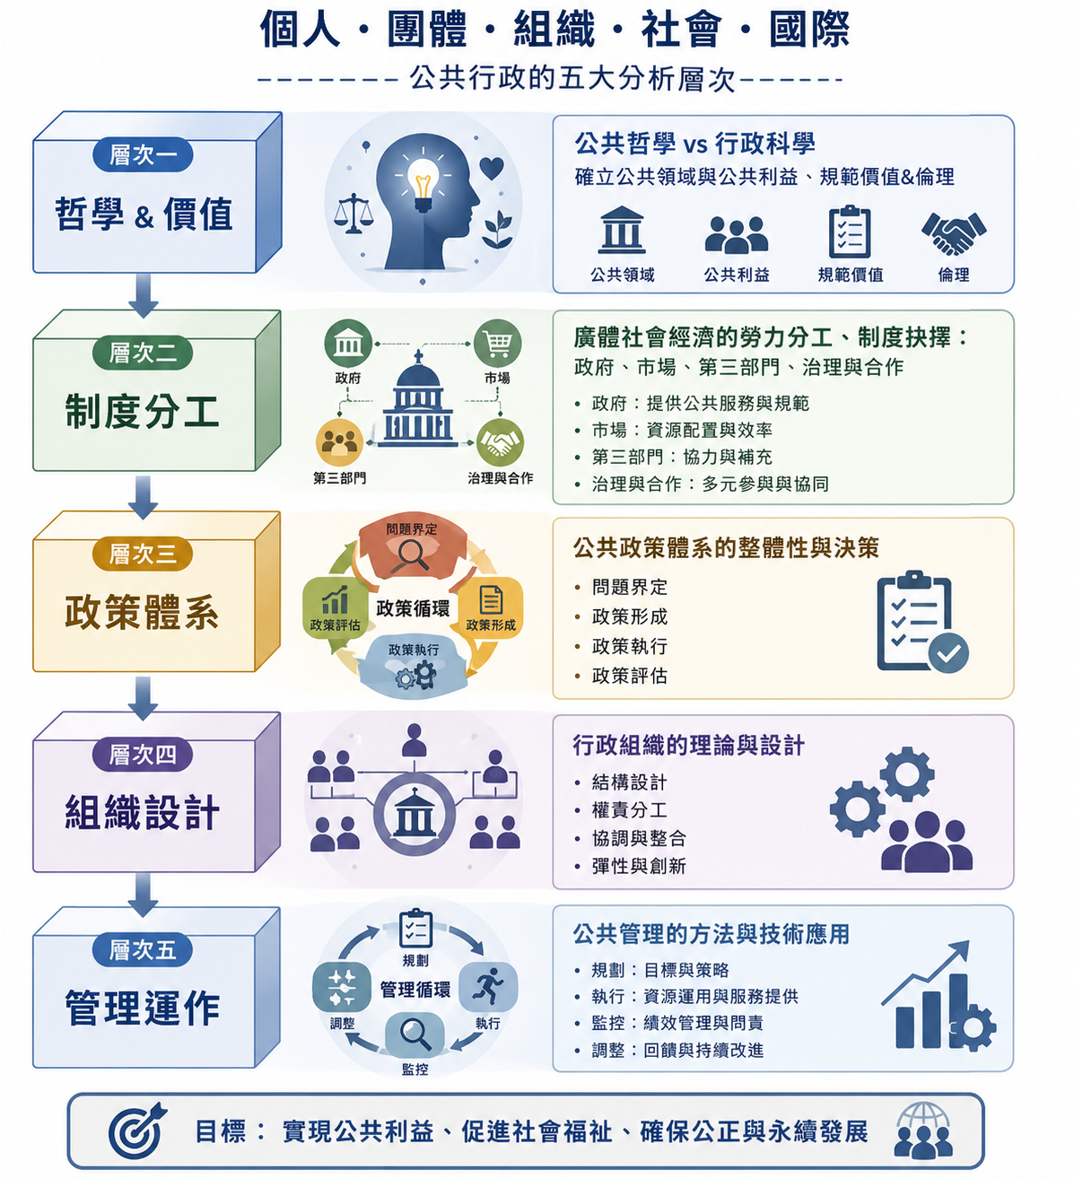
Figure 3.1 The Five Analytical Levels of Public Administration Theory
The five units of analysis are: (1) Individual; (2) Group; (3) Organization; (4) Society; (5) International. Crossing the two axes produces twenty-five governance coordinates (see Table 3.1). For example, “policy system × society” corresponds to AI-assisted society-wide policy simulation and evaluation; “management operations × international” corresponds to cross-national comparative monitoring of AI governance performance (such as international comparisons of the EU AI Act's implementation effectiveness). The value of this coordinate system is that any AI application case can be clearly located along two dimensions simultaneously—which level of public administration theory it touches and which unit of analysis it affects—and can then be systematically compared with other cases on the same analytical plane, which is precisely what existing literature, classifying only by “application domain,” cannot achieve.
Level \ Unit | Individual | Group | Organization | Society | International
Philosophy & Values | Ethical questions of AI decisions and individual dignity | Defining the public interest of specific groups | Weighing an agency's core values (efficiency vs. accountability) | Redefining the public interest in the age of AI | Disputes over the universality of global AI ethics principles
Institutional Division of Labor | Whether personal data governance belongs to government or market | Dominant mechanisms for AI governance in specific industries | Collaboration between agencies and AI vendors | Redistribution of government–market–third-sector roles | Multilateral cooperation mechanisms for cross-national AI governance
Policy System | Semantic analysis of individual complaints | Interest-group opinion analysis and policy formation | AI-assisted agency policy implementation | Society-wide policy simulation and evaluation | Cross-national policy diffusion and comparative evaluation
Organizational Design | Individual civil servants' roles and AI-collaboration design | Team collaboration and human–AI role allocation | Agency structure and authority/responsibility adjusted by AI | Reconfiguration of inter-agency coordination mechanisms | Design of AI governance units within international organizations
Management Operations | AI-assisted monitoring of individual performance | Team performance management and feedback | Automation and monitoring of internal agency processes | Monitoring of national governance performance | Comparative monitoring of cross-national governance outcomes
Table 3.1 Twenty-Five Coordinates for Public Administration AI Governance
The twenty-five coordinates and seven audits do not require mechanically filling in all one hundred seventy-five positions. Researchers should first select a primary coordinate based on the nature of the case, then trace the relevant governance chains and audit evidence; cross-cell movement should be recorded only when a case crosses multiple levels or units of analysis. This selection principle prevents the framework from expanding excessively and keeps the analysis operable.

3.3 Three Functional Transfers of Administrative Power
When AI enters public administration, its effects extend beyond intervention at a particular governance coordinate. Through three distinguishable mechanisms, it transfers functions previously performed by administrative officials with defined status, authority, and responsibility to data, models, system designers, or vendors. These are functional transfers of administrative power: they explain how AI changes administration; they do not claim that statutory authority itself has been ceded.
P1—context construction and fact recognition—concerns which data count as facts, which populations become targets, and which classifications and thresholds establish the starting point for subsequent judgment. It is the concrete mechanism of the framing power addressed by the context-construction chain. P2—administrative discretion and value judgment—concerns which options are recommended, ranked, or excluded, and how efficiency, fairness, risk, and individual justice are weighed. P3—substantive influence over public-power decisions—asks whether technical output directly or near-directly triggers benefits, investigations, penalties, debts, or other legal and resource effects.
The three transfers need not occur sequentially, nor do they form a single ladder of automation. A system may intervene deeply in P1 while exerting only limited influence over P3; conversely, rules-based automation may directly produce legal effects without machine learning. The transfers describe the mechanisms through which AI changes administration. Their institutional consequences are described by the three structural effects below.

3.4 Three Structural Effects
Once these functional transfers occur, they may generate three analytically distinct, though empirically coupled, structural effects: cross-coordinate movement, in which AI expands from case processing in management operations into policy systems, institutional division of labor, society, or other units of analysis; boundary dissolution, in which human judgment, technical rules, organizational procedures, and policy formation can no longer be clearly separated; and authority reconfiguration, in which the statutory decision-maker no longer coincides with the model, data specialists, vendor, or system integrator that materially shapes the outcome.
Functional transfers and structural effects should not be conflated. The former answer how AI changes administration; the latter answer what institutional changes result. The stress-test demonstrations in Chapter 5 treat the recurrence of these three effects as evidence that established public-administration theory is under explanatory pressure.

3.5 Four Governance Chains: Context Construction, Authority, Reasoning, and Responsibility
This article draws on Romzek and Dubnick's (1987) pluralistic view of accountability, combined with policy-framing research (Ulnicane et al., 2021), to propose four governance chains that can be traced independently or linked together. The addition made here is not to claim that existing research has never addressed framing, but to place “how the context is defined” at the very front end of the administrative accountability process, linking it to the three subsequent links of authority, reasoning, and responsibility. This is the theoretical function of the context-construction chain.
Context-Construction Chain: asks how the governance context itself is defined, framed, and selected—who decides which data, which variables, and which questions are included in the analytical frame, and which are excluded? Generative AI's choice of training data, prompt engineering, preset categories, and situational templates in effect exercise a “framing power” that precedes the authority chain: it determines which version of the problem subsequent decision-makers can even see, yet is not itself necessarily subject to democratic accountability mechanisms. When a policy analyst uses an AI tool to summarize public opinion, or an administrator uses AI to summarize complaint cases, the AI's choice of “which voices are summarized and which are marginalized” is itself an act of context construction; without interrogating this link, the authority, reasoning, and responsibility chains may function well yet still rest on a context definition that has already been narrowed or skewed. This governance chain has a genuine theoretical precursor: in examining the impact of the information society on public administration, Lu (1996b) already cited Cleveland's (1985) argument that the hierarchies of power, information-monopoly influence, and social class built on information monopoly and resource scarcity in industrial society would tend to dissolve and reorganize in the information society, owing to the shareability, cumulativeness, and diffusibility of information (Lu, 1996b, pp. 244–245). The present analysis argues that generative AI further deepens this trend—it does not merely change the distribution of information, but directly intervenes in the upstream process by which information itself is filtered, summarized, and framed, which is exactly the core phenomenon the context-construction chain seeks to capture, and precisely what the traditional three-link authority–reasoning–responsibility accountability framework fails to address.
Authority Chain: asks where the legitimacy of a decision comes from—legal authorization, administrative discretion, or the algorithm's own technical authority? When an AI system substantively makes a judgment with the force of an administrative disposition, whether its source of authority can still be traced back to the system of democratic accountability is the central concern of this chain.
Reasoning Chain: asks how the reasons for a decision are formed, and whether they can be traced and explained. This chain directly corresponds to the administrative-law duty to give reasons for a disposition; when the nonlinear inference of a deep-learning model makes it difficult for a civil servant to clearly explain the reasoning path, the reasoning chain breaks.
Responsibility Chain: asks, when an AI decision errs or causes harm, whether responsibility should be attributed to the software developer, the data engineer, or the front-line civil servant. A break in this chain constitutes what this article calls a “responsibility void.”
The four governance chains stand in a logically sequential relationship: the context-construction chain determines how a problem is seen and framed; the authority chain determines who has the power to decide on that basis; the reasoning chain determines whether that decision can be explained and traced; the responsibility chain determines who bears the consequences when the decision causes harm. The four chains are interlocking, and a break at any single link may loosen the legitimacy of the entire governance chain; proposing these four chains also turns “accountability” from a vague matter of principle into something that can be disaggregated, individually examined, and used as an analytical tool to diagnose exactly where a given AI governance case breaks down—in context construction, authority, reasoning, or responsibility.
Governance Chain | Core Question | Typical Failure Mode
Context-Construction Chain | Who decides which data, variables, and questions are included in or excluded from the governance context? | Algorithmic framing power displaces democratic deliberation; the problem definition itself is never tested through due process
Authority Chain | Does a decision's legitimacy come from legal authorization, administrative discretion, or the algorithm's technical authority? | AI's de facto influence displaces institutional authorization; the source of authority cannot be traced back to the system of democratic accountability
Reasoning Chain | What data, model, and judgment form the reasons for a decision? Can they be understood and traced? | Nonlinear inference makes it impossible to fulfill the duty to give reasons, producing a “black box” rupture
Responsibility Chain | When a decision errs or causes harm, to whom should responsibility be attributed? | Responsibility is scattered among vendors, engineers, and civil servants, producing a responsibility void
Table 3.2 Overview of the Four Governance Chains
From the standpoint of public philosophy, the four governance chains are not merely a technical accountability procedure but a continuous process of institutionalizing public values: the context-construction chain determines what counts as a public problem; the authority chain confirms who holds legitimate power to decide; the reasoning chain requires that a decision be defended with comprehensible facts, norms, and values; the responsibility chain requires that, when public values are harmed, there exists a subject who can answer, correct, remedy, and bear the consequences. The four chains thus convert abstract public values into traceable governance relationships, and the seven audits then examine whether each relationship carries sufficient evidence. To make clear the linkage among the four chains, their corresponding audits, and the main points of rupture in the three document-based cases examined in Chapter 5, this article summarizes them in Figure 3.2 below.
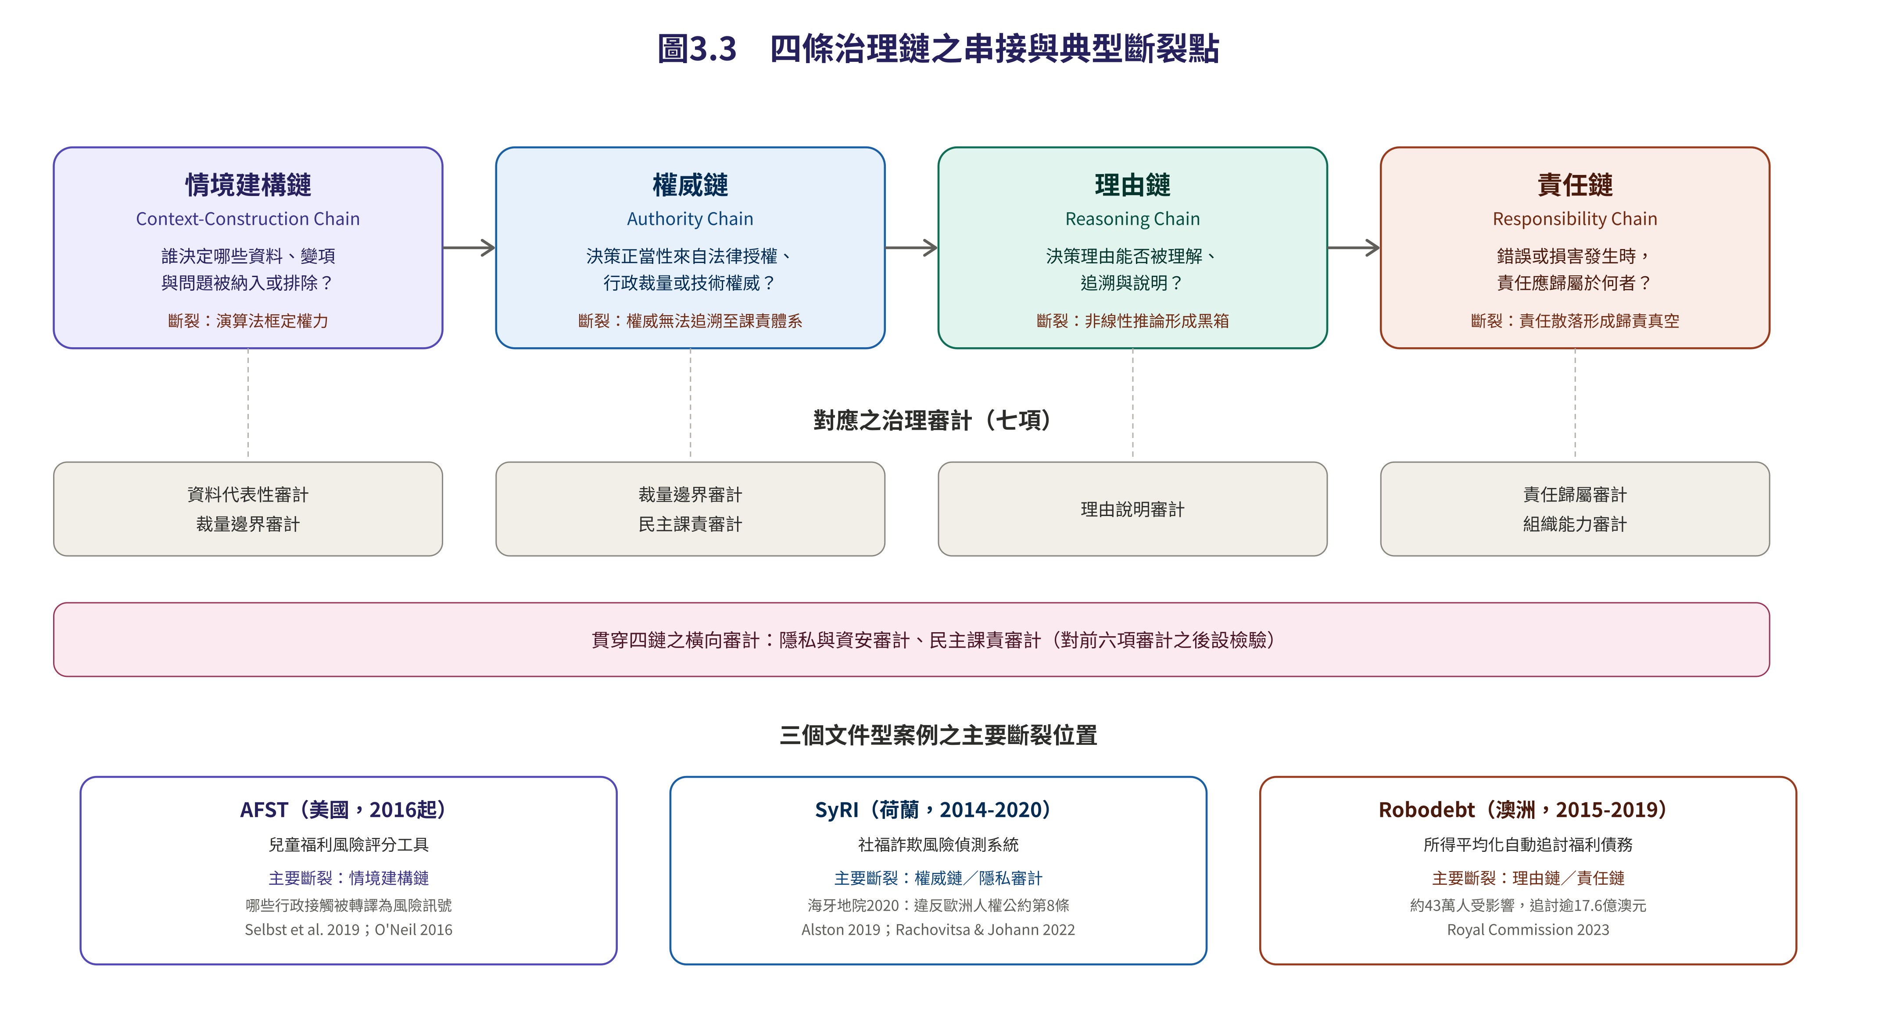
Figure 3.2 Linkage of the Four Governance Chains and Typical Points of Rupture
Source: constructed by the author.

3.6 Seven Governance Audits as an Analytical Tool
Continuing the critique above—that existing literature on bias, privacy, and accountability mostly remains at the level of principled discussion rather than an operable analytical tool—this article converts ethical principles commonly discussed in the literature into seven governance audits that can be concretely applied to individual cases:
1. Data Representativeness Audit: examines the data source, coverage period, missing groups, labeling rules, and bias-testing records; if a particular group is persistently absent or shows a markedly higher error rate, this is judged a representativeness warning.
2. Reason-Giving Audit: examines input sources, model version, prompt templates, human review, and the reason documentation provided to affected individuals; if a decision cannot be connected back to comprehensible facts and norms, the reasoning chain is judged broken.
3. Responsibility Attribution Audit: examines procurement contracts, responsibility charts, review sign-off, incident reporting, and remedy procedures; if there is no named decision-maker or actionable remedy procedure after an error occurs, a responsibility void is judged to exist.
4. Privacy & Security Audit: examines data classification, the legal basis for use, de-identification, access controls, logs, and vendor data-handling terms; any highly sensitive data lacking clear authorization or a traceable record constitutes a major warning.
5. Discretion Boundary Audit: judges the degree of permissible AI involvement based on the clarity of task rules, the need for value weighing, rights impact, and reversibility; high-discretion or high-impact decisions must not be replaced by merely formal human sign-off in place of substantive judgment.
6. Organizational Capacity Audit: examines staff training, model monitoring, complaint handling, vendor management, and the capacity to halt a system; if an agency cannot independently detect, explain, or suspend erroneous output, this is judged insufficient capacity.
7. Democratic Accountability Audit: examines public explanation, external oversight, stakeholder participation, appeal mechanisms, and periodic reporting; if the goals, effectiveness, and harms of a high-risk system cannot withstand public scrutiny, democratic legitimacy is judged insufficient.
The seven audits are mutually independent yet together form an analytical tool that can be repeatedly applied across different cases; compared with existing literature that merely “discusses” ethical principles, this audit framework converts abstract principles into operable, comparable, and cumulative analytical output. To clarify the correspondence between the four governance chains and the seven audits, this article summarizes their main correspondence in Table 3.3.
Governance Chain | Main Corresponding Governance Audits
Context-Construction Chain | Data Representativeness Audit, Discretion Boundary Audit
Authority Chain | Discretion Boundary Audit, Democratic Accountability Audit
Reasoning Chain | Reason-Giving Audit
Responsibility Chain | Responsibility Attribution Audit, Organizational Capacity Audit
(Cutting across all four chains) | Privacy & Security Audit, Democratic Accountability Audit
Table 3.3 Correspondence between the Four Governance Chains and the Seven Governance Audits
It should be specifically noted that the Privacy & Security Audit and the Democratic Accountability Audit do not correspond to a single governance chain alone, but serve as horizontal checks cutting across all four chains of context construction, authority, reasoning, and responsibility: whether data has been properly de-identified affects whether the data selection at the context-construction stage infringes individual informational self-determination; the Democratic Accountability Audit, meanwhile, is a meta-level check on the overall results of the preceding six audits, confirming whether the operation of the four governance chains as a whole still corresponds to the legitimacy foundation that democratic governance requires.
This analysis must also acknowledge that the concrete design of the seven audits above draws mainly on existing tools from the information-science and AI-ethics community, such as Raji et al.'s (2020) end-to-end algorithmic audit, Mökander et al.'s (2024) governance–model–application three-layer audit, and Madaio et al.'s (2020) fairness checklist—all three originate primarily from computer science, human–computer interaction, and information ethics rather than from public administration itself. However, the public administration and government-audit professions have in recent years independently developed comparable tools of a similar nature, showing that the two scholarly communities are converging toward similar directions: the AI accountability framework issued by the U.S. Government Accountability Office (GAO, 2021) was itself developed by a supreme audit institution for use by federal inspectors general and auditors, organizing its audit practice around four pillars—governance, data, performance, and monitoring—whose institutional character is highly consistent with the government-accountability purpose this article's seven audits aim to serve; the algorithmic impact assessment tool established by the Treasury Board of Canada Secretariat (2024) under its Directive on Automated Decision-Making takes the form of a formal government risk-assessment questionnaire, requiring federal agencies to complete risk and mitigation scoring before adopting an automated decision system, and is in nature closer to a government-practice counterpart of this article's discretion-boundary and organizational-capacity audits. In addition, Bovens's (2007) accountability-analysis framework, proposed within public law and public administration theory, distinguishes the actors, forums, and types of accountability, providing this article's responsibility chain and democratic-accountability audit with an accountability-theoretic foundation closer to the public administration tradition than Raji et al.'s more technically oriented audit tool. The seven audits proposed here can therefore be understood as connecting operational techniques from the information field to public administration's own long-standing concern with accountability theory, rather than being transplanted unilaterally from the information field without theoretical conversion.

3.7 AI-Embedded Stress Testing as Methodology
The methodology this article adopts is not simply to collect and organize application cases of AI governance, but to systematically apply the twenty-five coordinates, four governance chains, and seven audits above to actual generative-AI applications in the public sector, thereby testing whether existing public administration theory—including representative bureaucracy, due process, and accountability systems—retains its explanatory power once AI is embedded. The spirit of this methodology is not to remain at “describing” what changes AI brings, but to “test” whether public administration theory is sufficient to withstand, explain, and even regulate the structural shock brought by generative AI. Chapters 4 and 5 are the concrete implementation of this stress test.
Specifically, an AI-embedded stress test places AI within a particular governance coordinate and administrative context, then examines in sequence the changes in actors, authority, roles, boundaries, responsibility, reasoning, and theoretical explanatory power; its purpose is not to prove a theory true or false, but to reveal the resilience and points of rupture of existing public administration theory. Its operational steps are shown in Table 3.4.
Step | Operation
1 | Locate the primary and extended coordinates across five analytical levels × five units of analysis
2 | Identify three functional transfers: P1 context construction, P2 administrative discretion, and P3 substantive influence over public-power decisions
3 | Identify three structural effects: cross-coordinate movement, boundary dissolution, and authority reconfiguration
4 | Trace four governance chains: context construction, authority, reasoning, and responsibility
5 | Apply the seven governance audits to examine public-value, procedural, and organizational evidence
6 | Stress-test heterogeneous cases across policy domains and governance mechanisms
7 | Identify recurring rupture patterns and assess the resilience and scope conditions of established theory
8 | Make a meta-exception judgment: paradigm reconstruction is a possible conclusion, not a prior assumption
Table 3.4 Operational Steps of the AI-Embedded Stress Test
Case selection should pursue heterogeneity across policy domains and governance mechanisms rather than sheer numbers; each case must be able to place stress on at least one governance coordinate, the four governance chains, and several audits. Chapter 5 applies this principle, selecting institutions such as representative bureaucracy, administrative accountability, and organizational capacity as objects of the stress test; future research could further extend to heterogeneous cases such as police use of force, welfare eligibility and benefits, personnel evaluation, administrative penalties, environmental regulation, healthcare administration, and national security, subjecting each in turn to a full stress test.
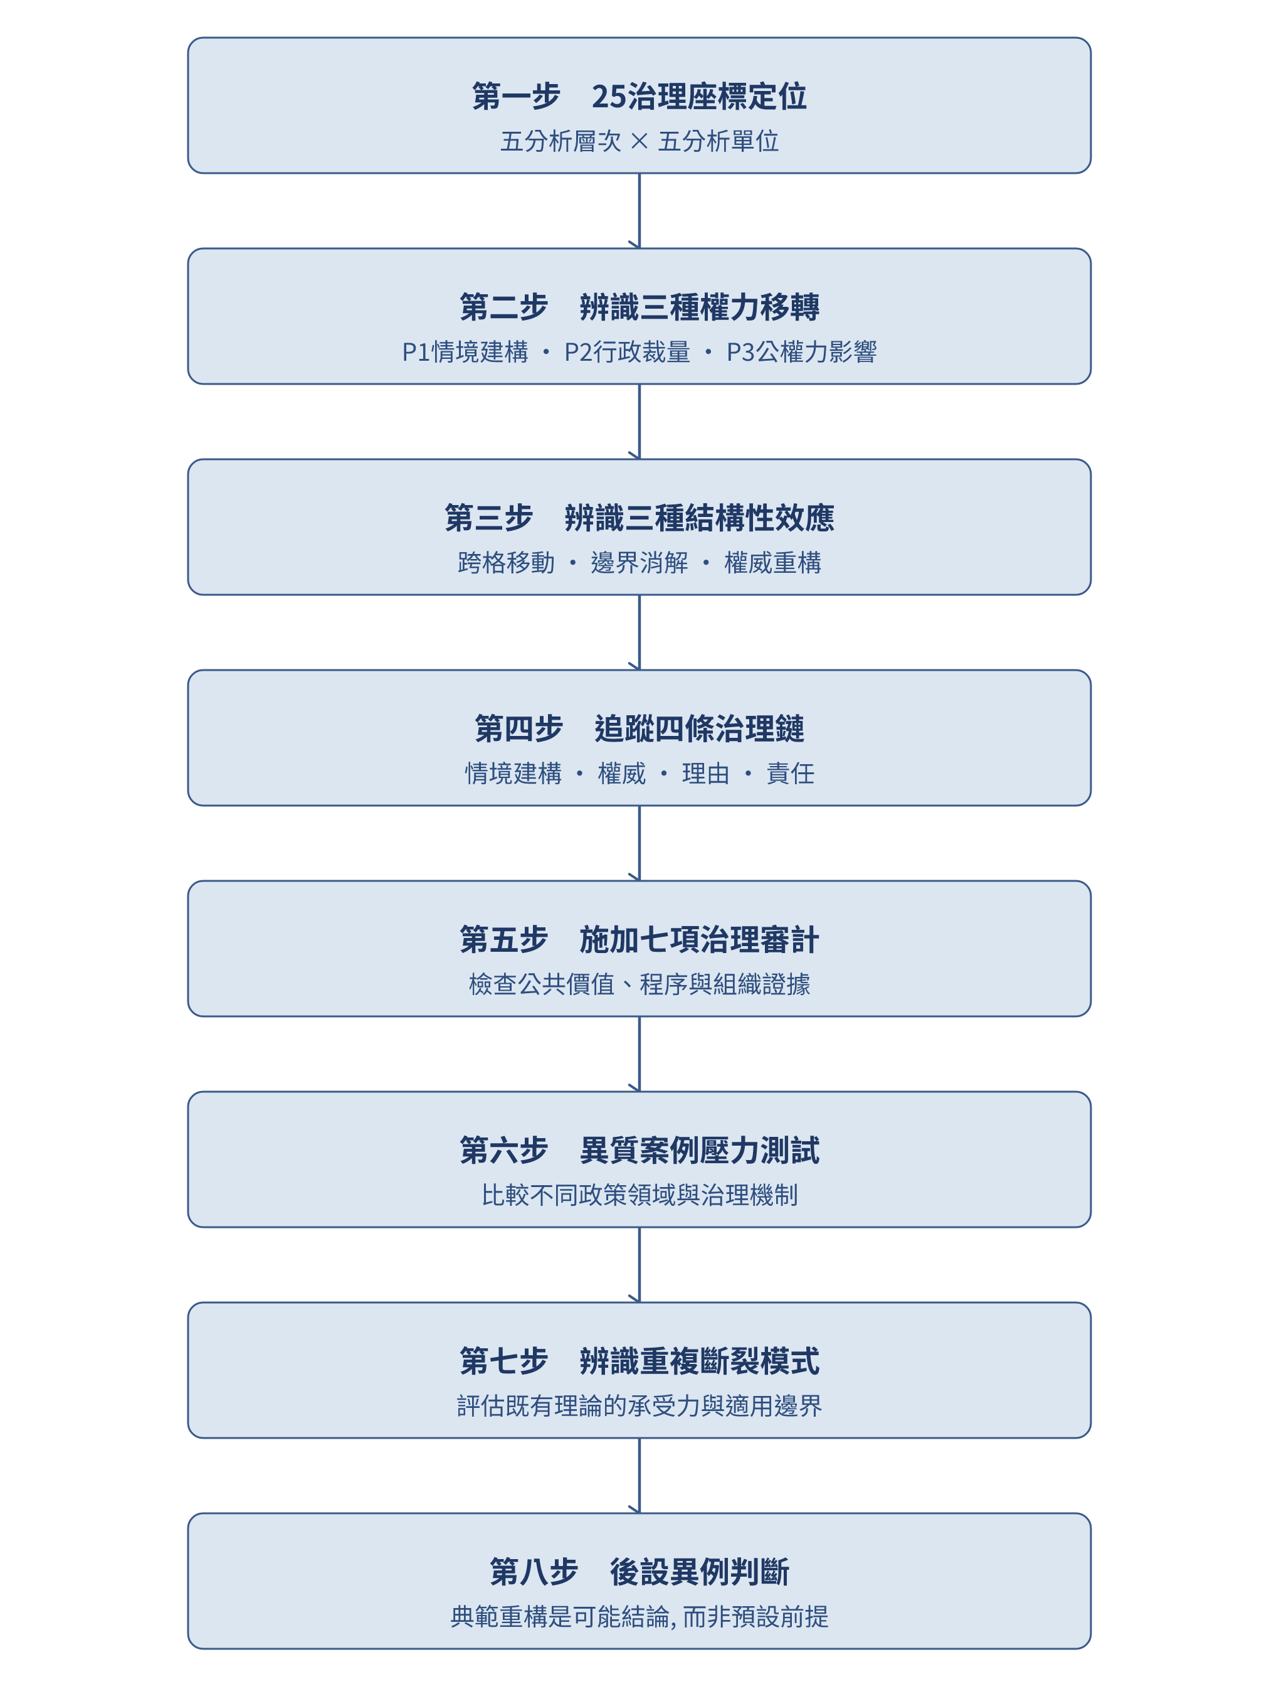
Figure 3.3 Research Design for the AI-Embedded Stress Test of Public Administration Theory
Source: constructed by the author.

3.8 From Conceptual Framework to Operable Coding and Evaluation Indicators
This framework also has the potential to be converted into a tool for quantitative research and governance evaluation, but its operationalization should not mechanically multiply the twenty-five coordinates by the seven audits into one hundred seventy-five fixed items. The twenty-five coordinates are first a classification system for case positioning and scope of exposure, recording the primary cell, secondary cells, and intensity of AI intervention; the three structural effects can then form dynamic indicators: cross-cell movement can be scored by the number of cells moved through, the theoretical-level distance, and the scope of influence; boundary dissolution can be scored by the overlap of human and AI roles, the coupling of policy and technical rules, and the degree of penetration of organizational boundaries; authority reconfiguration can be scored by the gap between formal authority and actual influence, dependence on external vendors, and the number of new actors involved.
The four governance chains can each establish a chain-integrity score, checking whether the source of context, statutory authorization, records of reasons, and named responsibility are traceable; the seven audits can adopt a 0-to-4 evidence-maturity scale, where 0 represents no institution or evidence, 1 represents a principled declaration, 2 represents a procedure that exists but is inconsistently implemented, 3 represents a stable procedure and record, and 4 represents external review, continuous monitoring, and remedial feedback. Each case thereby produces four sets of results—a coordinate-exposure profile, a structural-effects profile, four-chain integrity, and seven-audit maturity—rather than being compressed into a single overall score.
Subsequent development of a formal measurement tool could first use the Delphi method and cognitive interviews to confirm content validity, then use two independent coders across heterogeneous cases to test Cohen's kappa, the intraclass correlation coefficient, and inter-rater agreement; depending on the properties of the indicators, multilevel models, formative measurement models, or latent-class analysis could then be used to compare stress patterns across policy domains. Because most of this framework's indicators jointly “form” governance risk rather than being reflected by a single latent trait, future work should not rely solely on traditional internal-consistency coefficients to judge validity. What this article currently offers is an analytical record and a measurement blueprint, not a formal scale that has completed reliability and validity testing; its coding thresholds, weights, inter-rater agreement, and predictive validity still need to be established through subsequent empirical research. The dimensions, scoring questions, and endpoint definitions of the coding prototype are detailed in Table 3.5.
Code | Dimension | Core Scoring Question | Nature of Score | 0–4 Endpoints
S1 | Cross-Cell Movement | Does AI's influence extend from its original cell to other theoretical levels or units of analysis? | Risk | 0 = confined to a single cell; 4 = crosses multiple levels and units with institutional impact
S2 | Boundary Dissolution | Can human judgment, technical rules, organizational procedure, and policy formation be clearly distinguished? | Risk | 0 = roles and rules clear; 4 = decision role, rules, and responsibility substantively indistinguishable
S3 | Authority Reconfiguration | Do the formal statutory authority and the actor who actually influences the outcome coincide? | Risk | 0 = fully coincide; 4 = an external or technical actor substantively dominates with unclear authorization
C1 | Context-Construction Chain | Can problem definition, data inclusion, classification framework, and exclusion criteria be traced? | Integrity | 0 = no record; 4 = fully recorded, externally reviewed, and open to challenge
C2 | Authority Chain | Does each decision link have a clear legal source, scope of authorization, and named decision-maker? | Integrity | 0 = authority unclear; 4 = legal source, scope, decision-maker, and review level all complete
C3 | Reasoning Chain | Can the decision be connected back to facts, data, model version, norms, and value judgments? | Integrity | 0 = no comprehensible reason; 4 = reconstructable, comprehensible, contestable, and reviewable
C4 | Responsibility Chain | When error or harm occurs, is there someone responsible for answering, correcting, remedying, and bearing consequences? | Integrity | 0 = responsibility void; 4 = responsible party, procedure, remedy, and consequences all clear
A1 | Data Representativeness Audit | Is there evidence of data source, missing groups, labeling rules, and group error rates? | Maturity | 0 = no institution; 4 = continuous monitoring, external review, and revision based on results
A2 | Reason-Giving Audit | Are inputs, sources, prompts, model version, human review, and individual reasons preserved? | Maturity | 0 = no institution; 4 = fully documented, reviewable by affected parties and external bodies
A3 | Responsibility Attribution Audit | Are responsibilities for procurement, design, deployment, review, reporting, and remedy named? | Maturity | 0 = no institution; 4 = authority/responsibility complete, and accountability can actually be triggered after an incident
A4 | Privacy & Security Audit | Is there a legal basis, data classification, access control, logs, and vendor data-handling terms? | Maturity | 0 = no institution; 4 = continuous monitoring, independent testing, and complete incident response
A5 | Discretion Boundary Audit | Is the degree of AI involvement set according to rule clarity, rights impact, and reversibility? | Maturity | 0 = no boundary; 4 = risk tiering, substantive human judgment, and stop conditions all complete
A6 | Organizational Capacity Audit | Does the agency have training, monitoring, vendor management, complaint handling, and shutdown capacity? | Maturity | 0 = fully dependent on outsiders; 4 = can independently detect, explain, correct, and stop the system
A7 | Democratic Accountability Audit | Are the system's goals, effectiveness, harms, participation, external oversight, and remedy disclosed? | Maturity | 0 = no public scrutiny; 4 = regular disclosure, substantive participation, external oversight, and remedy all complete
Table 3.5 Coding Prototype for the Public Administration AI Governance Stress Test (PA-AIGST)
Note: S1–S3 are risk scores, where a higher score indicates greater structural stress; higher scores on C1–C4 and A1–A7 indicate greater governance integrity or evidence maturity. Because the three sets of scores point in different directions, they should be presented as separate profiles rather than summed before theoretical weights have been established. Intermediate levels follow general maturity anchors: 1 = principled declaration; 2 = partial procedure with inconsistent implementation; 3 = institutionalized procedure with stable records. The twenty-five governance coordinates are coded separately for case positioning and scope of exposure and are not folded into a single overall score.

4. A Typology of Applications for Generative-AI-Enabled Public Governance
Traditional AI applications in public governance were mostly confined to risk prediction from structured data; generative AI further penetrates the transformation and generation of unstructured material such as official documents, regulatory text, and citizen complaint emails. Building on the twenty-five governance coordinates proposed in Chapter 3, and focusing on the three analytical levels of “service delivery,” “policy formation,” and “internal administration,” this chapter constructs a “typology of generative AI applications in the public sector” to demonstrate the positioning capacity of the reconceptualized framework.

4.1 Service Delivery: Conversational Interaction, Language Equity, and Precision Benefit Delivery
Service-delivery applications mainly fall at “management operations × individual/group,” including conversational services, multilingual assistance, and preliminary application review. Their governance significance lies not in a list of functions but in how the system presets the range of permissible questions, handles personal data, and allocates human review and remedy; they should therefore be examined through the context-construction, data-representativeness, and discretion-boundary audits.

4.2 Policy Formation: Large-Scale Textual Analysis, Policy Simulation, and Forecasting
Policy-formation applications mainly fall at “policy system × group/society,” used for analyzing public-opinion text, comparing regulations, and simulating policy. AI's summarization and classification affect which opinions become policy-relevant information, so records of data selection, prompts, model version, and human judgment must be preserved to examine the context-construction and reasoning chains.

4.3 Internal Administration: Drafting Official Documents, Knowledge Management, and Decision Support
Internal-administration applications mainly fall at “organizational design/management operations × organization,” including drafting official documents, RAG-based knowledge retrieval, and decision support. Their risks concentrate on confidential data, erroneous content, and organizational dependence, and should be jointly examined through the privacy-and-security, reason-giving, and organizational-capacity audits.

4.4 Summary: Coordinate Positioning and Governance Implications of the Application Typology
Comparative Dimension | Service Delivery (Management Operations × Individual/Group) | Policy Formation (Policy System × Group/Society) | Internal Administration (Organizational Design/Management Operations × Organization)
Main Subjects | General citizens, businesses, and vulnerable groups | Policymakers, researchers, and decision-making levels | Internal civil servants, front-line officials
Core Technical Application | Intelligent dialogue, real-time multilingual translation | Large-scale text summarization, semantic argument analysis | RAG knowledge-base retrieval, draft document generation
Main Governance Value | Service responsiveness, digital inclusion, reduced administrative burden | Data-driven decision-making, increased public participation | Reduced cognitive load, administrative efficiency and consistency
Key Challenges and Risks | Model hallucination leading to erroneous guidance | Oversimplification of data, biased sampling of digital public opinion | Information-security leaks, civil servants' over-reliance
Potential Risk in the Context-Construction Chain | The dialogue system's preset question-and-answer range already frames what citizens can ask | What AI's summarization includes or omits determines which opinion is treated as mainstream | The ranking of knowledge-base retrieval determines which precedents and grounds civil servants can see
Human-in-the-Loop (HITL) Requirement | Medium to high (requires real-time correction mechanisms) | High (requires expert judgment to assess feasibility) | Low to medium (focused on final approval and regulatory comparison)
Table 4.1 Coordinate Positioning and Academic Comparison of Three Major Types of Generative AI Application in the Public Sector
Although the three application types belong to different governance coordinates, they collectively point toward the institutional stress examined in the next chapter: as AI's unit of analysis extends from the organization to the individual and societal levels, do existing mechanisms of representative bureaucracy, accountability, and organizational capacity remain sufficient to withstand this structural shock? The additional row in Table 4.1, “potential risk in the context-construction chain,” also shows that all three application types embed some degree of framing power—this observation forms the analytical starting point of Chapter 5, Section 1.

5. Institutional Barriers as a Governance-Chain Stress Test
This chapter uses public documents from governments, courts, and royal commissions of inquiry to demonstrate how the four governance chains and seven audits can be applied to automated decision-making; because no interviews, fieldwork, or primary-data analysis were conducted, what follows is mechanism identification rather than a complete case evaluation. Representative bureaucracy theory offers an institutional reference point: administrative discretion must be able to respond to the interests of plural groups (Kingsley, 1944; Meier, 2019); if discretion is pre-framed by data and models, even preserved human review may compress the substantive space for active representation.

5.1 AFST: Datafied Risk and the Context-Construction Chain
Allegheny County, Pennsylvania, has used the AFST since 2016, generating child-welfare hotline risk scores from cross-system administrative data; public documents themselves acknowledge limitations in identity matching and shifts in underlying data (Allegheny County Department of Human Services, 2017, 2018). Its primary coordinate is “management operations × individual/family,” but because data fields, labels, and thresholds predefine risk, it also moves upward to “policy system × society.” The context-construction chain requires asking which administrative contacts are translated into a risk score and which family experiences are never datafied; the data-representativeness audit examines data source, gaps, and group error rates, while the discretion-boundary audit examines whether a high score becomes a preset that is difficult to overturn. If human review is merely formal, the substantive space for front-line social workers to actively represent a family's circumstances through professional judgment may be compressed (O'Neil, 2016; Selbst et al., 2019).

5.2 SyRI: Statutory Authority, Proportionality, and Privacy
The Netherlands' SyRI has, since 2014, merged administrative data from multiple sources to detect risk of welfare, tax, and labor-law fraud, and was preferentially deployed in low- and middle-income neighborhoods. The District Court of The Hague ruled in 2020 that its regulatory basis failed to strike a fair balance between the interest in preventing fraud and the right to private life, in violation of Article 8 of the European Convention on Human Rights (District Court of The Hague, 2020; Rachovitsa & Johann, 2022). Its coordinate is “institutional division of labor × individual/society”: the authority chain examines whether statutory authorization can support cross-agency data processing, while the context-construction chain asks why particular communities became priority targets for review. The privacy-and-security audit must examine necessity, proportionality, and traceability, while the democratic-accountability audit examines whether the model, risk indicators, and remedy are subject to external review. This case shows that having a legal basis does not equate to a complete governance chain.

5.3 Robodebt: A Cascading Failure of the Reasoning and Responsibility Chains
Australia's Robodebt scheme used income averaging and automated processes to generate welfare debts. The Federal Court found the relevant debts to lack legal force; a Royal Commission subsequently found that the scheme continued to operate without a lawful basis, revealing a cascading failure of legal advice, internal warnings, organizational culture, and political and administrative accountability (Prygodicz v Commonwealth of Australia (No 2), 2021; Royal Commission into the Robodebt Scheme, 2023). Its coordinate moves from “management operations × individual” to “institutional division of labor × society.” The reasoning chain requires that every debt be connected back to individual income facts and norms, and must not substitute statistical estimation for individualized reasons; the responsibility chain must identify named responsibility at each link—rule design, legal review, execution, notification, and appeal. The reason-giving, responsibility-attribution, and organizational-capacity audits jointly examine the factual and legal basis, reporting records, and stop mechanisms. This case shows that a human signature or a formal appeals process is not sufficient to repair a break in reasoning and responsibility that originates at the rule-coding stage.

5.4 Cross-Context Comparison: The Seven Audits and Governance Evidence
Taiwan's Executive Yuan Reference Guidelines on the Use of Generative AI require personnel to make the final judgment, verify output, protect confidential data, and maintain accountability and human control (Executive Yuan, 2023). Its analytical value lies in showing how preventive controls correspond to authority and discretion boundaries, reason verification, privacy and security, and the responsibility chain. From an end-to-end audit perspective, governance evidence must cover goals, data, development, deployment, monitoring, and incident handling, and must be able to answer where AI intervenes, who reviews it, how remedy is provided, and when it is stopped (Raji et al., 2020).

5.5 Recurring Failure Patterns: Cross-Cell Movement, Boundary Dissolution, and Authority Reconfiguration
The cross-context comparison reveals three possible recurring failure patterns: cross-cell movement, in which the cumulative effect of a management tool moves upward into the policy, institutional, and value levels; boundary dissolution, in which policy analysis, administrative execution, and technical design become difficult to clearly distinguish; and authority reconfiguration, in which model vendors, data engineers, and system integrators acquire substantive influence, separating statutory authority from actual decision-making power. The entry of new actors is the mechanism through which authority reconfiguration forms, not a parallel fourth phenomenon. Only when these patterns recur across heterogeneous cases do they constitute evidence for theoretical reconstruction.

5.6 Summary: The Theoretical Limits of the Demonstration Stress Test
This chapter has completed a demonstration stress test: twenty-five-coordinate positioning, four-chain tracing of legitimacy, and seven-audit specification of evidence. The three cases reveal possible rupture mechanisms, but are not yet sufficient to prove a paradigm shift; subsequent work must test these findings against decision records, interviews, error rates, appeals, and contract data.

6. Policy Translation of the Discretion-Boundary Audit: A Human–AI Collaborative Governance Matrix and Strategic Recommendations
This article argues that government adoption of AI must follow a “principle of proportionality between rights protection and risk,” building a governance framework that balances “technical efficiency” with “democratic values.” This chapter does not propose another separate theoretical model; rather, it translates Chapter 3's discretion-boundary audit into a policy instrument. The two-axis matrix helps agencies allocate the degree of human involvement according to discretion intensity and rights impact; its legitimacy must still be jointly examined by the four governance chains and the other six audits.

6.1 A Human–AI Collaborative Framework: Delineating “Human Involvement” and the Boundary of Discretion
This research proposes a “Human–AI Collaborative Intelligent Governance Matrix” built on the two axes of “intensity of task discretion” and “severity of citizen-rights impact,” dividing application domains into four risk tiers:
Citizen-Rights Impact \ Task Discretion | Low Discretion | High Discretion
High Impact | Quadrant IV: Supervised Backup Zone (exception-based human review) | Quadrant I: Red-Line Control Zone (mandatory substantive review / Human-in-Command)
Low Impact | Quadrant III: Autonomous Assistance Zone (automated AI generation / Human-on-the-Loop) | Quadrant II: Strict Control Zone (final human sign-off / Human-in-Command)
Table 6.1 The Human–AI Collaborative Intelligent Governance Matrix
1. Quadrant I (Red-Line Control Zone: high discretion / high impact): involves deprivation of welfare benefits, severe tax penalties, or judicial assessment. Mandatory substantive human involvement (HITL) and human command (Human-in-Command) apply; AI serves only an assistive role with no default legal effect, and human civil servants bear full responsibility.
2. Quadrant II (Strict Control Zone: high discretion / low impact): such as drafting policy proposals and checking for regulatory conflicts. Human review (HITL) is adopted, with civil servants exercising professional judgment for fact-checking and value balancing.
3. Quadrant III (Autonomous Assistance Zone: low discretion / low impact): such as converting the format of official documents or internal RAG retrieval. A high degree of human-on-the-loop (HOTL) automation is permitted, with humans conducting only periodic sample audits.
4. Quadrant IV (Supervised Backup Zone: low discretion / high impact): such as preliminary review of standardized public-service applications. Exception-based human involvement is adopted; the system processes automatically but an unconditional channel for escalation to full manual re-review must be established.

6.2 Regulatory Mechanism Design: Ethical Review, Regulatory Sandboxes, and Dynamic Algorithmic Auditing
Establishing a “Public AI Ethics Review Board”: mandating that high-risk AI systems pass a cross-disciplinary review before launch, substantively corresponding to Chapter 3's democratic-accountability audit; the review process should also examine the system's context-construction chain—that is, whether its choice of training data, prompt templates, and preset filtering logic has already narrowed the range of problems a decision can reach.
Promoting a “Public Governance Regulatory Sandbox”: piloting innovative AI applications for a limited time in specific areas, collecting bias data for dynamic correction, corresponding to the continuous implementation of the data-representativeness audit.
Implementing “Dynamic Algorithmic Auditing and Explainability Labeling”: periodically testing for data drift and clearly labeling all AI-generated output with an “AI-assisted generation” tag, corresponding to the institutionalization of the reason-giving audit.

6.3 Organizational Momentum and Capacity Building for Digital Transformation
Based on dynamic capabilities theory (Teece et al., 1997), government should promote “dual-track AI literacy” among civil servants (operational capability and critical capacity for algorithmic auditing); establish cross-disciplinary intelligent governance teams to break down information silos; and cultivate an organizational culture of “responsible innovation” and tolerance for experimentation—this corresponds to an institutional response to Chapter 3's organizational-capacity audit.
Figure 6.1 synthesizes the overall relationship among the twenty-five governance coordinates, three functional transfers of administrative power, three structural effects, four governance chains, and seven governance audits developed across the preceding chapters.
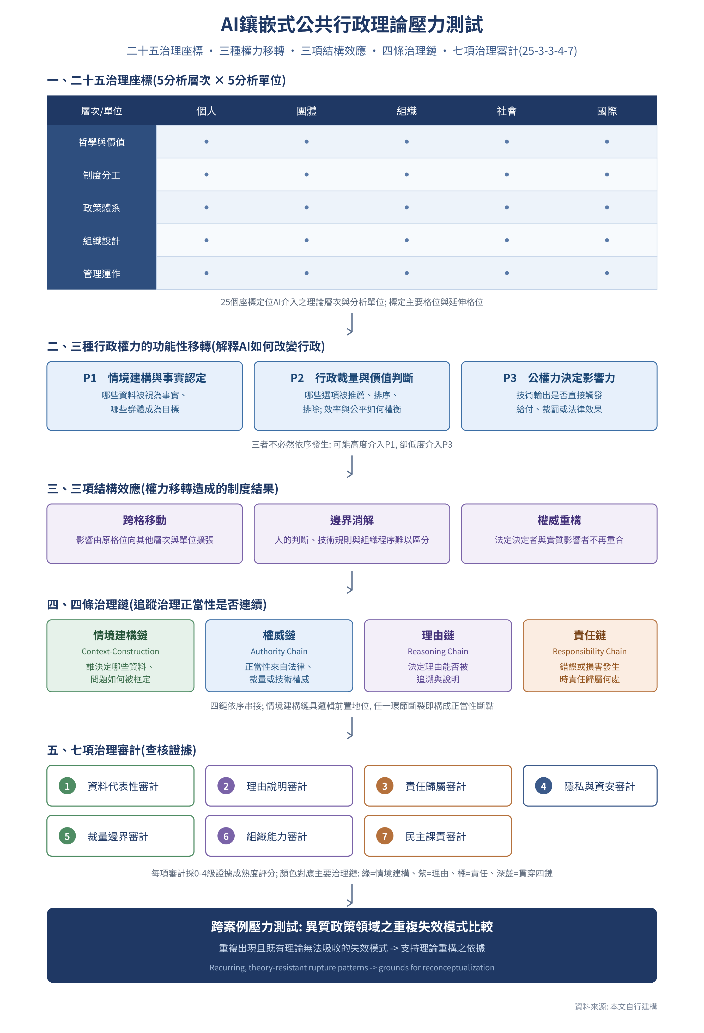
Figure 6.1 Overall Framework of the 25-3-3-4-7 Model
Source: constructed by the author.

7. Conclusion and Future Directions

7.1 Summary: From Dialectic to Synthesis
The framework proposed here integrates existing AI governance research into a stress test of public administration theory: locating where AI intervenes using the twenty-five governance coordinates, tracing legitimacy along the four chains of context construction, authority, reasoning, and responsibility, specifying auditable evidence through the seven governance audits, and then comparing across heterogeneous cases whether cross-cell movement, boundary dissolution, and authority reconfiguration recur. The document-based demonstrations of AFST, SyRI, and Robodebt show that technological intervention can cause problem framing, actual authority, decision reasoning, and responsibility to become separated from one another.

7.2 Academic and Practical Contributions
This analysis offers value for both research and practice. On the research side, it integrates existing work on multi-level governance, policy framing, artificial discretion, algorithmic accountability, public legitimacy, and layered auditing into a stress-testing procedure of “coordinate positioning — structural-effect identification — governance-chain tracing — seven audits — cross-case comparison,” allowing different policy domains to accumulate comparable evidence using a shared vocabulary. Its contribution lies in conceptual integration, a measurement blueprint, and testable propositions; it is not yet sufficient, on its own, to claim that a paradigm shift has occurred in public administration. On the practical side, this framework can be developed into a diagnostic and evaluation tool for government agencies' AI governance, separately presenting coordinate exposure, structural effects such as cross-cell movement and boundary dissolution, four-chain integrity, and seven-audit maturity, helping agencies identify whether a problem lies in data, procedure, authority, organizational capacity, or democratic accountability, rather than producing only a single score with no diagnostic meaning.
Public governance cannot substitute technical optimization for the balancing of public values. AI can serve as an administrative aid, but its factual influence must remain subject to continuous checking by statutory authority, comprehensible reasons, named responsibility, human involvement, and democratic accountability.

7.3 Research Limitations and Recommendations for Future Research
This article has not collected agency decision records, interviews, error rates, or appeal data, and cannot yet estimate external validity or claim that the seven audits already possess scale-level reliability and validity. Subsequent research must use heterogeneous cases to revise the boundaries of the coordinates, the indicators of the governance chains, and the thresholds for rupture, and to develop deployable audit tools.
1. Empirical research and quantitative surveys: using questionnaires or in-depth interviews to empirically examine front-line civil servants' (street-level bureaucrats') psychological resistance, automation bias, and shifts in discretion when actually using generative AI, and using this to test the reliability and validity of the seven governance audits.
2. Cross-national comparative research: comparing institutional differences and governance outcomes in public-sector AI regulatory frameworks and human–AI division of labor across the EU (e.g., under the AI Act), the United States, and Asian governments, thereby testing the applicability of the twenty-five governance coordinates across different governance contexts.
3. Longitudinal tracking and development of governance-chain audit tools: conducting long-term longitudinal tracking of public AI systems already in operation, examining the long-term impact of algorithmic bias and drift on the rights of specific vulnerable groups, and developing deployable audit tools for the context-construction chain and other governance chains.
4. Comparative stress testing across heterogeneous cases: future research could select contexts such as police use of force, welfare eligibility and benefits, personnel evaluation, administrative penalties, environmental regulation, healthcare administration, and national security, comparing which governance chains repeatedly rupture and whether cross-cell movement, boundary dissolution, and authority reconfiguration (including technology vendors and data professionals acquiring de facto influence) form a stable pattern.

References

Chinese-Language Literature
Ding, Y.-C., & Lin, T.-L. (2020). An exploration of the application potential of artificial intelligence in enhancing government public governance [in Chinese]. Archives Semiannual, 19(2), 24–41.
Executive Yuan. (2023). Reference guidelines for the use of generative AI by the Executive Yuan and its subordinate agencies [in Chinese]. https://www.ey.gov.tw/Page/448DE008087A1971/40c1a925-121d-4b6b-8f40-7e9e1a5401f2
Lee, L.-W., Chu, P.-Y., & Tseng, H.-L. (2023). Key factors driving government data governance: A causal model from the internal stakeholders' perspective [in Chinese]. Journal of Public Administration, 64, 35–77. https://doi.org/10.30409/JPA.202303_(64).0002
Lee, T.-P., Chang, C.-Y., & Li, C.-L. (2022). Unintended discrimination in the application of artificial intelligence in public policy: A systematic literature review [in Chinese]. Journal of Public Administration, 63, 1–49. https://doi.org/10.30409/JPA.202209_(63).0001
Chang, P.-H., Chen, D.-Y., Liao, C.-P., Huang, H.-Y., Wang, C.-W., Chang, Y.-H., & Chen, Y.-H. (2024). A study of institutional design strategies and regulatory adaptation for public services under the AI wave [in Chinese]. Journal of Public Administration and Policy, 78, 95–126. https://doi.org/10.29865/PAP.202406_(78).0004
Lu, C.-H. (1996a). A literature review framework for public administration [in Chinese]. NOU Journal of Public Administration, 5, 177–210.
Lu, C.-H. (1996b). New issues for public administration in the information society [in Chinese]. Taiwan Journal of Political Science, 7, 231–256.
Tseng, H.-L., Liao, C.-P., & Lee, T.-S. (2022). Models and application cases of public–private data collaboration: An analysis of collaboration mechanisms [in Chinese]. Journal of Public Administration, 62, 43–77.
Huang, H.-Y., Tseng, K.-C., Liao, C.-P., & Chen, D.-Y. (2021). When artificial intelligence enters government: Reflections on public administration theory's response to AI [in Chinese]. Civil Service Review, 13(2), 91–114.
Huang, H.-Y., & Chen, D.-Y. (2023). Public administration research under AI collaboration: A multi-level reflection on public-sector organizational issues [in Chinese]. Taiwan Journal of Political Science, 96, 139–178. https://doi.org/10.6166/TJPS.202306_(96).0004
Liao, H.-C. (2024). Opportunities and challenges of artificial intelligence in public administration [in Chinese]. Civil Service Review, 16(2), 1–20.
Hsiao, N.-Y., & Chu, P.-Y. (2022). Digital development and civil service adaptation: The case of data governance [in Chinese]. Civil Service Review, 14(1), 1–24.

English-Language Literature
Alston, P. (2019). Report of the Special Rapporteur on extreme poverty and human rights (A/74/48037). United Nations General Assembly.
Allegheny County Department of Human Services. (2017). Developing predictive risk models to support child maltreatment hotline screening decisions. https://analytics.alleghenycounty.us/wp-content/uploads/2017/04/Developing-Predictive-Risk-Models-package-with-cover-1-to-post-1.pdf
Allegheny County Department of Human Services. (2018). Allegheny Family Screening Tool: Frequently asked questions. https://analytics.alleghenycounty.us/wp-content/uploads/2018/10/17-ACDHS-11_AFST_102518.pdf
Bovens, M. (2007). Analysing and assessing accountability: A conceptual framework. European Law Journal, 13(4), 447–468. https://doi.org/10.1111/j.1468-0386.2007.00378.x
Bovens, M., & Zouridis, S. (2002). From street-level to system-level bureaucracies: How information technology is transforming administrative discretion. Public Administration Review, 62(2), 174–184.
Busuioc, M. (2021). Accountable artificial intelligence: Holding algorithms to account in public administration. Public Administration Review, 81(5), 825–836.
Cleveland, H. (1985). The twilight of hierarchy: Speculations on the global information society. Public Administration Review, 45(1), 185–195.
Cobbe, J., Lee, M. S. A., & Singh, J. (2021). Reviewable automated decision-making: A framework for accountable algorithmic systems. Proceedings of the 2021 ACM Conference on Fairness, Accountability, and Transparency, 598–609. https://doi.org/10.1145/3442188.3445921
Cobbe, J., Veale, M., & Singh, J. (2023). Understanding accountability in algorithmic supply chains. Proceedings of the 2023 ACM Conference on Fairness, Accountability, and Transparency, 1186–1197. https://doi.org/10.1145/3593013.3594073
Criado, J. I., Sandoval-Almazán, R., & Gil-Garcia, J. R. (2025). Artificial intelligence and public administration: Understanding actors, governance, and policy from micro, meso, and macro perspectives. Public Policy and Administration, 40(2), 173–184.
Davis, F. D. (1989). Perceived usefulness, perceived ease of use, and user acceptance of information technology. MIS Quarterly, 13(3), 319–340.
District Court of The Hague. (2020). NJCM c.s./De Staat der Nederlanden (SyRI) [Judgment].
Dunleavy, P., Margetts, H., Bastow, S., & Tinkler, J. (2006). New public management is dead—long live digital-era governance. Journal of Public Administration Research and Theory, 16(3), 467–494.
Dunleavy, P., & Margetts, H. (2023). Data science, artificial intelligence and the third wave of digital era governance. Public Policy and Administration, 40(2), 185–214.
Eggers, W. D., Schatsky, D., & Viechnicki, P. (2017). AI-augmented government: Using cognitive technologies to redesign public sector work. Deloitte Center for Government Insights.
Engin, Z., Crowcroft, J., Hand, D. J., & Treleaven, P. (2025). Algorithmic government: A four-layer framework for AI in public governance [Preprint].
Floridi, L., Cowls, J., Beltrametti, M., et al. (2018). AI4People—An ethical framework for a good AI society: Opportunities, risks, principles, and recommendations. Minds and Machines, 28, 689–707.
Gasser, U., & Almeida, V. A. F. (2017). A layered model for AI governance. IEEE Internet Computing, 21(6), 58–62.
Grimmelikhuijsen, S., & Meijer, A. (2022). Legitimacy of algorithmic decision-making: Six threats and the need for a calibrated institutional response. Perspectives on Public Management and Governance, 5(3), 232–242.
Hood, C. (1991). A public management for all seasons? Public Administration, 69(1), 3–19.
Janssen, M. (2025). Generative AI as a complex adaptive system in public administration. Government Information Quarterly (forthcoming).
Kingsley, J. D. (1944). Representative bureaucracy: An interpretation of the British civil service. Antioch Press.
Lipsky, M. (1980). Street-level bureaucracy: Dilemmas of the individual in public services. Russell Sage Foundation.
Madaio, M. A., Stark, L., Wortman Vaughan, J., & Wallach, H. (2020). Co-designing checklists to understand organizational challenges and opportunities around fairness in AI. Proceedings of the 2020 CHI Conference on Human Factors in Computing Systems, 1–14.
Margetts, H., & Dunleavy, P. (2013). The second wave of digital-era governance: A quasi-paradigm for government on the web. Philosophical Transactions of the Royal Society A, 371(1987), 20120382.
Meier, K. J. (2019). Theoretical frontiers in representative bureaucracy: New directions for research. Perspectives on Public Management and Governance, 2(1), 39–56.
Mökander, J., Schuett, J., Kirk, H. R., & Floridi, L. (2024). Auditing large language models: A three-layered approach. AI and Ethics, 4, 1085–1115.
O'Neil, C. (2016). Weapons of math destruction: How big data increases inequality and threatens democracy. Crown.
Prygodicz v Commonwealth of Australia (No 2) [2021] FCA 634.
Rachovitsa, A., & Johann, N. (2022). The human rights implications of the use of AI in the digital welfare state: Lessons learned from the Dutch SyRI case. Human Rights Law Review, 22(2), 1–25.
Raji, I. D., Smart, A., White, R. N., et al. (2020). Closing the AI accountability gap: Defining an end-to-end framework for internal algorithmic auditing. Proceedings of the 2020 Conference on Fairness, Accountability, and Transparency, 33–44.
Romzek, B. S., & Dubnick, M. J. (1987). Accountability in the public sector: Lessons from the Challenger tragedy. Public Administration Review, 47(3), 227–238.
Royal Commission into the Robodebt Scheme. (2023). Report. Commonwealth of Australia.
Selbst, A. D., Boyd, D., Friedler, S. A., Venkatasubramanian, S., & Vertesi, J. (2019). Fairness and abstraction in sociotechnical systems. Proceedings of the Conference on Fairness, Accountability, and Transparency, 59–68.
Tallberg, J., Erman, E., Furendal, M., et al. (2023). The global governance of artificial intelligence: Next steps for empirical and normative research. Perspectives on Politics, 21(4), 1275–1293.
Teece, D. J., Pisano, G., & Shuen, A. (1997). Dynamic capabilities and strategic management. Strategic Management Journal, 18(7), 509–533.
Tornatzky, L. G., & Fleischer, M. (1990). The processes of technological innovation. Lexington Books.
Treasury Board of Canada Secretariat. (2024). Directive on Automated Decision-Making. Government of Canada.
Ulnicane, I., Knight, W., Leach, T., Stahl, B. C., & Wanjiku, W.-G. (2021). Framing governance for a contested emerging technology: Insights from AI policy. Policy and Society, 40(2), 158–177.
U.S. Government Accountability Office. (2021). Artificial intelligence: An accountability framework for federal agencies and other entities (GAO-21-519SP).
Valle-Cruz, D., Criado, J. I., Sandoval-Almazán, R., & Ruvalcaba-Gomez, E. A. (2020). Assessing the public policy-cycle framework in the age of artificial intelligence. Government Information Quarterly, 37(4), 101509.
Veale, M., & Brass, I. (2019). Administration by algorithm? Public management meets public sector machine learning. In K. Yeung & M. Lodge (Eds.), Algorithmic regulation (pp. 121–149). Oxford University Press.
Wieringa, M. (2020). What to account for when accounting for algorithms: A systematic literature review on algorithmic accountability. Proceedings of the 2020 Conference on Fairness, Accountability, and Transparency, 1–18.
Wirtz, B. W., Weyerer, J. C., & Sturm, B. J. (2020). The dark sides of artificial intelligence: An integrated AI governance framework for public administration. International Journal of Public Administration, 43(9), 818–829.
Wirtz, B. W., Weyerer, J. C., & Kehl, I. (2022). Governance of artificial intelligence: A risk and guideline-based integrative framework. Government Information Quarterly, 39(4), 101685.
Yeung, K. (2018). Algorithmic regulation: A critical interrogation. Regulation & Governance, 12(4), 505–523.
Young, M. M., Bullock, J. B., & Lecy, J. D. (2019). Artificial discretion as a tool of governance: A framework for understanding the impact of artificial intelligence on public administration. Perspectives on Public Management and Governance, 2(4), 301–313.
Zhu, L. (2025). Public administration with, of, and through AI: Toward a paradigm framework. Public Administration Review (forthcoming).
Zuiderwijk, A., Chen, Y.-C., & Salem, F. (2021). Implications of the use of artificial intelligence in public governance: A systematic literature review and a research agenda. Government Information Quarterly, 38(3), 101577.

