Generative AI-Assisted Research Workflows:
Applications, Risks, and Accountability in Public Administration
Conceptual Framework, Cyclical Review, and Non-Delegable Responsibilities
生成式人工智慧協作研究流程：公共行政中的應用、風險與責任治理
概念架構、循環查核與不可讓渡責任
Lancelot Lu 盧建旭
Doctor of Public Administration, University of Southern California, USA
jslu2020@gmail.com；jyanshiulu@gmail.com
lancelotlu.org
AI Use Disclosure | Level 2. The research question, theoretical judgments, literature selection, and final text are the author’s responsibility. Generative AI was used for literature organization, structural discussion, draft tables, figure organization, and language editing. All citations and central claims were checked against original sources by the author. AI is not listed as an author and bears no academic or legal responsibility.

Abstract
Generative AI has entered public administration research and government practice, delivering efficiency gains while also introducing risks such as hallucinated citations, content homogenization, data leakage, and blurred lines of accountability. Drawing on conceptual construction and a problematizing literature review, this article takes Gasser and Almeida’s (2017) three-layer governance model as its starting point and adopts and extends Wirtz et al.’s (2020) five-domain governance framework. Integrating their perspectives on AI risks and regulation, it forms an expanded set of five governance domains—technology and services, generative challenges, law and regulation, public policy, and collaboration—and identifies three structural effects: cross-coordinate movement, boundary dissolution, and authority reconfiguration. Crossing the five governance domains with the four stages of ideation, execution, validation, and dissemination produces a cyclical review matrix. The analysis shows that these three effects allow risks and impacts to cut across established categories, obscure the human–AI division of labor, and reconfigure authority from a single formal positional source into a chain linking situational framing, model influence, human review, and lawful adjudication. Responsibility remains with human researchers or public organizations throughout, yet the content of that responsibility shifts along the workflow from problem ownership and evidence stewardship to final adjudication and public disclosure. On this basis, the article proposes three non-delegable responsibilities, criteria for identifying the structural effects, and principles for graded disclosure and review, offering a conceptual foundation for subsequent empirical research and organizational rule design.
Keywords: generative AI; human–AI collaboration; cross-coordinate movement; cyclical review; academic accountability

1. Introduction

1.1 Background and Motivation
Since late 2022, generative AI has rapidly entered literature organization, draft writing, and policy text processing in public administration research and practice. It can raise efficiency, but it also brings fabricated citations, content homogenization, and the question of who should be responsible for the resulting text. Research and official documents can no longer be assumed to be produced entirely by humans working alone; yet machine output still must not be finalized without verification.
While encouraging the use of GenAI, governments simultaneously face governance and accountability disputes. The U.S. Office of Management and Budget (OMB, 2024) issued guidance urging agencies to experiment cautiously with AI, and several countries have built government-facing assistants. Yet cases in which erroneous rulings or fabricated data have entered formal documents show that once a tool enters the workflow, accountability problems follow. For public administration, GenAI is not merely convenient software; it also participates in problem definition, evidence organization, and external communication. Sound governance can realize its benefits; the absence of management may just as easily amplify its risks.
For researchers, the pressure to produce academic output remains intense, and the efficiency GenAI offers may create temptations that compromise research integrity. Researchers can use it to accelerate literature review and writing, but journals and scholarly associations simultaneously require disclosure of its use and acceptance of responsibility. The issue is not whether AI is used, but whether, after it is used, the researcher still retains judgment and completes the necessary verification.
Existing discussions of AI governance mostly start from more traditional discriminative AI, typically assuming that technology can be classified, risk can be inventoried, and collaboration occurs primarily among people. Gasser and Almeida’s (2017) three-layer governance model addresses AI governance from the technical, ethical, and social/legal levels, helping to clarify interdependence among levels; Wirtz et al. (2020) further distinguish AI technology and services, AI challenges, the regulatory process, public policy, and collaborative governance. The generativity, versatility, and interactivity of GenAI, however, expose these frameworks’ existing categories to new cross-domain and accountability problems.
Specifically, GenAI subjects existing layered governance to three structural effects. First, cross-coordinate movement: GenAI’s inputs, outputs, and effects move among the domains of technology, risk, regulation, policy, and collaboration, and may also move back and forth among the stages of ideation, execution, validation, and dissemination. Second, boundary dissolution: GenAI destabilizes the boundaries between tool and service, retrieval and generation, data and argument, and human researcher and assistive tool. Third, authority reconfiguration: although the model bears no legal or ethical responsibility, it can acquire real influence—comparable to that of an expert—through situational framing, information ranking, and suggestion generation, reconfiguring authority from a single statutory positional source into a chain linking situational framing, model influence, human review, and lawful adjudication. Governance problems therefore involve not only the separation of formal authority from actual influence, but also how new actors enter the process of authority formation and whether their influence can still be connected back to democratic authorization, reason-giving, and responsibility.
Accordingly, this article does not apply any existing framework to GenAI wholesale. It first clarifies the original analytical levels of those frameworks and then reorganizes the governance problem around the research workflow. Its core position is that AI may participate in operations and assist in verification, but the choice of problem, judgment of evidence, gatekeeping of data, and final determination must not be transferred to an unaccountable model.
Concerns about information quality, citation norms, and public responsibility amid technological change have long existed in Taiwanese public administration research (Lu, 1996a, 1996b, 1997). GenAI causes these problems to reappear at greater speed and scale, making the preservation of human critical judgment and final responsibility a central governance concern.
This article was completed before Lu’s (2026) shared “25–3–3–4–7” framework—twenty-five governance coordinates, three functional shifts in administrative power, three structural effects, four governance chains, and seven governance audits—was formulated. It therefore does not use the twenty-five governance coordinates, the three functional shifts, or the four governance chains as its analytical backbone; instead, it engages primarily with Gasser and Almeida’s (2017) three-layer model and Wirtz et al.’s (2020) five-domain framework. The three structural effects used here—cross-coordinate movement, boundary dissolution, and authority reconfiguration—are earlier formulations arising from the same problem consciousness. This article’s five-governance-domain × four-stage cyclical review matrix is an independent analytical tool focused on research-workflow governance. It should not be substituted for, or treated as directly corresponding to, the twenty-five governance coordinates.

1.2 Research Questions and Purpose
Building on the foregoing premises, this article poses three interrelated questions.
First, how does GenAI actually enter the research and practice workflows of public administration? The analysis observes four stages—ideation, execution, validation, and dissemination—focusing not on cataloguing scattered techniques but on how roles, risks, and responsibility move within the workflow.
Second, when Gasser and Almeida’s (2017) three-layer AI governance model is used to explain this workflow, what is its scope and what are its limits? The analysis examines whether technology and services can be clearly distinguished, whether existing frameworks adequately cover generative risks, and how the collaboration layer handles human–AI responsibility.
Third, if these limitations are acknowledged, how should governance be adjusted using cross-coordinate movement, boundary dissolution, and authority reconfiguration as criteria? For example, human–AI verification checkpoints could be built into the workflow, and applications, risks, evidence, and responsibility could be integrated into an operable checklist for universities, government agencies, and journals.
This article has three aims: first, to describe the applications and risks present in the workflow; second, to offer a grounded critique and extension of existing governance frameworks; and third, to propose responsible-use guidance of practical reference value. It aims to establish a concept-level starting point open to discussion and revision, rather than to offer a fixed answer detached from context.

1.3 Method and Scope
The framework proposed here adopts a conceptual construction method combined with a problematizing review of the literature, following the problematizing logic emphasized by Alvesson and Sandberg (2020). It examines the basic assumptions of existing AI governance frameworks and forms analytical propositions through conceptual comparison and critical reconstruction. It aims to offer a framework that can be tested by subsequent empirical research, rather than to conduct a systematic literature review, meta-analysis, or causal-effect estimation.
Literature selection follows theoretical relevance and covers three types of material: first, representative research on AI governance, public-sector AI, and human–AI collaboration; second, institutional documents such as the European Union’s AI Act (2024), U.S. OMB Memorandum M-24-10, and Taiwan’s Executive Yuan GenAI guidelines; third, norms on GenAI use, disclosure, and authorship responsibility from academic publishers and research-ethics bodies (e.g., American Psychological Association, 2023; Nature, 2023). This analysis engages primarily with Gasser and Almeida’s (2017) three-layer governance model and Wirtz et al.’s (2020) integrated governance framework, examining their explanatory scope against the concrete risks found in the GenAI research workflow. Because this article does not follow a systematic review procedure, its selection of literature cannot be taken as a statistical distribution of all research within a given period.
The scope of this article is as follows: (1) technical scope: it focuses on text-based GenAI centered on large language models (LLMs) and does not discuss purely image- or audio/video-generating models; (2) domain scope: it focuses on public administration research and government practice, without extending to business management or educational applications, in order to foreground public accountability and the public interest; (3) governance level: it focuses on research workflows and organizational governance, setting aside national-level industrial policy for now.
This article therefore advances conceptual propositions and normative claims; their scope of application, organizational effects, and external validity still need to be tested through case studies, interviews, surveys, or experiments.

1.4 Contributions and Structure
The present analysis anticipates three contributions.
Theoretically, taking Gasser and Almeida’s (2017) three-layer governance model as a starting point and combining it with Wirtz et al.’s (2020) perspective on risk, regulation, and public management, this article proposes an expanded set of five governance domains and uses cross-coordinate movement, boundary dissolution, and authority reconfiguration to explain why GenAI cannot be treated merely as a governance object within a single layer. This integration advances the existing discussion from “how to regulate AI” to “how influence moves, how boundaries change, and how responsibility is allocated and traced once AI enters the workflow.”
Analytically, this article crosses the four stages of ideation, execution, validation, and dissemination with the five governance domains to form a 4×5 matrix, then uses the three structural effects as criteria for determining cross-coordinate movement, allowing risks, responsibilities, and verification checkpoints to be located within the workflow. The matrix is not the result of empirical classification, nor are its criteria a validated scale; rather, it is a conceptual tool for subsequent case coding, expert validity testing, surveys, and comparative research.
In practical and normative terms, this article proposes directions for tiered disclosure and workflow verification, for reference by academic and research-ethics bodies, government agencies, and journals. As this article is a work of conceptual construction whose external validity remains to be empirically tested, each section should be read as a revisable analytical framework rather than a validated standard operating procedure.
The remainder of the article proceeds as follows: research questions and method; the four-stage workflow and gaps in the literature; the five governance domains and three structural effects; regulation and co-regulation; matrix analysis; and conclusions and future research.

2. Literature Review: The Four-Stage Research Workflow
This section organizes, from a workflow perspective, the capabilities, risks, and responsibilities of GenAI across ideation, execution, validation, and dissemination, and identifies the explanatory gaps in existing governance frameworks.

2.1 GenAI and Public Administration Research: From Tool to Collaborator
GenAI can improve the efficiency of information gathering, drafting, coding, and cross-checking, but it cannot itself bear textual responsibility or grasp the full context of a given article. The division of labor between humans and AI must therefore be premised on humans retaining the choice of problem, judgment of evidence, and final determination.
Figure 1. Human–AI Collaborative Research Workflow
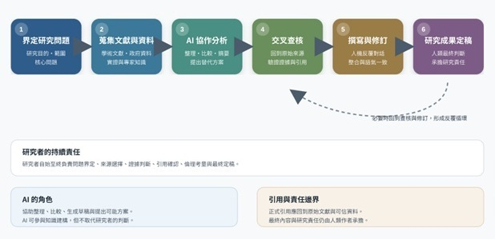
If broken down according to typical research tasks, the workflow can first be divided into five stages; the next section integrates these into a four-stage analytical model.
- Research ideation and design: assisting with brainstorming research topics, an initial review of gaps in existing research, drafting alternative formulations of research questions and hypotheses, and comparing the strengths and weaknesses of different research designs (e.g., surveys, in-depth interviews, and case studies).
- Literature collection and organization: suggesting keywords and database search strategies, quickly summarizing large volumes of literature, performing preliminary thematic classification and coding, and assisting in building a literature matrix for later comparison.
- Data collection and analysis: assisting in drafting surveys or interview outlines, performing preliminary thematic coding of qualitative data, writing code needed for statistical analysis or text mining, and producing preliminary charts.
- Writing and revision: assisting with drafting, polishing text and reviewing logic, adjusting formatting and citation style (e.g., APA format), and assisting with cross-language summaries and translation.
- Review, dissemination, and application: simulating possible reviewer comments to strengthen the argument in advance; assisting in producing presentations and figures; and translating findings into accessible policy briefs to communicate with civil servants and general readers.
AI’s role spans ideation, organization, analysis, revision, and dissemination; its output can only serve as candidate material. Whether the research question matters, whether the evidence is credible, and whether the conclusions align with public values must still be judged by the researcher.
Figure 2. Four Conceptual Approaches to AI-Assisted Research
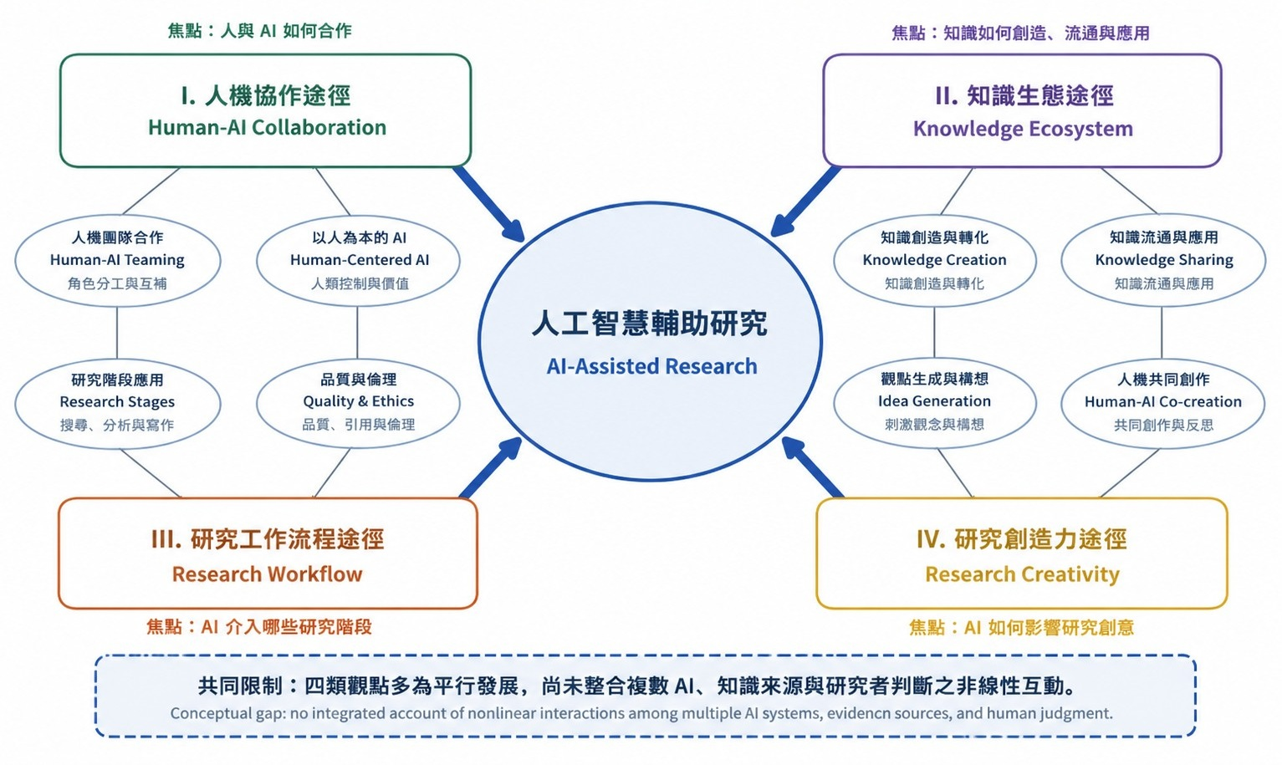
GenAI generates text or code using foundation models and large language models, and is characterized by generativity, versatility, and interactivity (Bommasani et al., 2021; Dwivedi et al., 2023). Compared with traditional AI centered on classification and prediction, it intervenes more deeply in problem definition, argumentation, and communication.
Public administration’s attention to AI has shifted from the efficiency and institutional integration concerns of e-government (Dawes, 2008), toward the bias and accountability of algorithmic governance and the organizational effects of AI entering front-line work (Busuioc, 2021; Jeffares, 2021), and further toward the human–AI collaboration and epistemic legitimacy raised by GenAI (Mergel et al., 2023). Yet relatively little of this research places risk within the full workflow, connecting decision-making authority, verification obligations, and the locus of responsibility.
This analysis therefore does not attempt to tally the volume of existing literature, but instead aims to fill the conceptual gap between “position within the workflow,” “governance risk,” and “allocation of responsibility,” which remains insufficiently connected.

2.2 A Four-Stage Research Workflow Model
Existing research mostly treats GenAI as a set of scattered tools, lacking an overall workflow perspective. This article synthesizes the research life-cycle theory of the science of science (Borgman, 2015) with public administration research practice (Pollitt, 2013) to propose a four-stage model: Ideation, Execution, Validation, and Dissemination. GenAI plays a different role at each stage, and risk and responsibility change accordingly. These four stages do not form a one-way process but a cycle capable of repeated feedback; for example, once validation uncovers a problem, it may be necessary to return to ideation or execution for readjustment.
Figure 3. The GenAI Human–AI Collaborative Research Workflow (Four Stages)
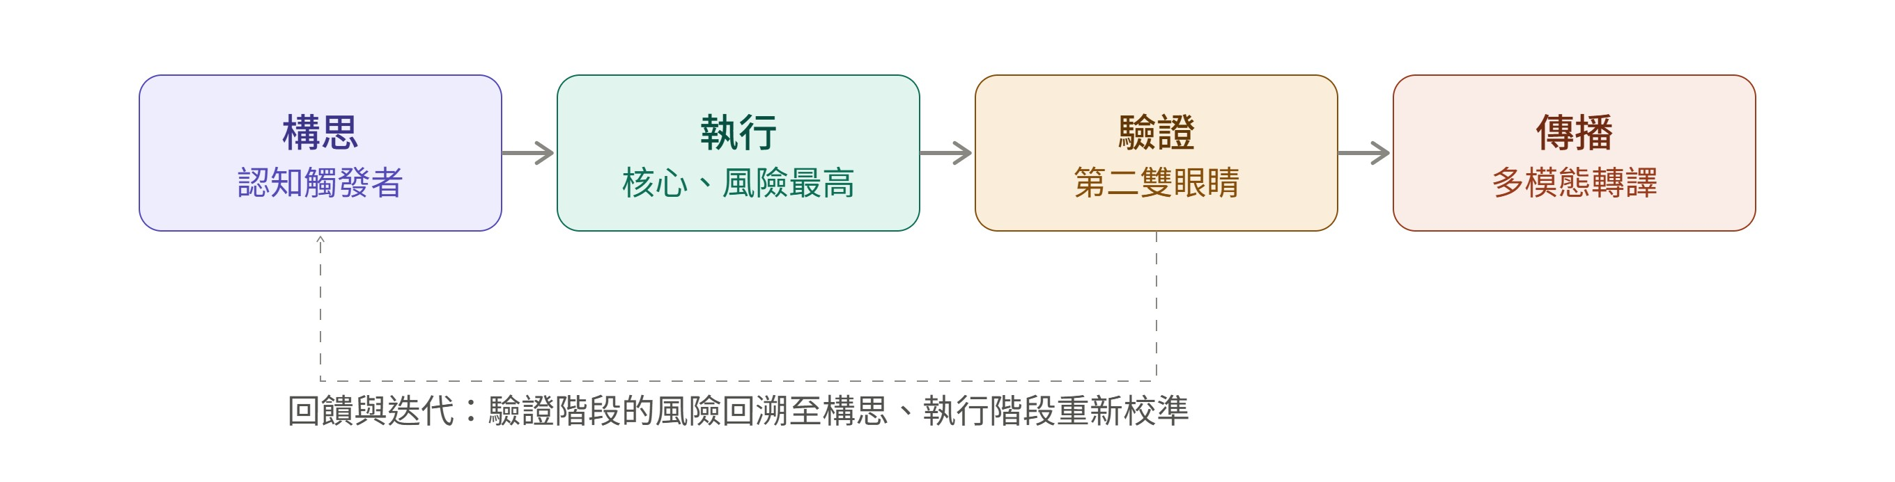

Stage One: Ideation
The ideation stage refers to the process of forming a research question, identifying a theoretical gap, and establishing hypotheses. GenAI can act here as a “cognitive trigger,” assisting the researcher with brainstorming, cross-domain conceptual linkage, and preliminary hypothesis generation, although the novelty and feasibility of its output must still be judged and checked by the researcher and cannot be accepted at face value. Specific applications include automated identification of research gaps, cross-domain conceptual linkage, and theory-based hypothesis generation.
GenAI’s involvement at the ideation stage may carry three risks. The first is homogenization risk: if researchers use the same models and prompts, research questions may converge, endangering academic diversity; Bender et al. (2021) describe this phenomenon as a “collective echo of stochastic parrots.” The second is problem-framing bias: because LLM training data is dominated by experience from English-speaking countries, it may overlook local contexts such as Taiwan’s local governance or village/borough-chief systems (Bender et al., 2021). The third is originality dilution: researchers may find it difficult to distinguish AI suggestions from their own original ideas, which may affect scholarly identity. The governance priority at this stage is to preserve human ownership of the research question; GenAI can only augment, not replace, human judgment.

Stage Two: Execution
The execution stage covers literature collection, data processing, analysis, and writing, and is where GenAI intervenes most often. Its applications include assisting with retrieval and summarization, preliminary coding, writing code, and generating drafts; but AI output can only serve as candidate material, and citations, data processing, and analytical results must still be checked against original sources, research records, and reproducible procedures.
Three main risks exist at this stage. First, hallucinated citations: GenAI may produce non-existent or erroneous bibliographic information, directly threatening research integrity, so citations must be individually checked against original sources (Walters & Wilder, 2023). Second, the reproduction and amplification of bias: models may reproduce stereotypes in the training data about particular groups or bureaucracies (Barocas et al., 2019). Third, data leakage: public administration research often uses internal government documents or sensitive public-opinion data, and uploading these to public cloud-based models may violate research ethics and information-security norms (Gasser & Almeida, 2017). This stage therefore requires mandatory verification mechanisms.

Stage Three: Validation
The validation stage refers to examining the correctness, reproducibility, and robustness of research findings, including fact-checking, statistical re-verification, counterfactual reasoning, and responses to peer review. GenAI can act here as a “second pair of eyes”: a model with browsing capability can be used to verify the authenticity of citations, check for errors in quantitative model specification, or be asked to act as devil’s advocate to challenge the research hypotheses.
However, the validation stage contains a methodological paradox: using GenAI to validate GenAI-generated content risks forming a “self-referential validation loop.” Because LLMs are stochastic and opaque, the same prompt may yield different validation results, which is unfavorable to scientific reproducibility (Borgman, 2015). In addition, automation bias may lead researchers to over-trust AI validation results and lower their guard (Skitka et al., 1999). Validation in public administration research is not merely a methodological issue but also a matter of public accountability: if a flawed policy evaluation is adopted by government after being “validated” by AI, substantive public harm may result. This stage must therefore establish the principle of “human final adjudication,” which is central to the accountability framework that follows.

Stage Four: Dissemination
The dissemination stage refers to the process of communicating research findings to the academic community, policymakers, and the public, including paper writing, policy briefs, visualization, and media communication. GenAI applications include multimodal translation (automatically converting academic papers into policy briefs, plain-language summaries, or social-media posts), enhanced visualization, and personalized communication for different stakeholders.
The risks at this stage shift from methodological to democratic-governance concerns. First, information ecosystem pollution: large volumes of unlabeled AI-generated policy analysis entering the public domain may cause information overload and declining trust (Floridi et al., 2018). Second, political-neutrality risk: AI-generated content may carry political leanings that violate administrative neutrality. Third, the “politics of authenticity”: when citizens cannot tell whether policy communication was AI-generated, government legitimacy may be called into question. This stage corresponds to Wirtz’s L4 and L5 layers and requires establishing obligations of transparency and mechanisms for building stakeholder trust.
Figure 3 depicts the four stages proceeding in sequence—ideation, execution, validation, and dissemination—with a dashed line at the bottom indicating that once validation uncovers a risk, the process can return to an earlier stage for readjustment. Figure 4 maps the human–AI collaboration checkpoints, main risks, and governance priorities at each of the four stages; problems found during validation must be fed back into ideation or execution for recalibration.
Figure 4. Human–AI Collaboration Checkpoints, Main Risks, and Governance Responses across the Four Stages
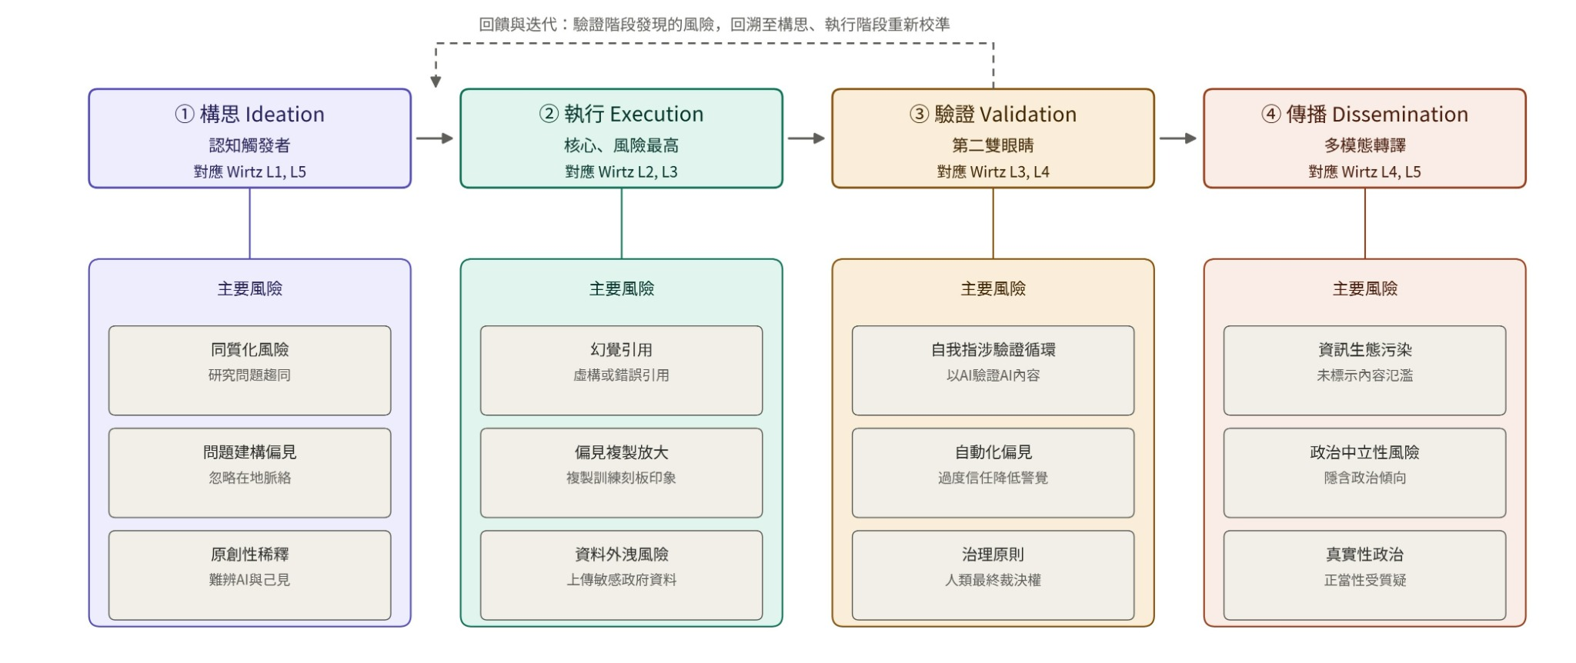

2.3 AI Platforms and the Knowledge-Interaction Ecosystem
Different AI platforms each have strengths in retrieval, closed-document question answering, long-document analysis, or general-purpose generation; no single tool is suited to every research task. The governance priority is not to chase platform rankings, but to select tools according to data sensitivity and task risk, while preserving cross-tool and human verification.
A more workable approach is to select tools by task and cross-validate: retrieval-oriented AI is used to explore sources, closed-document tools are used for specific datasets, and general-purpose models assist with synthesis and editing, with the researcher always checking facts and citations against the originals afterward. The framework proposed here refers to the interaction among the researcher, AI, primary sources, government data, expert knowledge, and the research context as a “Knowledge Interaction Ecosystem” (KIE; Figure 5). AI can participate in knowledge construction, but formal citation and final responsibility must still return to original sources and human judgment.
Figure 5. The AI Knowledge-Interaction Ecosystem
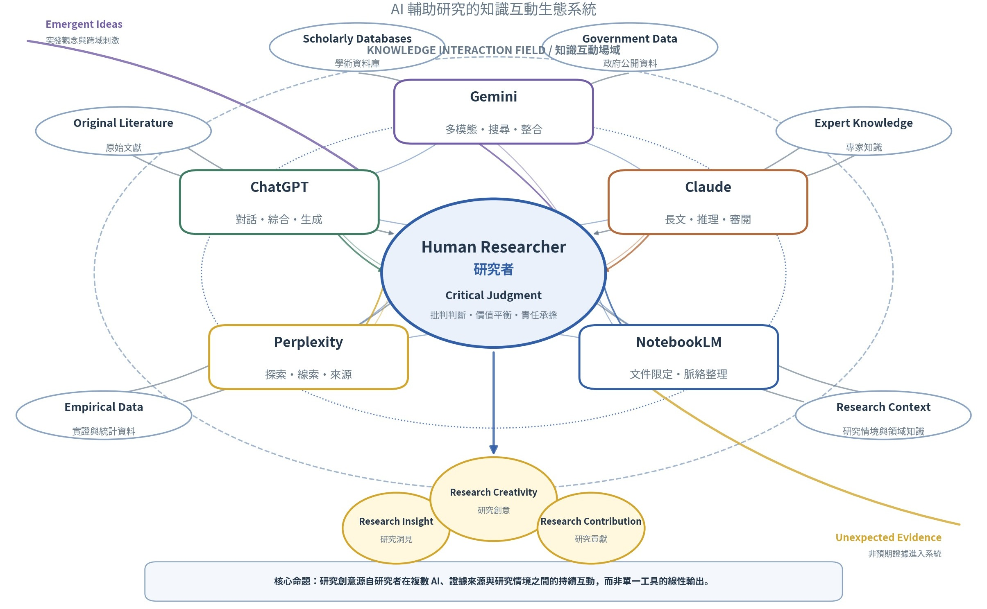

2.4 Risk, Responsibility, and Gaps in the Literature
Existing literature can be organized into three dimensions of GenAI risk: on the legal and regulatory side, model opacity, privacy violations, and information-security vulnerabilities weaken explainability and compliance capacity; on the social side, over-reliance may cause de-skilling and erosion of trust; on the ethical side, fabricated citations, bias, and undisclosed use endanger research integrity and public accountability (Floridi, 2023; Wirtz et al., 2020). AI output must therefore be checked against original sources, sensitive data must not be uploaded indiscriminately, and researchers must retain final judgment and disclosure responsibilities.
Existing research still shows three gaps. First, much of it focuses on a single stage such as writing, retrieval, or risk, lacking a full-workflow perspective. Second, existing layered models mainly address traditional AI and struggle to account for GenAI’s generativity, versatility, and human–AI co-creation. Third, information-management and education research rarely incorporates public administration’s distinctive concerns—administration according to law, democratic legitimacy, the public interest, and organizational accountability. This analysis therefore crosses the four-stage workflow with the five governance domains to locate risk, decision-making authority, and verification obligations.

2.5 The Taiwanese Public Administration Context
Discussion in Taiwan has gradually shifted from algorithmic governance and public values toward human–AI collaboration, institutional usage guidelines, and public trust in services; shared concerns include human responsibility, transparency, data security, and public accountability.
Between 2020 and 2022, discussion remained centered on algorithmic governance, bias, and public values; between 2023 and 2024, the concept of human–AI collaboration and institutional usage guidelines gradually emerged; from 2025 onward, research began shifting toward civil servants’ attitudes toward use, the design of public services, and citizen trust (Huang, 2025; Center for Digital Governance Research, 2025).
Huang et al. (2021) reflect on AI’s impact on public administration theory and values; Huang and Chen (2023) further develop the concept of “AI collaboration.” The GenAI guidelines of the Executive Yuan (2023) and National Yang Ming Chiao Tung University (2023) adopt the position that use is permitted but risk must be controlled, requiring users to retain final judgment and to attend to confidentiality, personal data, and intellectual property.
Overall, discussion in Taiwan has confirmed the importance of human responsibility, transparency, and data security, but still lacks research that integrates stage of use, structural effects, and the movement of responsibility into a set of recursive checkpoints.

3. Analytical Framework: An Expanded Five-Domain Governance Model
This section begins from existing layered models, explains GenAI’s three structural effects, and proposes recursive verification and non-delegable responsibility.

3.1 From a Three-Layer Model to Five Governance Domains
Gasser and Almeida (2017) address AI’s opacity and information asymmetry through three interdependent layers—technical, ethical, and social/legal: the technical layer covers data, algorithms, and standards; the ethical layer addresses fairness, transparency, and non-maleficence; the social/legal layer translates the first two into norms and legal constraints. Its value lies in avoiding the conflation of technical, ethical, and legal issues, but it does not yet offer an operational unit for how public organizations allocate regulatory, policy, and collaborative responsibility within a workflow.
Wirtz et al. (2020) instead propose five layers—AI technology and services, AI challenges, the regulatory process, public policy, and collaborative governance—and further divide the regulatory process into framework setting, risk/benefit assessment, risk evaluation, and risk management. This article takes these five layers as its main structure, integrates Gasser and Almeida’s layer-interdependence perspective, and adds, specific to GenAI, generative risk, human–AI responsibility, and workflow verification, forming the five governance domains in Table 1. The contribution here is not to claim yet another five-layer classification, but to convert an existing classification into a workflow framework capable of tracking cross-domain influence and shifting responsibility.
The five governance domains stand in a bidirectional relationship: technical understanding, risk identification, and regulatory definition progress bottom-up, while collaborative consensus and public values feed back into regulation and policy. All domains must operate together; no single technical standard or ethical declaration can substitute for governance as a whole.
Table 1. Expanded Five Governance Domains, Governance Tasks, and GenAI Challenges
Layer | Core Content | Governance Task | GenAI Challenge
L1 Technology & Services | Diversity of AI technologies and service infrastructure | Technology inventory, capability assessment, contextualized governance | A single foundation model serves many purposes; technology and service cannot be cleanly separated (P1)
L2 Challenges | Technical, ethical, and social challenges | Risk assessment, impact analysis | New generative risks such as epistemic disruption, authorship, and capability spillover (P2)
L3 Regulation | Scope of regulation and locus of responsibility; the four-stage regulatory process | Regulatory adaptation, oversight design | Ambiguous authorship/copyright, transparency obligations, traceability of accountability
L4 Public Policy | Policy instruments and organizational practice | Combining policy instruments, standard-setting | Need for local/on-premises models, verification logs, labeling standards
L5 Collaboration | Multi-stakeholder collaboration | Building trust, building consensus | Shift from human–human collaboration to human–AI collaboration; calibrating trust (P3)

Figure 6. The Expanded Five Governance Domains (integrating Gasser & Almeida, 2017; Wirtz et al., 2020)
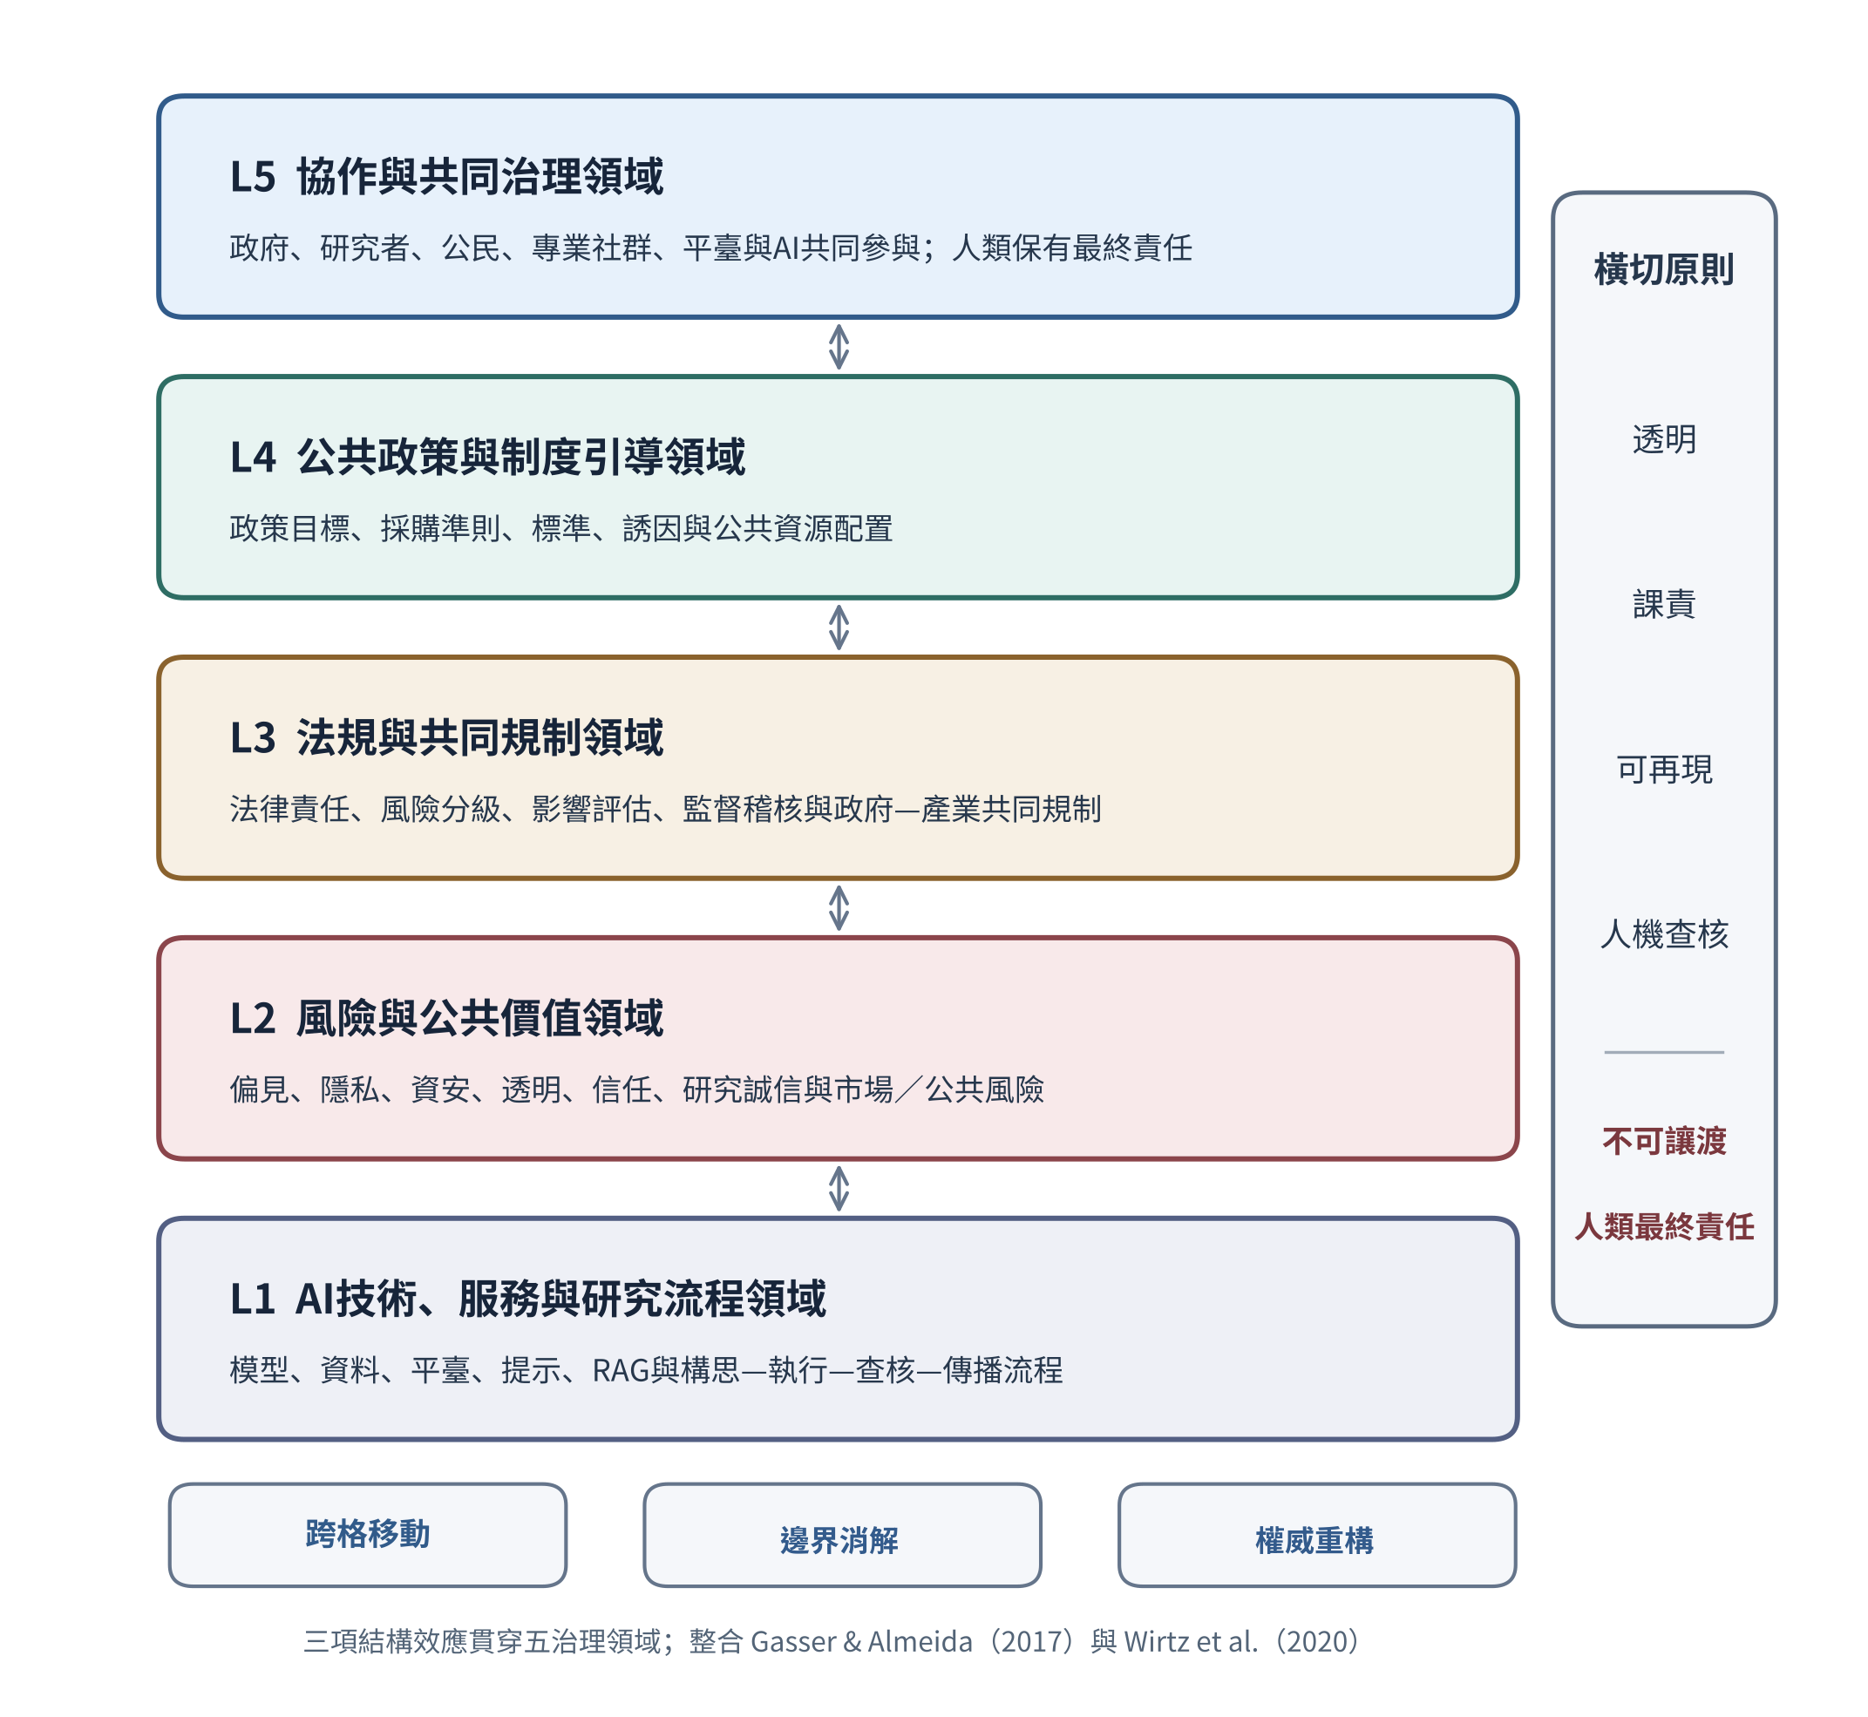

3.2 Three Structural Effects of GenAI
GenAI’s tendencies toward fabrication, bias, opacity, unaccountability, and agentic operation are not merely isolated risks; they also reshape governance categories and relationships of responsibility. The present analysis summarizes these as three structural effects: cross-coordinate movement, boundary dissolution, and authority reconfiguration.

(1) Cross-Coordinate Movement: Influence and Responsibility Crossing Existing Governance Cells
The same model may successively participate in problem definition, data processing, counter-argument, and policy dissemination, causing inputs, outputs, and consequences to cross the five governance domains and four stages. Governance cannot rely on a fixed classification based on where a tool first enters the workflow; whenever its use, data, audience, or decisional effect changes, risk should be re-tiered and the handover of responsibility recorded.

(2) Boundary Dissolution: Unstable Divisions among Technology, Knowledge, and Organizational Labor
GenAI causes the boundaries between technology and service, retrieval and generation, data and argument, human researcher and tool, and research and administrative decision-making to interpenetrate (Orlikowski, 2007). Governance must redraw the boundaries of responsibility based on records of data flow, model version, prompts, human edits, and publication authority, rather than relying solely on system names or nominal divisions of labor.

(3) Authority Reconfiguration: From a Single Statutory Source to a Traceable Chain of Authority
GenAI holds no legal standing as an author or agency decision-maker, yet it can acquire expert-like cognitive influence through training data, prompt templates, information ranking, and fluent text. Authority is therefore no longer exercised solely downward from a formal position, but is reconfigured into a chain of authority linking “situational framing — model suggestion — human review — statutory determination.” This reconfiguration brings in new actors such as model vendors, data engineers, and system integrators, but their influence must still be connected back to democratic authorization and administrative discretion: the model may offer a suggestion, the reviewer must explain the reasons for accepting or rejecting it, and the person with statutory authority retains final determination and responsibility. Governance criteria therefore include the gap between formal authority and actual influence, the degree of dependence on external vendors, the number of new actors involved, and whether the chain of authority carries traceable records of authorization, reasons, and sign-off.
The three effects reinforce one another: cross-coordinate movement expands the scope of influence; boundary dissolution makes such movement harder to detect; and if the influence of authority is not made explicit, tracing responsibility becomes more difficult. Governance must therefore reconstruct dispersed actual influence into a traceable chain of authority, and convert the five governance domains from a static classification into a cycle that can be repeatedly located, verified, and revisited (Figure 7).
Figure 7. The Expanded GenAI Cyclical Review Framework
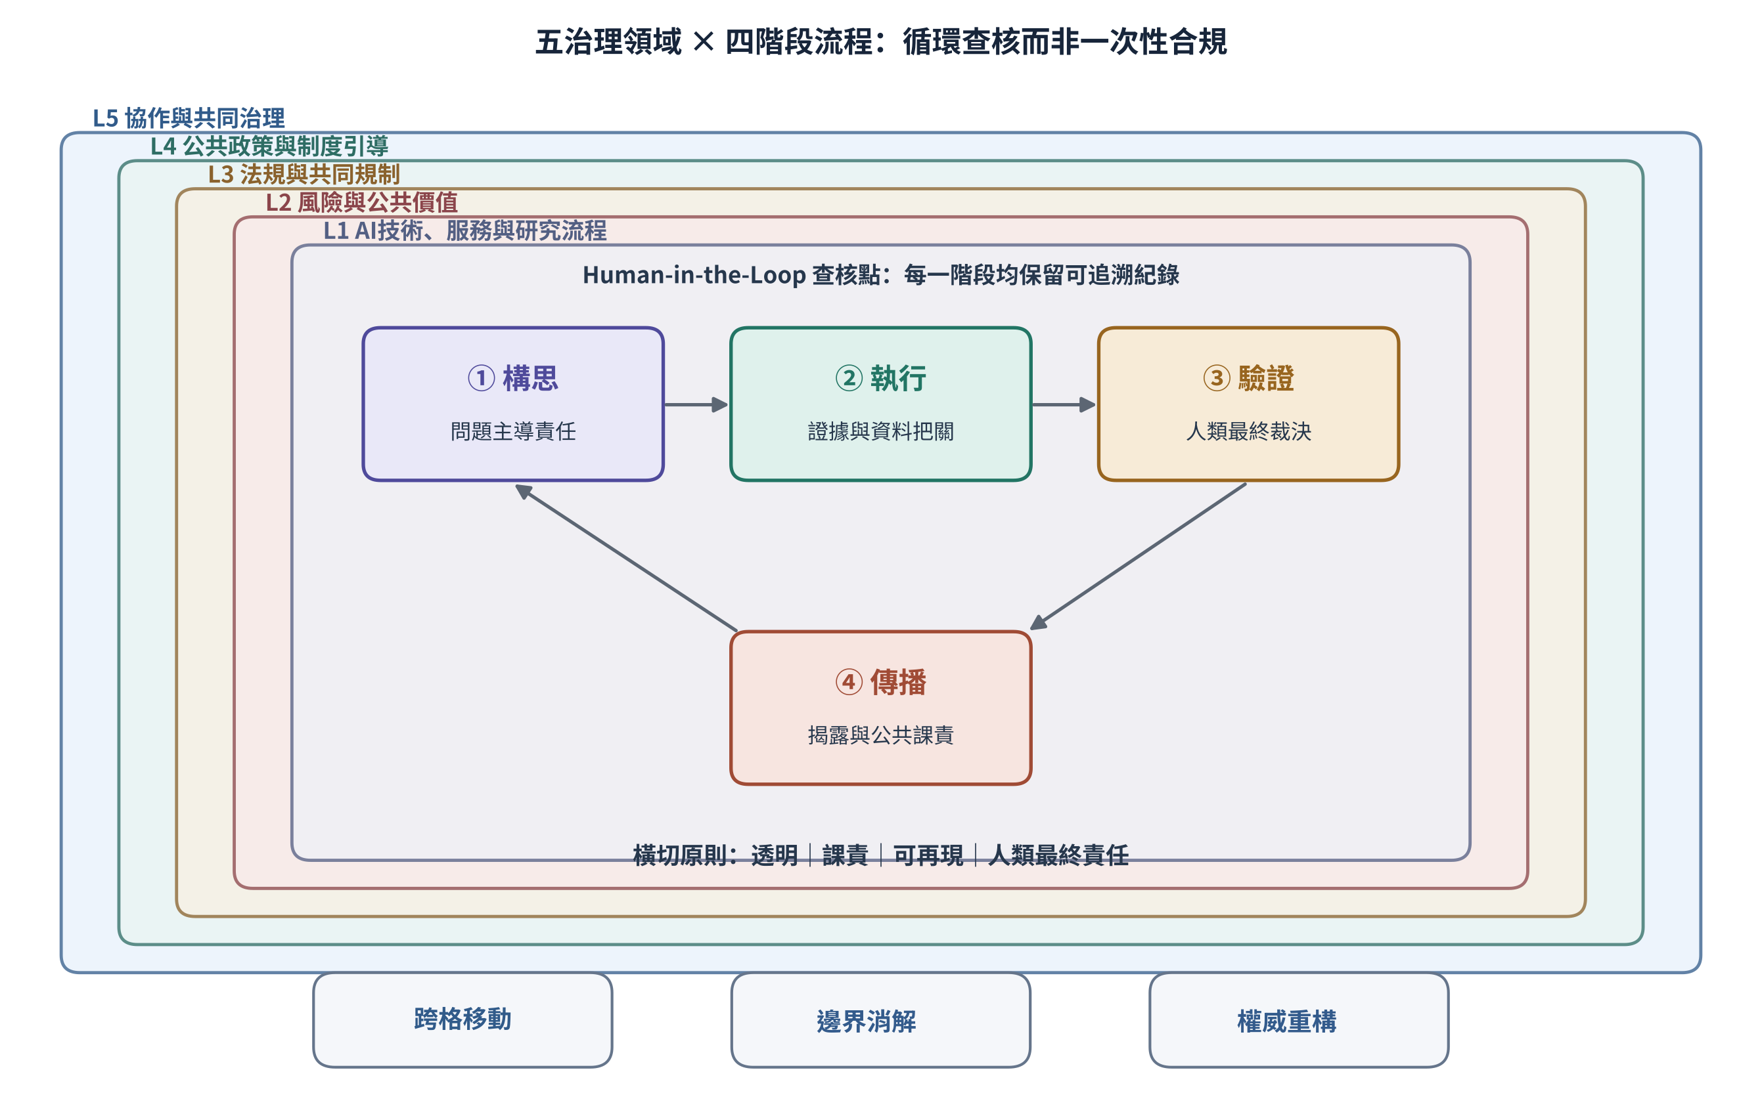

3.3 Public Administration’s Analytical Levels and the Local Context
Lu (1996a) locates public administration problems using five levels—philosophy and values, institutional division of labor, policy systems, organizational design, and management operations; this article’s five governance domains instead identify where GenAI intervenes within the workflow. The two originate differently and serve different functions, but the former can be used to examine purpose and legitimacy while the latter tracks technology, risk, and responsibility. Early research on information quality, source verification, and public responsibility (Lu, 1996a, 1996b, 1997) shows that these problems did not first arise with GenAI; this article uses that research only to supplement the Taiwanese research context, not as evidence that its theoretical propositions have already been established.
Figure 8. The Five Analytical Levels of Public Administration (Lu, 1996a)
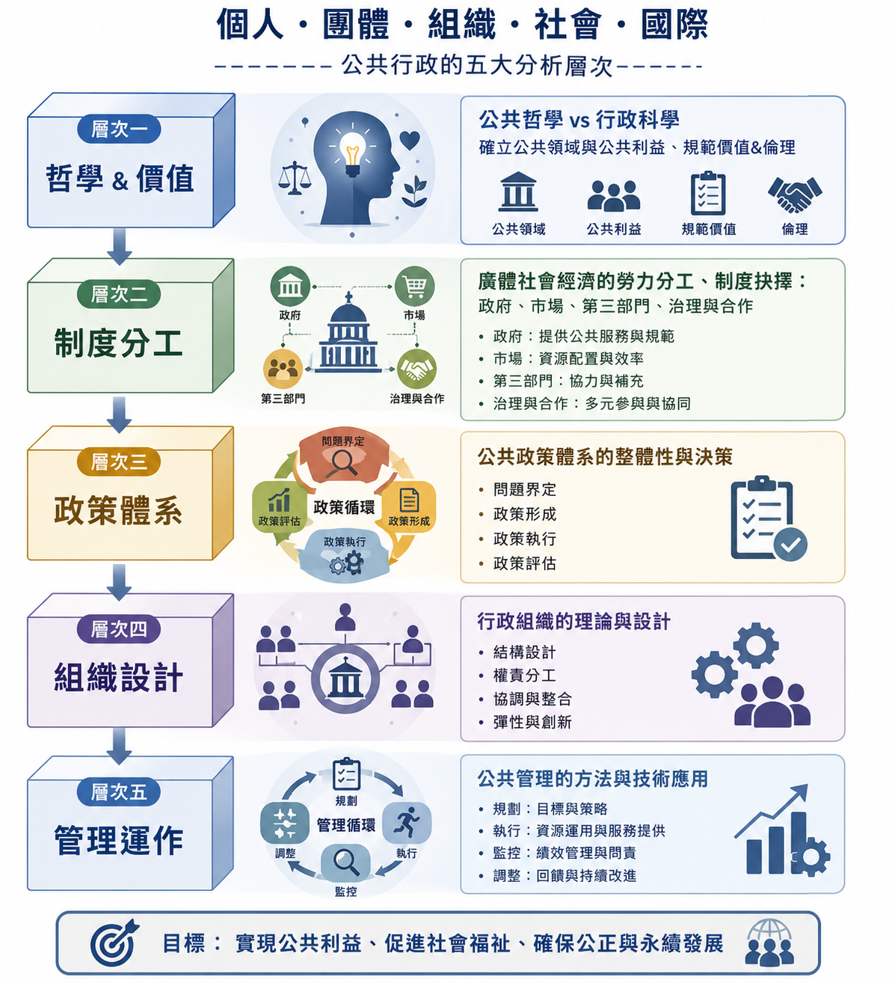

3.4 Non-Delegable Responsibilities
Human researchers, or the public organization holding statutory authority, bear at least three non-delegable responsibilities: deciding the problem and direction; making the final judgment on evidence, inference, and policy options; and gatekeeping data, text, and public release. AI may assist with operations and offer a second opinion, but it must not become a reason for a break in responsibility or for exemption from it.

3.5 Regulatory Theory and the Institutional Meaning of Co-Regulation
If the five governance domains are to be translated into institutional arrangements, it is still necessary to explain why government should intervene, how instruments should be allocated, and how public responsibility can be maintained amid rapid technological change.

(1) Market Failure and Dynamic Regulation
Wirtz et al. (2020) connect AI’s opacity, the spillover of discriminatory effects, and the shortage of trustworthy infrastructure to information asymmetry, externalities, and insufficient public goods, respectively, arguing on this basis that government cannot rely solely on industry self-regulation. Their regulatory process includes framework setting, risk/benefit assessment, risk evaluation, and risk management, and should allow for feedback-based revision. For GenAI, problem definition corresponds to the responsibility for ideation, risk assessment corresponds to verification during execution, risk evaluation corresponds to human determination, and risk management corresponds to disclosure and accountability. Because models are updated rapidly and risks cannot necessarily be enumerated in advance, static compliance must be supplemented with continuous monitoring and recursive verification.
In the AI context, information asymmetry manifests concretely as model opacity, externalities manifest as the spread of bias and erroneous decisions, and insufficient public goods manifest as a shortage of safety standards, trustworthy data, and shared verification infrastructure. This allows regulatory theory to move from abstract market failure to grounds for intervention that public administration can concretely identify.
The four-stage regulatory process is not a linear checklist: framework setting defines the problem to be governed; risk/benefit assessment gathers evidence; risk evaluation incorporates public values such as fairness, efficiency, and acceptability; risk management then selects instruments such as prohibition, standards, disclosure, or co-regulation. If a new use or new risk is found at any stage, the process should return to an earlier stage for reassessment.

(2) The Function and Risk of Co-Regulation
Co-regulation sits between direct government regulation and industry self-regulation: government sets the legal framework, basic rights, and risk objectives, while industry, standards bodies, academia, and civil society jointly develop technical standards, monitoring, and implementation details. It can combine public legitimacy with private-sector expertise and preserve room for adaptation through risk tiering, but it may also produce underrepresentation, regulatory capture, and mutual buck-passing between public and private actors. Jointly developed guidelines and checklists can therefore serve only as soft-law instruments; government or institutions must still retain oversight, remedy, and final accountability.

(3) Limits for GenAI Governance
Traditional regulatory theory typically assumes that risk can be identified and that the market is relatively stable; GenAI and agentic AI, however, may execute multiple tasks across stages, causing risk, authority, and responsibility to keep moving. Institutional design therefore cannot rely solely on an ex ante checklist; it must re-tier risk whenever use changes, preserve records of data flow and decisions, and allow external expertise and civic oversight into high-risk matters.

4. Analysis and Discussion: A Matrix of Applications, Risks, and Responsibility
This section crosses the four stages—ideation, execution, validation, and dissemination—with the five governance domains. Figure 9 first presents the overall relationship as “application — risk — responsibility,” marking cross-coordinate movement, boundary dissolution, authority reconfiguration, and the recursive feedback loop; the text that follows explains the core governance requirements of each stage.
Figure 9. The Four-Stage Application—Risk—Responsibility Matrix
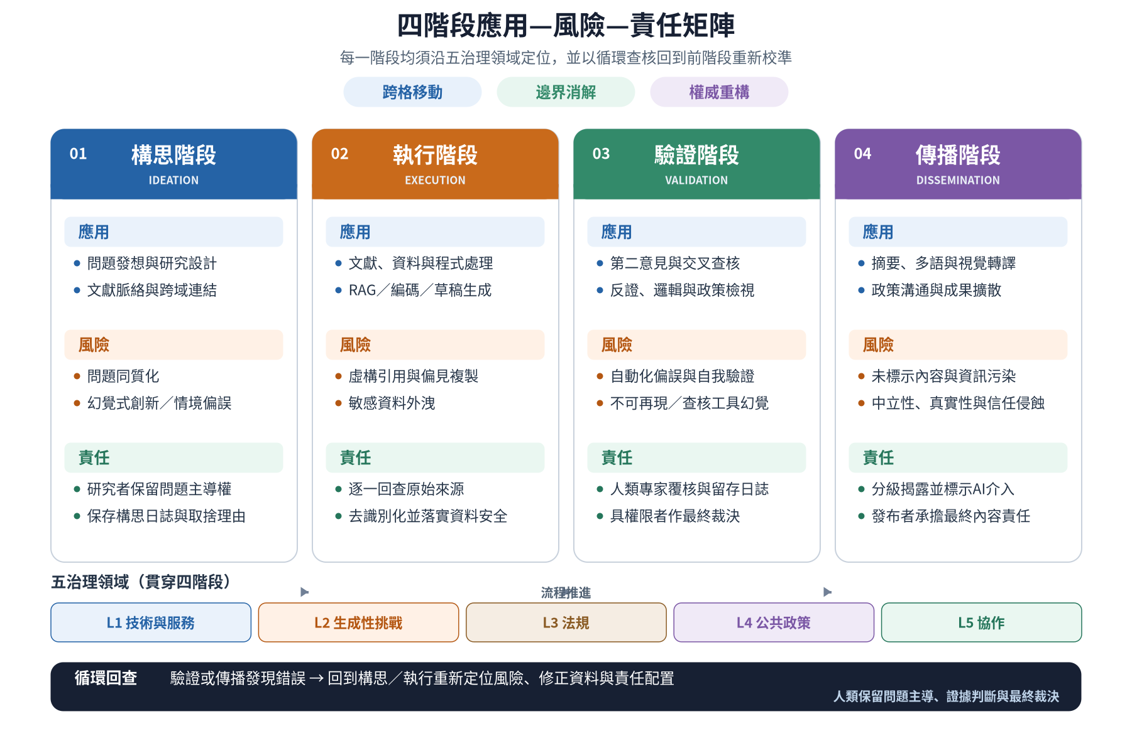

4.1 Application, Risk, and Responsibility at Each Stage
The core concern at the ideation stage is ownership of the problem. AI can assist with idea generation and cross-domain linkage, but may cause homogenization of research questions, insufficient attention to local context, and dilution of originality; researchers must record important choices and check AI suggestions against theoretical and practical context.
The execution stage involves the broadest intervention and the highest risk. Literature, data, code, and drafts must all be checked against original sources or reproducible records; sensitive data should be de-identified or handled in a controlled environment, and researchers bear the responsibility for checking against fabricated citations, reproduced bias, and data leakage.
The validation stage can use GenAI as a second opinion, but similar models answering one another cannot substitute for external evidence. High-risk conclusions must be reviewed by human experts, model versions and validation records must be preserved, and final determination must be made by someone with the requisite authority.
The dissemination stage can use GenAI for summarization, multilingual translation, and visual adaptation, but the publisher must still ensure accuracy, administrative neutrality, and appropriate disclosure. Where formal policy, rights, or resource allocation are involved, AI-generated content must not directly become an agency’s decision.

4.2 Cross-Stage Implications
The matrix reveals four cross-stage patterns. First, risk is most concentrated at the execution stage, and governance resources should be prioritized toward mandatory verification of citations, data, and analysis. Second, responsibility always rests with a human or organization, but its content shifts in sequence from driving the problem, to gatekeeping evidence and confidentiality, to final determination, and then to disclosure and accountability. Third, the core of the collaboration layer is not trusting AI, but calibrating trust through traceable records. Fourth, cross-coordinate movement requires re-tiering, boundary dissolution requires redrawing responsibility according to data flow, and authority reconfiguration requires building a chain of authority linking “situational framing — model suggestion — human review — statutory determination” and recording the actual influence of new actors, so that authority remains connected back to democratic authorization, reason-giving, and responsibility. Table 2 offers preliminary judgment criteria.
Table 2. Operational Criteria for the Three Structural Effects
Structural Effect | Core Question | Minimum Observable Evidence | Governance Response
Cross-Coordinate Movement | Does the AI’s use, data, audience, or decisional effect cross governance domains or workflow stages? | Records of changed use, data flow, stage handovers, and reuse of output | Re-tier risk at each crossing, assign a responsible person, and preserve handover records
Boundary Dissolution | Have the boundaries between technology/service, retrieval/generation, data/argument, or organizational division of labor become difficult to distinguish? | Platform and data source, RAG/generation labeling, records of prompts and human edits | Redraw responsibility based on actual data flow and operating authority; prohibit judgment based on system name alone
Authority Reconfiguration | Has authority shifted from a single statutory source to a chain jointly formed by the model, new actors, human review, and statutory determination? | Gap between formal authority and actual influence, dependence on vendors, new actors, records of accepted suggestions and review sign-off | Build a chain of authority linking “situational framing — model suggestion — human review — statutory determination,” reconnecting actual influence to democratic authorization, reasons, and responsibility
Note: This table is a conceptual coding blueprint, still awaiting expert validity testing, piloting, and cross-organizational validation.

5. Conclusion and Recommendations

5.1 Main Findings
GenAI is not merely a new tool; it causes influence to cross workflows and governance domains, dissolves existing divisions of labor, and reconfigures how authority is formed. Authority no longer derives solely from a formal position, but may be jointly formed among situational framing, model suggestion, human review, and statutory determination. The five governance domains retain positioning value, but must be crossed with the four-stage workflow to build a traceable chain of authority and recursive verification checkpoints, so that the actual influence of new actors—model vendors, technical staff, and users—can be reconnected to democratic authorization, reason-giving, and final responsibility.

5.2 Practical Recommendations
Researchers should individually check citations and evidence against original sources, and preserve records of models, prompts, and human edits; universities and journals may adopt tiered disclosure based on the degree of AI involvement; government agencies, in addition to tiering data, should reassess risk whenever use, audience, or decisional effect changes, and should distinguish operation, review, and determination. Content involving rights, resource allocation, or formal release must be signed off by someone with the requisite authority, and AI suggestions must not substitute for statutory discretion.

5.3 Limitations and Future Research
This analysis is a work of conceptual construction and has not been tested through interviews, surveys, or experiments; it focuses on text-generation models and the Taiwanese context and cannot be directly extrapolated to multimodal or agentic systems or other administrative cultures. Future research could convert Table 2 into survey items and proceed through expert content-validity testing, piloting, factor analysis, and cross-agency validation, and could compare the analytical units and applicable contexts of the U.S. National Institute of Standards and Technology (NIST), the International Risk Governance Council (IRGC), and the EU’s risk framework.

5.4 Closing Remarks
Technology may change how work is done, but it should not change who is responsible for judgment. Only as long as critique, choice, and final determination remain in human hands can human–AI collaboration truly add research value.

Appendix A: Responsible-Use Checklist for GenAI-Assisted Research Workflows
This table retains the eight core responsibility obligations across the four stages, for researchers, government agencies, and journal editorial offices to complete after each stage.
Table A1. Responsible-Use Checklist for GenAI-Assisted Research Workflows (Condensed Version)
Research Stage | Responsibility | Core Checklist Item | Done
Ideation | Problem ownership | Research questions and direction are decided by humans, with important trade-offs recorded. | □
Ideation | Data boundaries | No confidential, personal, or unauthorized data are entered. | □
Execution | Source verification | Citations, data, and facts are checked one by one against original sources. | □
Execution | Secure handling | Sensitive data are de-identified and processed in an appropriate environment. | □
Validation | Independent review | External evidence or human experts are used for verification; similar models are not used to validate one another. | □
Validation | Adjudication record | Model version, prompts, edits, and reasons for final adjudication are preserved. | □
Dissemination | Graded disclosure | The manner of AI use and the scope of human verification are labeled according to the degree of AI involvement. | □
Dissemination | Publication responsibility | A person with the requisite authority confirms accuracy, neutrality, and final responsibility. | □
Note: If any item is incomplete, progress to the next stage should be halted, or the exception reason, remedial measures, and named approver should be recorded.

References

Chinese-Language Literature
Executive Yuan. (2023). Reference guidelines for the use of generative AI by the Executive Yuan and its subordinate agencies [in Chinese].
Huang, C.-H. (2025). Are we ready to let AI serve us? The role and challenges of AI robots in citizen–government connections (book review) [in Chinese]. Journal of Public Administration, 69, 161–176.
National Yang Ming Chiao Tung University. (2023). Reference guidelines for the use of GenAI in academic research [in Chinese].
Huang, H.-Y., Tseng, K.-C., Liao, C.-P., & Chen, D.-Y. (2021). When artificial intelligence enters government: Reflections on public administration theory’s response to AI [in Chinese]. Civil Service Review, 13(2), 91–114.
Huang, H.-Y., & Chen, D.-Y. (2023). Public administration research under AI collaboration: A multi-level reflection on public-sector organizational issues [in Chinese]. Taiwan Journal of Political Science, 96, 139–178. https://doi.org/10.6166/TJPS.202306_(96).0004
Center for Digital Governance Research. (2025). Applications and challenges of GenAI in public services: A study of user behavior and trust in digital service design [in Chinese]. Commissioned research project, Ministry of Digital Affairs.
Lu, C.-H. (1996a). A literature review framework for public administration [in Chinese]. NOU Journal of Public Administration, 5, 177–210.
Lu, C.-H. (1996b). New issues for public administration in the information society [in Chinese]. Taiwan Journal of Political Science, 7, 231–256.
Lu, C.-H. (1997). A study on the exploration of public administration information on the WWW [in Chinese]. NOU Journal of Public Administration, 7, 41–66.
Lu, C.-H. (2026). Reconceiving artificial intelligence governance: Twenty-five governance coordinates, three functional shifts in administrative power, three structural effects, four governance chains, and seven governance audits from a public-administration perspective [Working paper, in Chinese]. Personal scholarly website.

English-Language Literature
Alvesson, M., & Sandberg, J. (2020). The problematizing review: A counterpoint to Elsbach and Van Knippenberg’s argument for integrative reviews. Journal of Management Studies, 57(6), 1290–1304.
American Psychological Association. (2023). APA journals policy on generative AI. American Psychological Association.
Barocas, S., Hardt, M., & Narayanan, A. (2019). Fairness and machine learning: Limitations and opportunities. FAT* Conference Proceedings.
Bender, E. M., Gebru, T., McMillan-Major, A., & Shmitchell, S. (2021). On the dangers of stochastic parrots: Can language models be too big? Proceedings of the 2021 ACM Conference on Fairness, Accountability, and Transparency, 610–623.
Bommasani, R., Hudson, D. A., Adeli, E., Altman, R., Arora, S., von Arx, S., et al. (2021). On the opportunities and risks of foundation models. arXiv. https://arxiv.org/abs/2108.07258
Borgman, C. L. (2015). Big data, little data, no data: Scholarship in the networked world. MIT Press.
Busuioc, M. (2021). Accountable artificial intelligence: Holding algorithms to account. Public Administration Review, 81(5), 825–836.
Dawes, S. S. (2008). The evolution and continuing challenges of e-governance. Public Administration Review, 68, S86–S102.
Dwivedi, Y. K., Kshetri, N., Hughes, L., et al. (2023). Opinion paper: “So what if ChatGPT wrote it?” Multidisciplinary perspectives on opportunities, challenges and implications of generative conversational AI. International Journal of Information Management, 71, 102642.
European Union. (2024). Regulation (EU) 2024/1689 laying down harmonised rules on artificial intelligence (Artificial Intelligence Act).
Floridi, L. (2023). AI as agency without intelligence: On ChatGPT, large language models, and other generative models. Philosophy & Technology, 36, 15.
Floridi, L., Cowls, J., Beltrametti, M., et al. (2018). AI4People—An ethical framework for a good AI society: Opportunities, risks, principles, and recommendations. Minds and Machines, 28, 689–707.
Gasser, U., & Almeida, V. A. F. (2017). A layered model for AI governance. IEEE Internet Computing, 21(6), 58–62.
Jeffares, S. (2021). AI and public services. In The Routledge handbook of public administration and technology. Routledge.
Mergel, I., Dickinson, H., Stenvall, J., & Gasco, M. (2023). Implementing AI in the public sector. Public Management Review, 25(11), 2025–2032.
Nature. (2023). Tools such as ChatGPT threaten transparent science; here are our ground rules for their use. Nature, 613, 612.
Office of Management and Budget. (2024). M-24-10: Advancing governance, innovation, and risk management for agency use of artificial intelligence. Executive Office of the President of the United States.
Orlikowski, W. J. (2007). Sociomaterial practices: Exploring technology at work. Organization Studies, 28(9), 1435–1448.
Pollitt, C. (2013). The evolving narratives of public management reform. Public Management Review, 15(6), 899–922.
Skitka, L. J., Mosier, K. L., & Burdick, M. D. (1999). Does automation bias decision-making? International Journal of Human-Computer Studies, 51(5), 991–1006.
Walters, W. H., & Wilder, E. I. (2023). Fabrication and errors in the bibliographic citations generated by ChatGPT. Scientific Reports, 13, 14045.
Wirtz, B. W., Weyerer, J. C., & Sturm, B. J. (2020). The dark sides of artificial intelligence: An integrated AI governance framework for public administration. International Journal of Public Administration, 43(9), 818–829.

